Anthology Student
Student Self-Service Student Accounts: Build an Online Payment Process Using Forms Builder and Workflow

Anthology

Web Site
www.campusmanagement.com

Contact Information
Phone: 1.561.923.2500
Sales/Support: 1.561.999.9904
Toll Free: 1.800.483.9106
Facsimile: 1.561.999.0096

Address
Campus Management Corp.
5201 Congress Ave
Boca Raton, FL 33487 USA

Copyright
© 2016 Campus Management Corp. All rights reserved. Campus Management Corp, Campus Management, the Campus Management logo, CampusVue, Talisma, CampusLink, CampusNet and CampusCare are registered trademarks or service marks of Campus Management Corp. and/or its affiliates, and may be registered in the U.S., other countries, or both. Other third party trademarks or service marks are property of their respective owners. Information is subject to change.

Contents
Resources 1
Angular JS 1
Understanding OData 3
Validation Regex property in Forms Builder 3
Log File Location & Names 3
Agenda 4
Introduction 5
Course Objectives 5
Target Audience 5
Course Prerequisites 5
Lesson 1: Create a Student Self-Service Form and Supporting Workflow for Accepting an Online Payment 6
Exercise: Create an Online Payment Form and Supporting Workflow 6
Lesson 2: Validate the Form and Supporting Workflow 90
Exercise: Validate the Student Self-Service Form and Supporting Workflow for Accepting an Online Payment 91

Resources
www.mycampusinsight.com

Note: If you do not have a MyCampusInsight login, contact your Customer Enablement Manager.

https://github.com/campusmanagement
http://community.campusmgmt.com

Angular JS
https://docs.angularjs.org/guide/introduction:
AngularJS is a structural framework for dynamic web apps. It lets you use HTML as your template language and lets you extend HTML's syntax to express your application's components clearly and succinctly. AngularJS's data binding and dependency injection eliminate much of the code you would otherwise have to write. In addition, it all happens within the browser, making it an ideal partner with any server technology.
AngularJS is what HTML would have been, had it been designed for applications. HTML is a great declarative language for static documents. It does not contain much in the way of creating applications, and as a result building web applications is an exercise in what do I have to do to trick the browser into doing what I want?
The impedance mismatch between dynamic applications and static documents is often solved with:
- a library - a collection of functions, which are useful when writing web apps. Your code is in charge and it calls into the library when it sees fit. E.g., jQuery.
- frameworks - a particular implementation of a web application, where your code fills in the details. The framework is in charge and it calls into your code when it needs something app specific. E.g., durandal, ember, etc.
AngularJS takes another approach. It attempts to minimize the impedance mismatch between document centric HTML and what an application needs by creating new HTML constructs. AngularJS teaches the browser new syntax through a construct we call directives. Examples include:
- Data binding, as in {{}}.
- DOM control structures for repeating, showing and hiding DOM fragments.
- Support for forms and form validation.
- Attaching new behavior to DOM elements, such as DOM event handling.
- Grouping of HTML into reusable components.

Angular JS Resources
https://www.w3schools.com/js/js_comparisons.asp
https://teropa.info/images/angular_expressions_cheatsheet.pdf

https://docs.angularjs.org/guide/expression

Understanding OData
http://www.odata.org/getting-started/understand-odata-in-6-steps/
OData (Open Data Protocol) is a standard that defines the best practice for building and consuming RESTful APIs. OData helps you focus on your business logic while building RESTful APIs without having to worry about the approaches to define request and response headers, status codes, HTTP methods, URL conventions, media types, payload formats and query options etc. OData also guides you about tracking changes, defining functions/actions for reusable procedures and sending asynchronous/batch requests etc. Additionally, OData provides facility for extension to fulfil any custom needs of your RESTful APIs.
OData RESTful APIs are easy to consume. The OData metadata, a machine-readable description of the data model of the APIs, enables the creation of powerful generic client proxies and tools. Some of them can help you interact with OData even without knowing anything about the protocol.
To learn more about the OData query syntax, see http://www.OData.org/ and look for "Basic Tutorial” and "Advanced Tutorial”.

Validation Regex property in Forms Builder
Validation Regex is the regular expression pattern to validate the input. Use site like http://RegExLib.com to search and test Regex patterns, or construct your own with Regex tools like Expresso. If the user input does not produce a Regex match, the "Validation message" will be displayed.
Examples:
Regex that enforces a minimum of 11 digits for a phone number where the first digit must be "1": 1\d{10}
Regex that enforces a phone number in the format (###)###-####: ^\([0-9]{3}\)[0-9]{3}\-[0-9]{4}$
Regex that matches a hyphen-separated social security number: ^\d{3}-\d{2}-\d{4}$

Log File Location & Names
Log files for Forms Builder are located at:
\\server\c$\logs - (where server is the hostname for your environment)
Look for FormsBuilderRenderer-date.txt & FormsBuilderDesigner-date.txt

Agenda

Time | Topic | Activity
8:30 – 8:45 AM | Course Overview and Introductions
8:45 – 9:00 AM | Student Self-Service Online Payment Process Overview | Demo
9:00 - 10:00 AM | Lesson 1: Create a Student Self-Service Form and Supporting Workflow for Accepting an Online Payment | Exercise: Create an Online Payment Form and Supporting Workflow
10:00 – 10:15 AM | Break
10:15 - 11:30 AM | Lesson 1: Create a Student Self-Service Form and Supporting Workflow for Accepting an Online Payment Continued
11:30 - 12:00 PM | Lesson 2: Validate the Form and Supporting Workflow | Exercise: Validate the Student Self-Service Form and Supporting Workflow for Accepting an Online Payment

Introduction
This is an advanced, hands-on session. Participants will learn how to build a student self-service Online Payment Process using Forms Builder, Workflow, and CampusNexus Student.

Course Objectives
Upon completion of this session, participants will be able to:
- Build an Online Payment Form Sequence
- Automate the Online Payment Process utilizing Workflow and CampusNexus Student configurations

Target Audience
Technical Business Analysts, System Administrators, Database Programmer, IT staff members

Course Prerequisites
Prerequisite Knowledge:
- Understanding of Business Processes
- Understanding of CampusNexus Student Application and Schema and/or CampusNexus CRM Application and Schema
- Aware of .NET Technologies and Understanding of VB.Net
- Create Variables, Assign Data Types, and a Basic Understanding of Development Languages
- Awareness of:
  - Windows Workflow Foundation (4.5)
  - CSS Themes
- SQL Knowledge
  - Ability to create SQL jobs, call Stored procedures and Write Queries
- General Development Knowledge of Variables, Arguments, Control Logic, Exception Handling, Debugging etc.

Lesson 1: Create a Student Self-Service Form and Supporting Workflow for Accepting an Online Payment
In this lesson, you will create an Application for Graduation process where the student will electronically sign the application as well as submit an Online Payment for the Graduation Fee.

Exercise: Create an Online Payment Form and Supporting Workflow

- Navigate to Google Chrome and Launch Designer from the Bookmarks Bar.
- Sign in using the following credentials:
administrator
testing
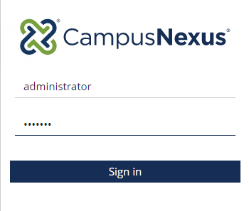

- Select the Form Designer to start creating your form.
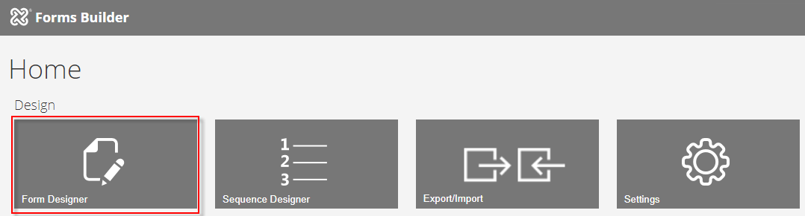

- Select New. A 1 Column panel is added to the Layout pane in the Designer.
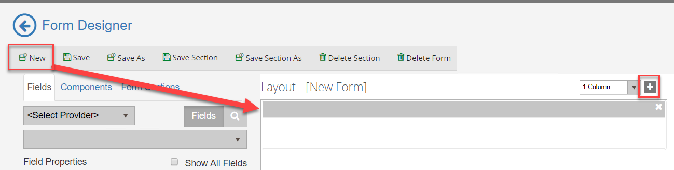

- From the Components tab, drag an HTML component into the panel of the Layout pane.
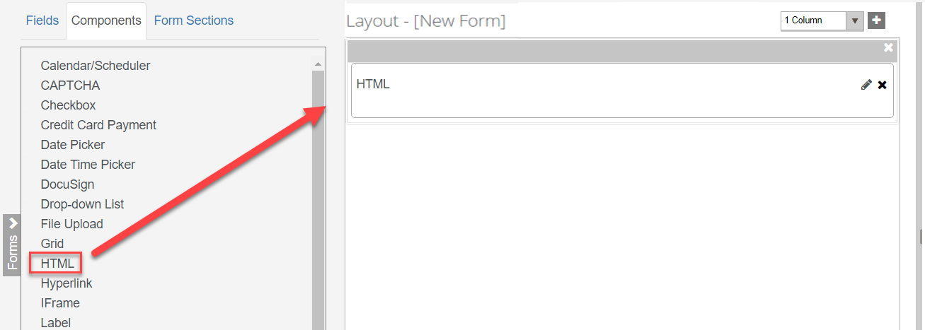

- Enter the following for the HTML component in the HTML property of the Control Property Settings pane:
<h3 style="color:#000066"><b>Application for Graduation</b></h3>
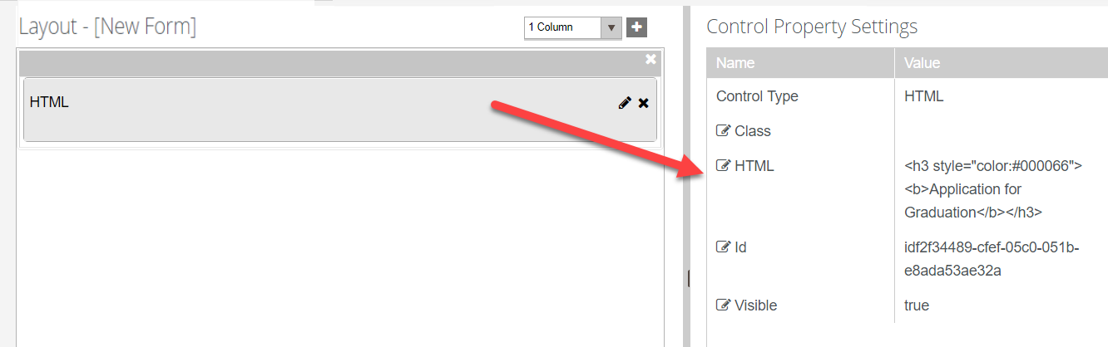

- Click the + and select the column option to add a 2 Column panel to the Layout pane.
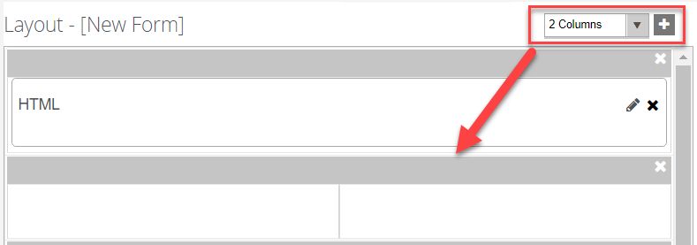
- From the Components tab, drag two HTML components into the panel of the Layout pane.

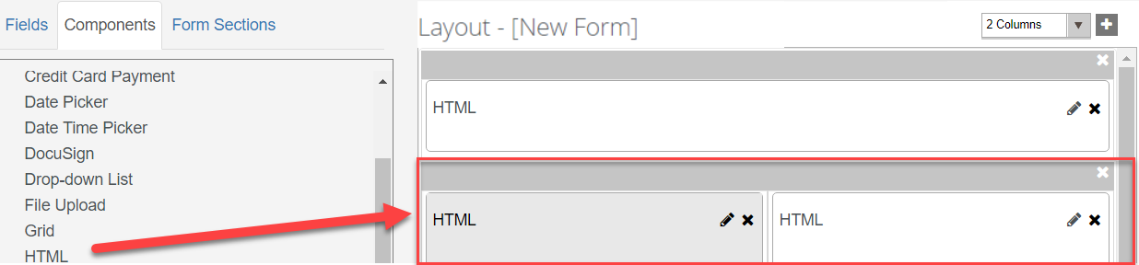

- For the first HTML component, enter the following in the HTML property of the Control Property Settings pane:
<b>Student Information:</b>
Note: The second HTML component is used as a place holder so we will not enter anything in the Control Property Settings pane for the second component.
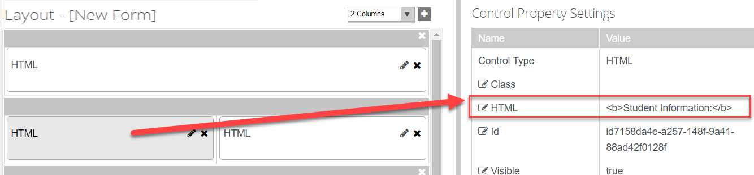

- Select the Fields tab and under Student select the Student entity. Drag the following fields into the second panel below the HTML components as shown below:
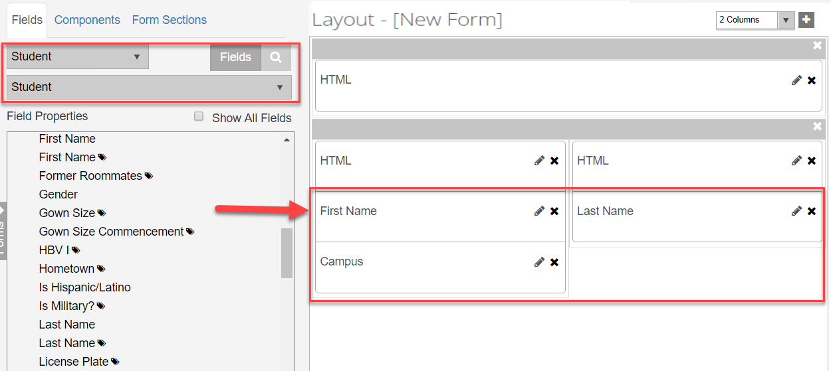
- Make sure the Read-only property in the Control Property Settings pane is set to true for the First Name and Last Name fields.
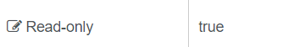

- Make sure the Required property in the Control Property Settings pane is set to false for the First Name and Last Name fields.
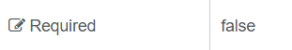

- Make sure the Disabled property in the Control Property Settings pane is set to true for the Campus field.
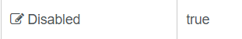

- Make sure the Required property in the Control Property Settings pane is set to false for the Campus field.


- From the Components tab, drag a Drop-down List component into the second panel of the Layout pane next to the Campus field as shown below.
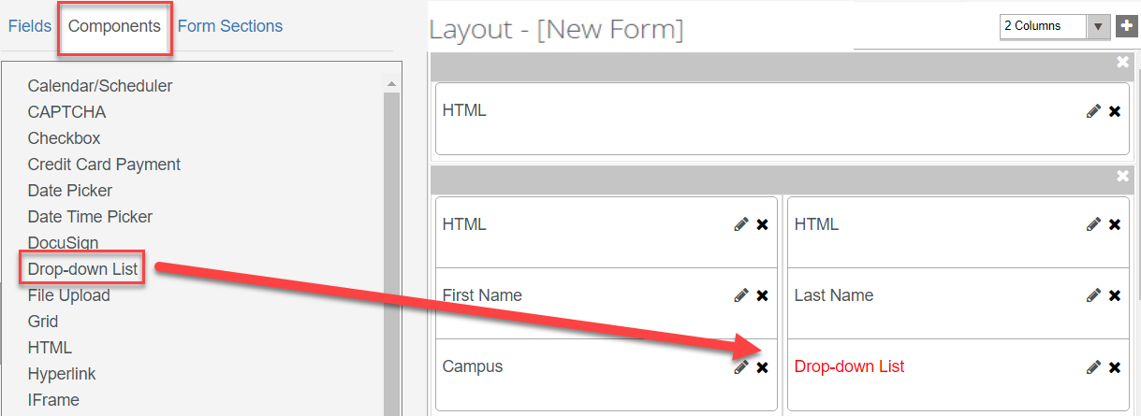
- Select the pencil icon on the component to edit the Short Description. Update it to read Program and click Save.
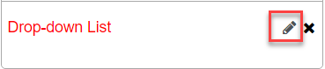
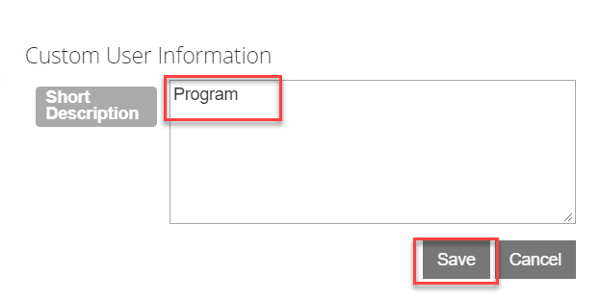
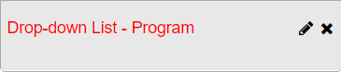

- Update the properties for the Drop-down List - Program field in the Control Property Settings pane:
Label- Program Version
Lookup Display Member – ProgramVersionName (We want to display the Name of the Program Version in our drop-down list.)
Lookup Query – StudentEnrollmentPeriods?$filter=Student/Id eq {{vm.models.studentEntity.Id}}&$select=Id,ProgramVersionName&$expand=Student($select=Id) (We want to filter the program versions for the student.)
Lookup Sort Member – ProgramVersionName (We want to sort our drop-down list by the Program Version Name.)
Lookup Value Member – Id (We will lookup our values based on the Id for the Student.)
Model – vm.models.studentEnrollmentPeriodEntity.Id (We will return the studentEnrollmentPeriodEntity.Id to pass back into our WF.)
Product – Student (This specifies the product we are querying the data from.)
Required – true (This makes the field required.)
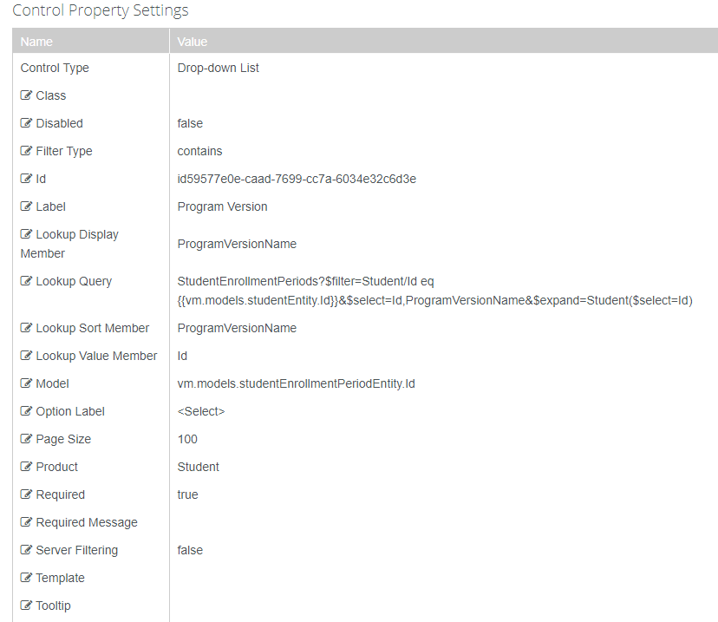
- Click the + and select the column option to add a 1 Column panel to the Layout pane.
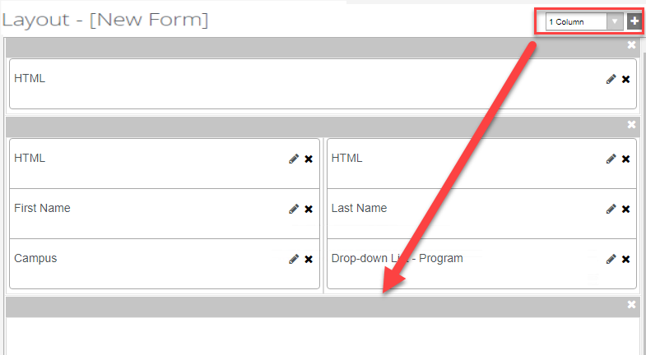
- From the Components tab, drag an HTML component into the panel of the Layout pane.

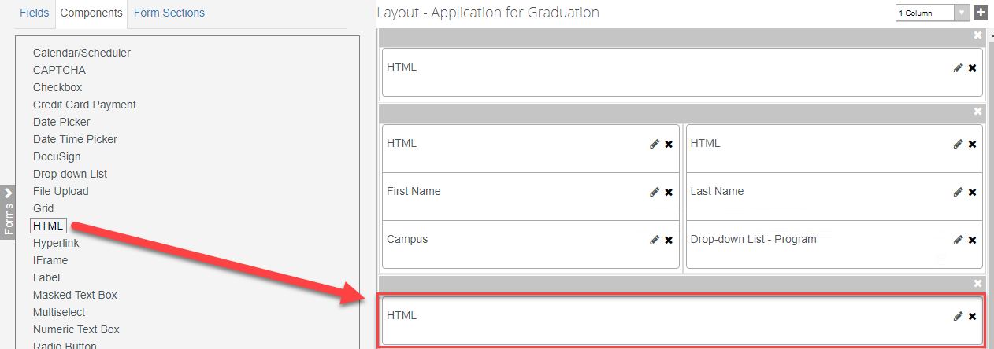

- For the HTML component, enter the following in the HTML property of the Control Property Settings pane:
<b>Name to be Displayed on Diploma:</b>
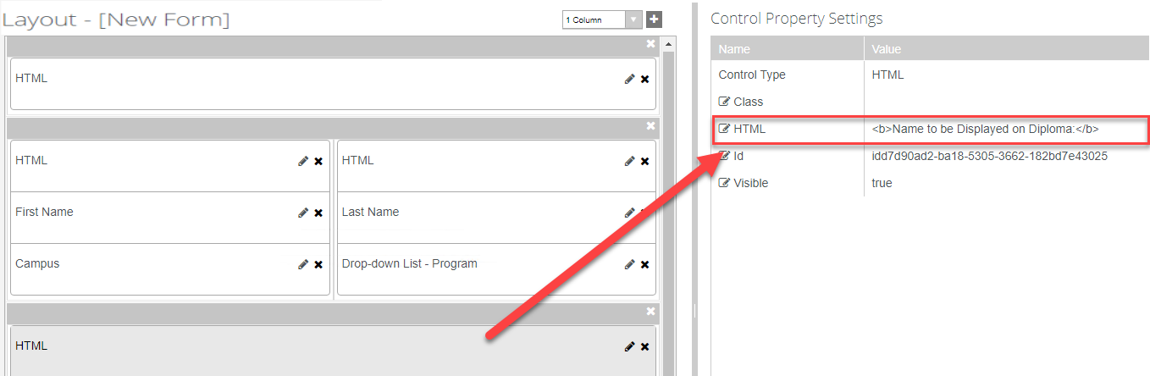

- Select the Fields tab and under Student select the Student entity. Drag the Diploma Name field into the panel below the HTML component as shown below:
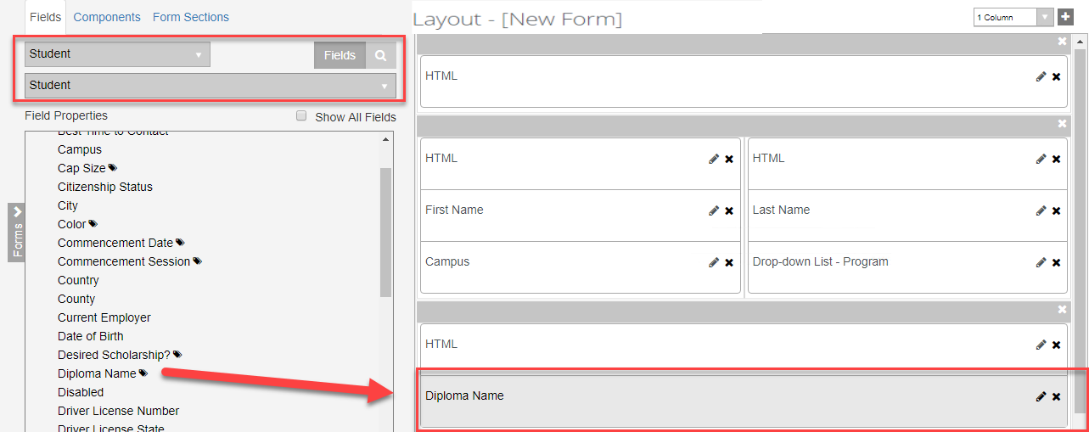

- Make sure the Required property in the Control Property Settings pane is set to true for the Diploma Name field.
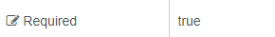

- Click the + and select the column option to add a 1 Column panel to the Layout pane.
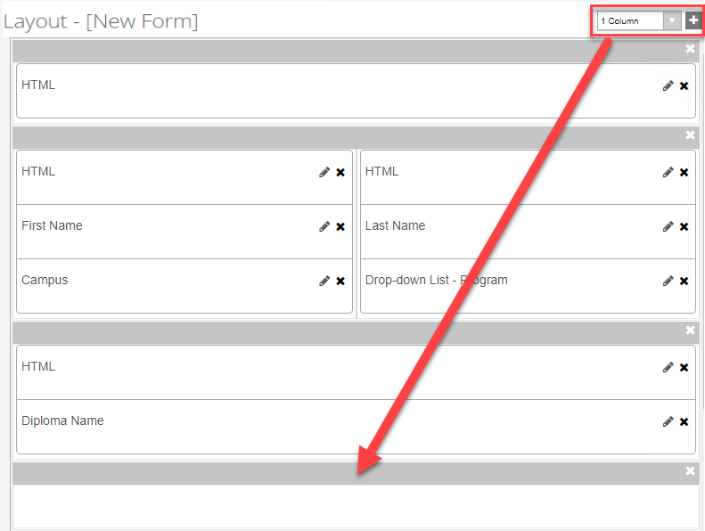
- From the Components tab, drag an HTML component into the panel of the Layout pane.
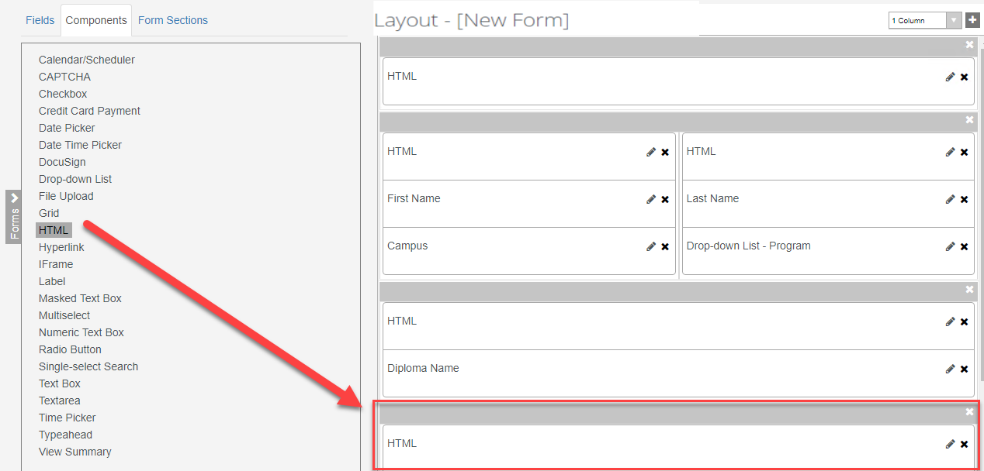

- For the HTML component, enter the following in the HTML property of the Control Property Settings pane:
<b>Mailing Address for Diploma:</b>
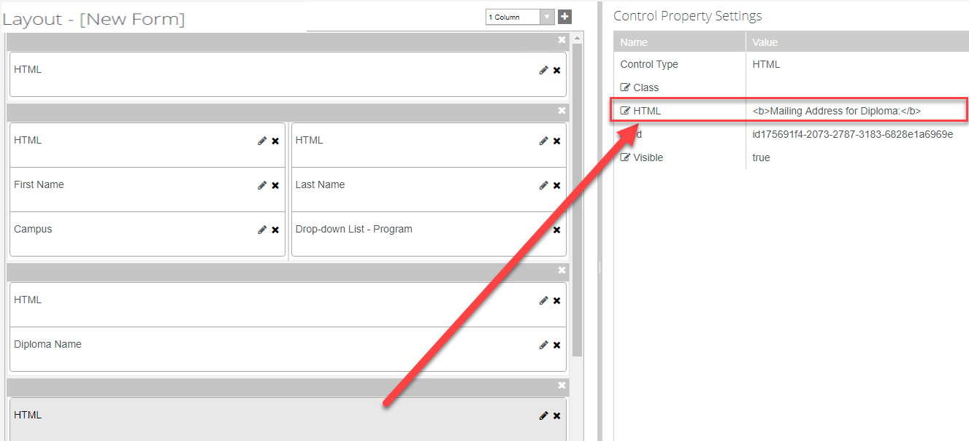

- Select the Fields tab and under Student select the Student Relationship Address entity. Drag the Street Address field into the panel below the HTML component as shown below:
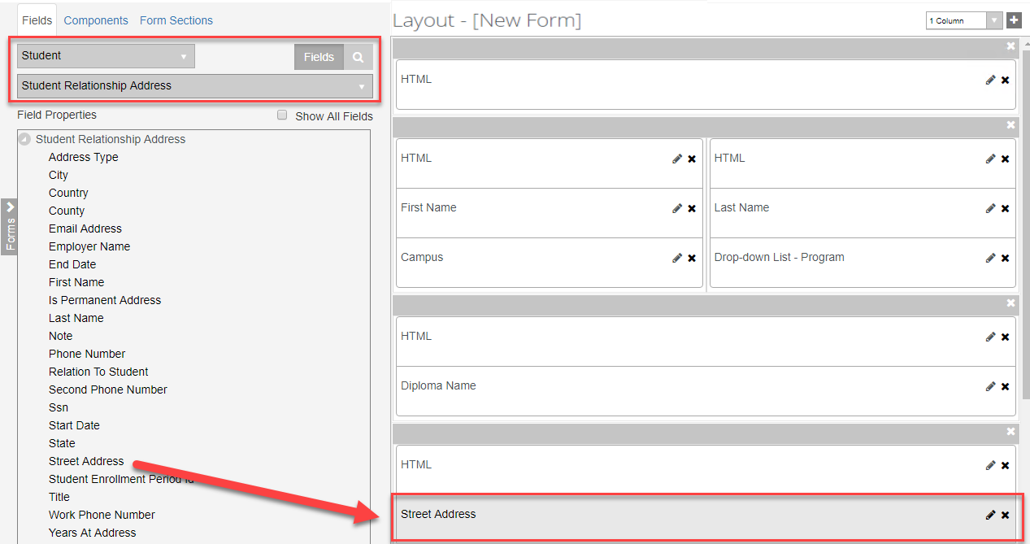

- Make sure the Required property in the Control Property Settings pane is set to true for the Street Address field.


- Click the + and select the column option to add a 3 Column panel to the Layout pane.
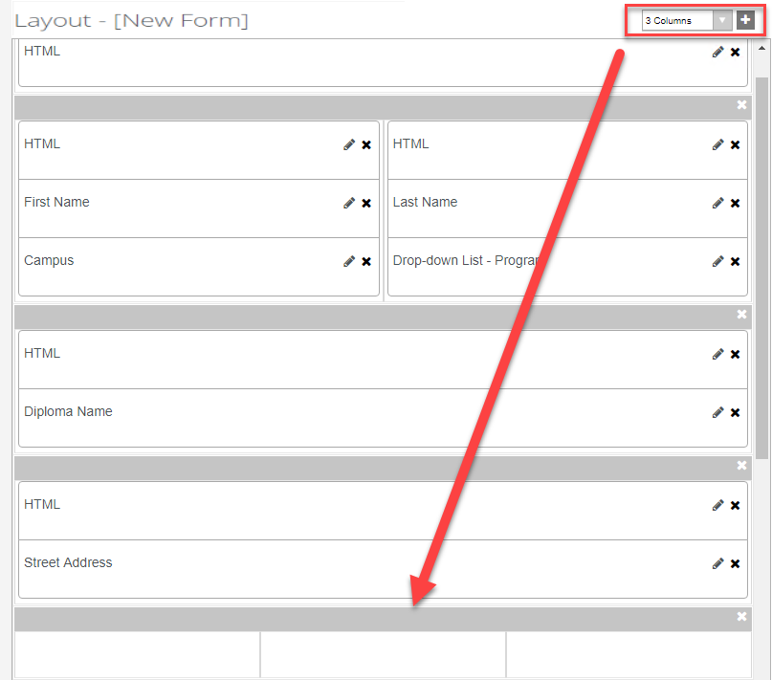

- Select the Fields tab and under Student select the Student Relationship Address entity. Drag the City, State, and ZIP Code/Postal Code fields into the panel as shown below:
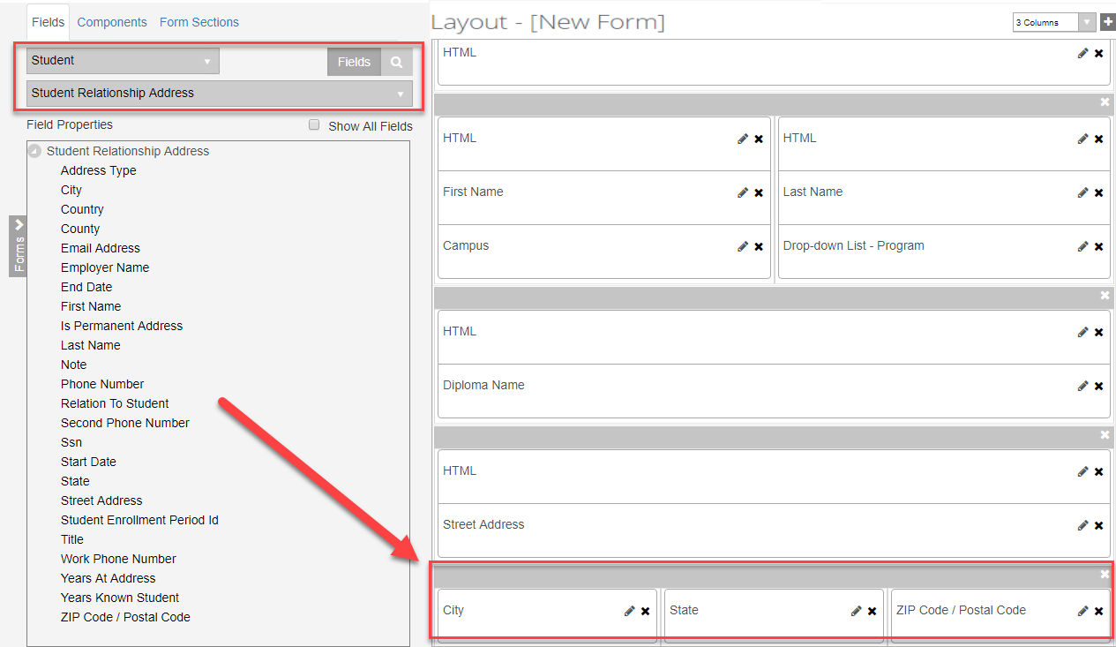

- Make sure the Required property in the Control Property Settings pane is set to true for the City, State, and ZIP Code/Postal Code fields.


- Click the + and select the column option to add a 3 Column panel to the Layout pane.
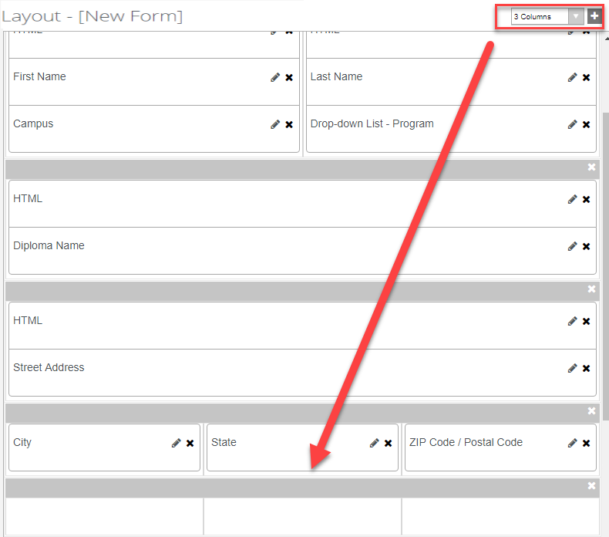

- From the Components tab, drag three HTML components into the panel of the Layout pane.
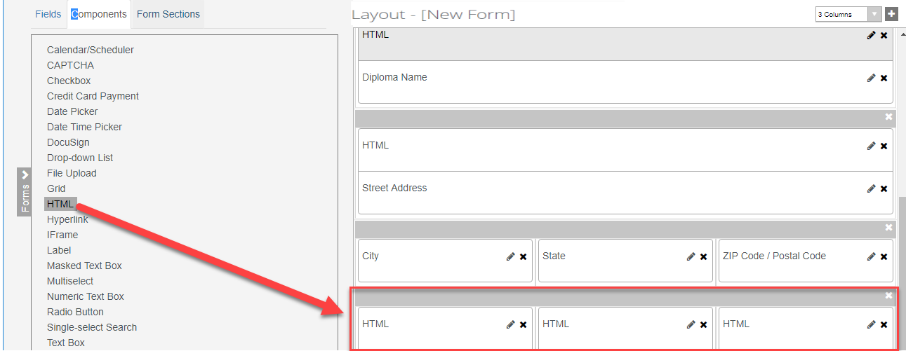

- For the first HTML component, enter the following in the HTML property of the Control Property Settings pane:
<b>Information Needed for Commencement Ceremony:</b>
Note: The second and third HTML components are used as place holders so we will not enter anything in the Control Property Settings pane for these components.
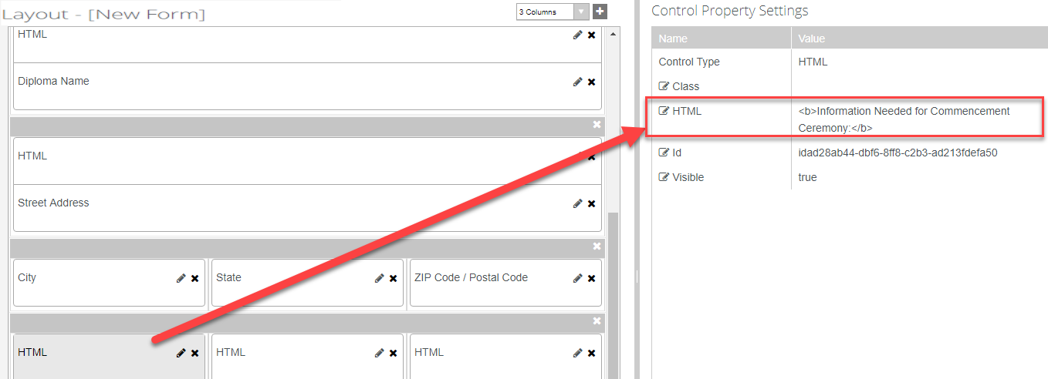

- Select the Fields tab and under Student select the Student entity. Drag the Commencement Session, Cap Size, and Gown Size Commencement fields into the panel below the HTML components as shown below:
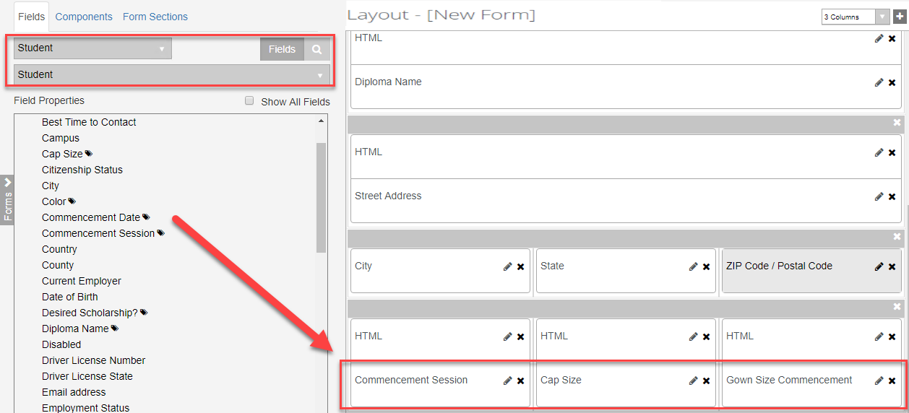

- Make sure the Required property in the Control Property Settings pane is set to true for the Commencement Session, Cap Size, and Gown Size Commencement fields.


- Click the + and select the column option to add a 2 Column panel to the Layout pane.
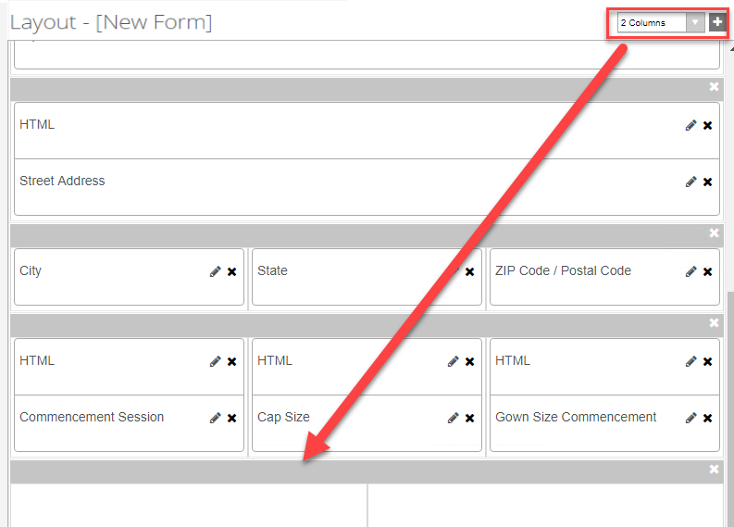

- From the Components tab, drag two HTML components into the panel of the Layout pane.
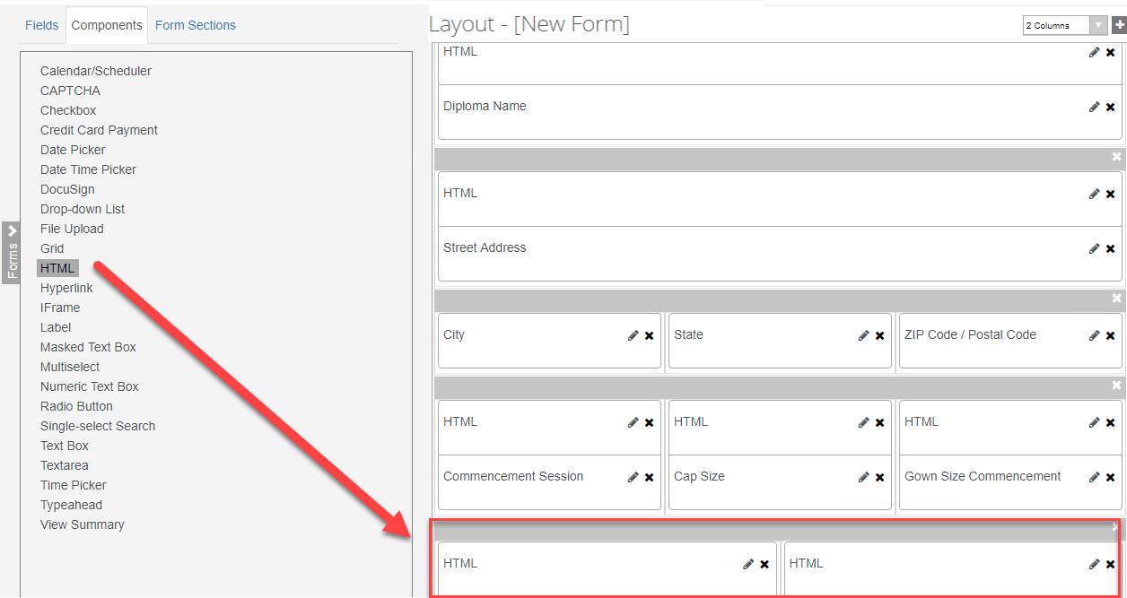

- For the first HTML component, enter the following in the HTML property of the Control Property Settings pane:
<b>By clicking Continue, you will be redirected to pay a $75 graduation fee. Once payment is received you will be required to electronically sign the Application for Graduation.</b>
Note: The second HTML component is used as a place holder so we will not enter anything in the Control Property Settings pane for this component.
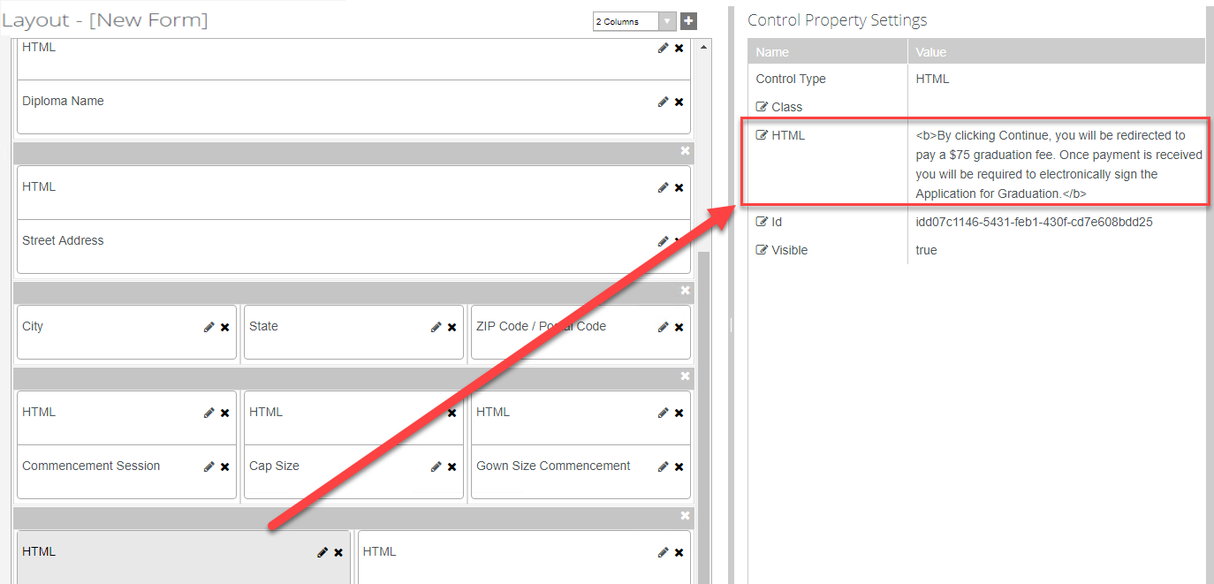
- From the Components tab, drag two DocuSign components into the panel of the Layout pane below the HTML components.
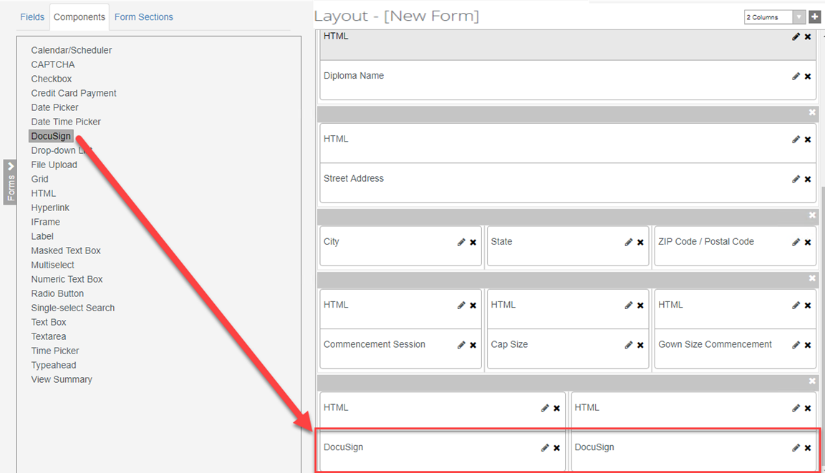

- Update the properties in the Control Property Settings pane as shown below for the first DocuSign component:
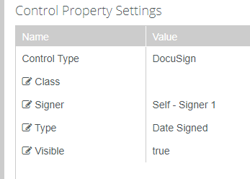

- Update the properties in the Control Property Settings pane as shown below for the second DocuSign component:
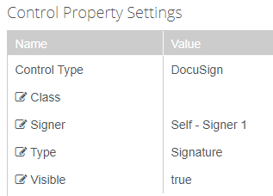

- Save and name your Form with your initials at the end as shown below.
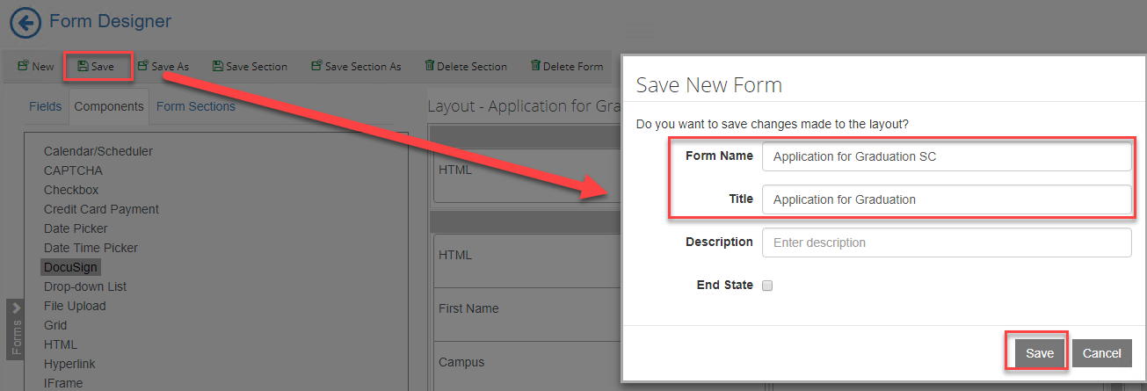

- Change the column drop-down to 2 Columns and select New to create a new form with a 2 Column panel.

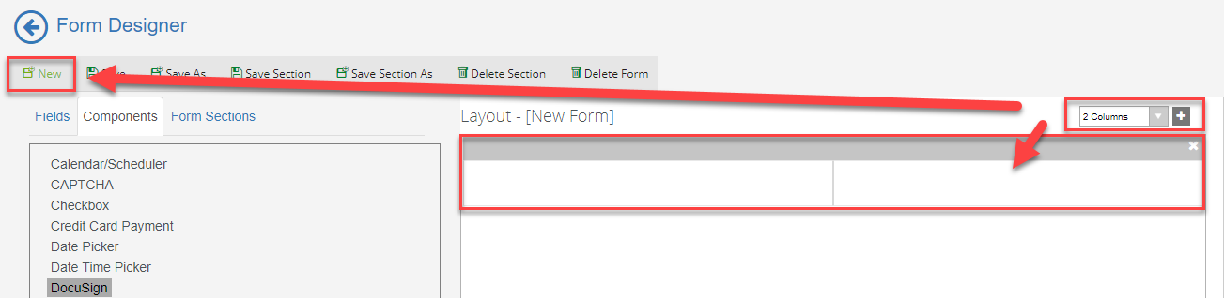

- Add a 3 Column and 1 Column panel to the Layout pane.
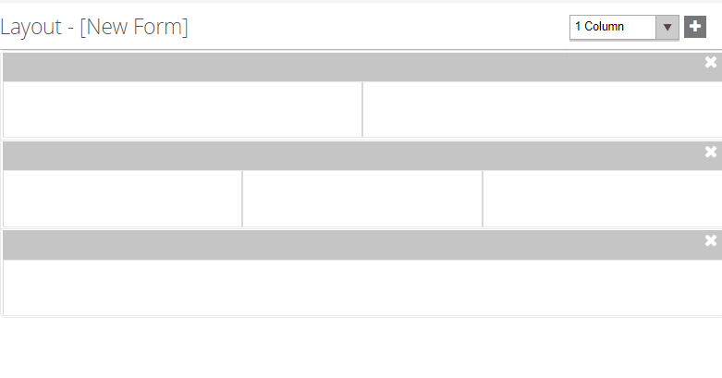

- Select the Fields tab and under Student select the Student entity. Drag the following fields into the first panel as shown below:
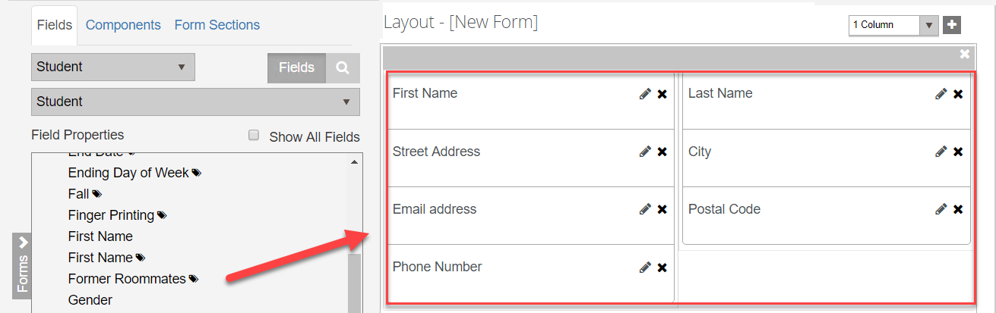

- Select the Fields tab and under Student select the Admissions Deposit entity. Drag the following properties into the second panel as shown below:
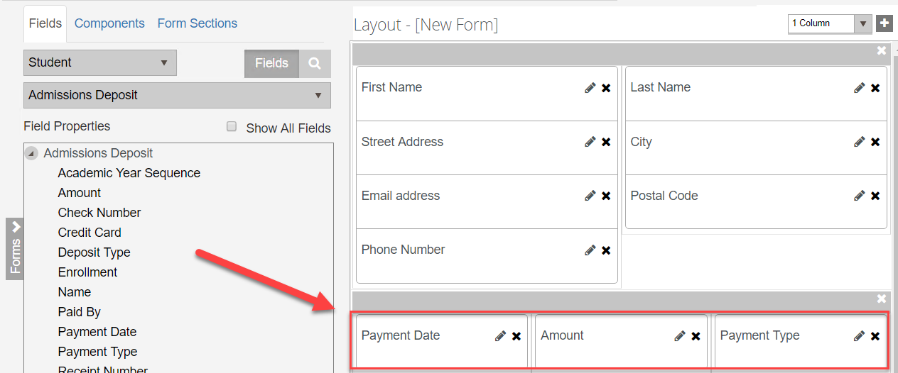

- Make sure the Required property in the Control Property Settings pane is set to true for the Payment Date field on the form.
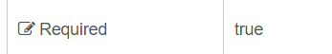

- Make the Read-only property true for the Amount field.
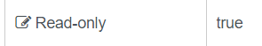

- Make the Disabled property true for the Payment Type field.

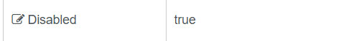

- From the Components tab, drag a Credit Card Payment component and an HTML component into the last panel of the Layout pane.

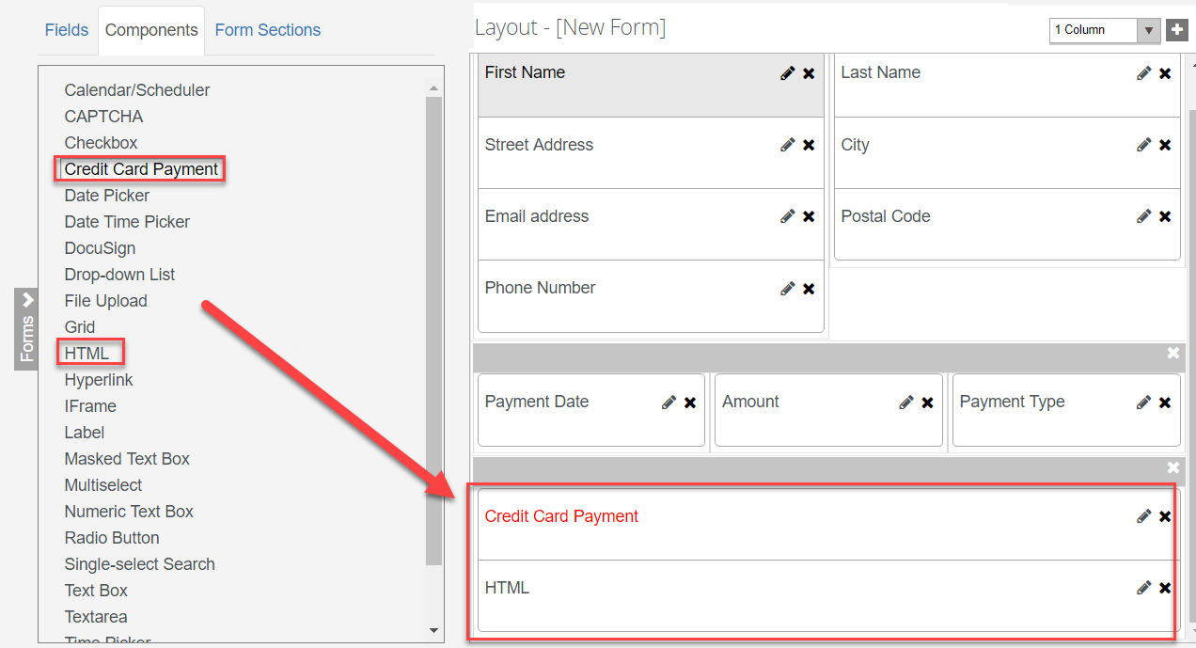

- Update the properties for the Credit Card Payment component in the Control Property Settings pane as shown below:
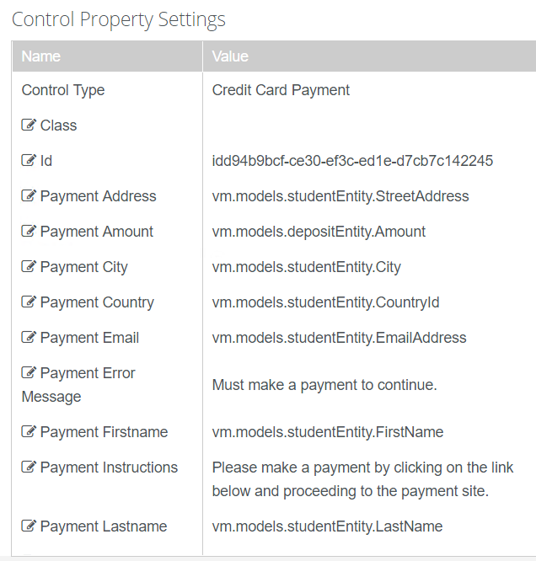
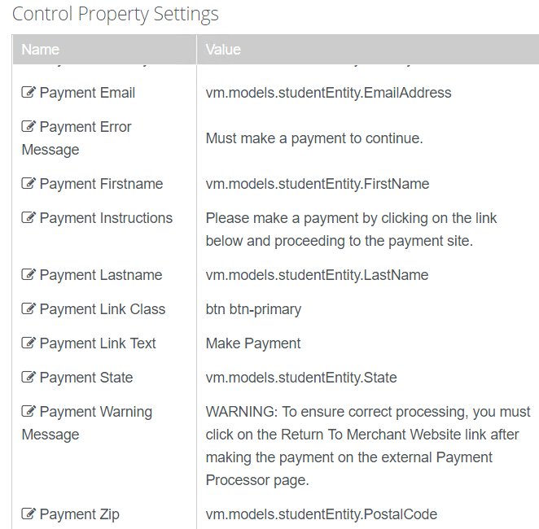

- Enter the following for the HTML component in the HTML property of the Control Property Settings pane:
<style> .navbar-default { display: none} </style>
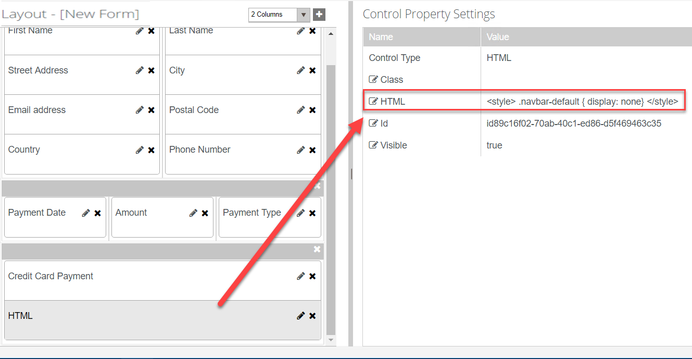
- Save and name your Form with your initials at the end as shown below.
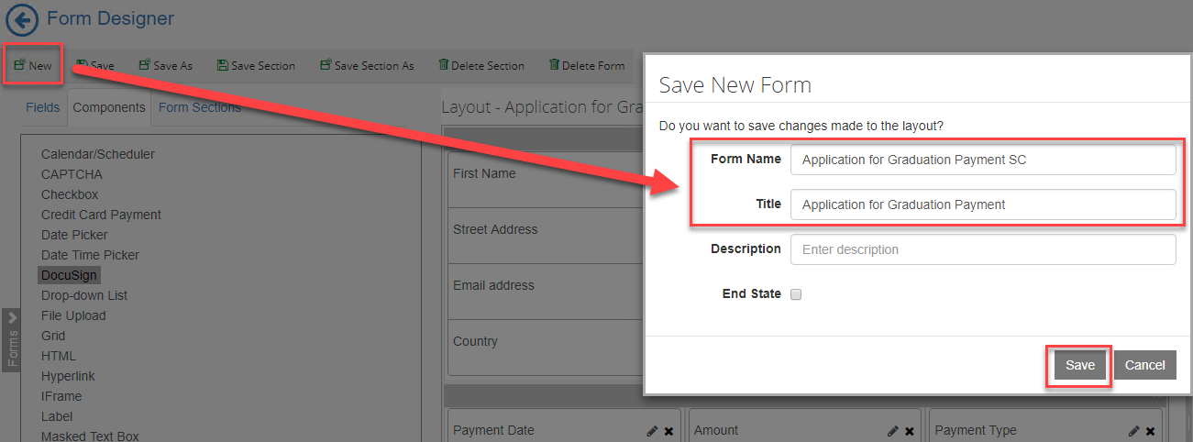

- On the top left bar, click on the arrow to navigate out of Form Designer.
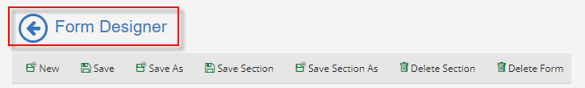

- Select Sequence Designer.
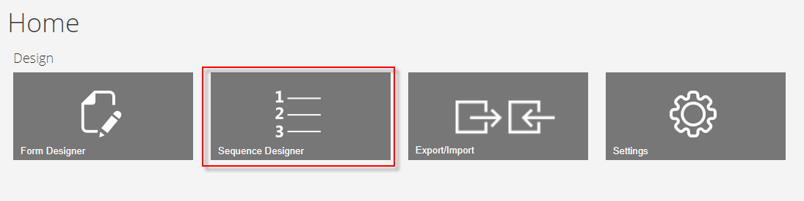
- Select New and a new panel will be created for you to drag your forms into for creating your sequence.
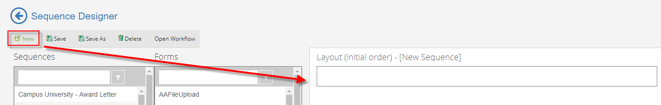

- From the Forms column drag your forms in the New Sequence panel in the Layout pane in the order shown below.
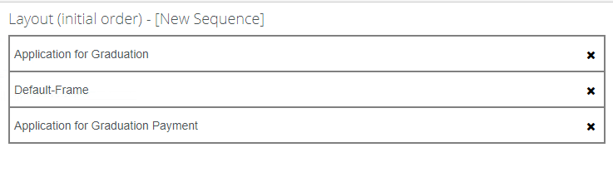

- In the Properties pane, update the properties as shown below and select Save.
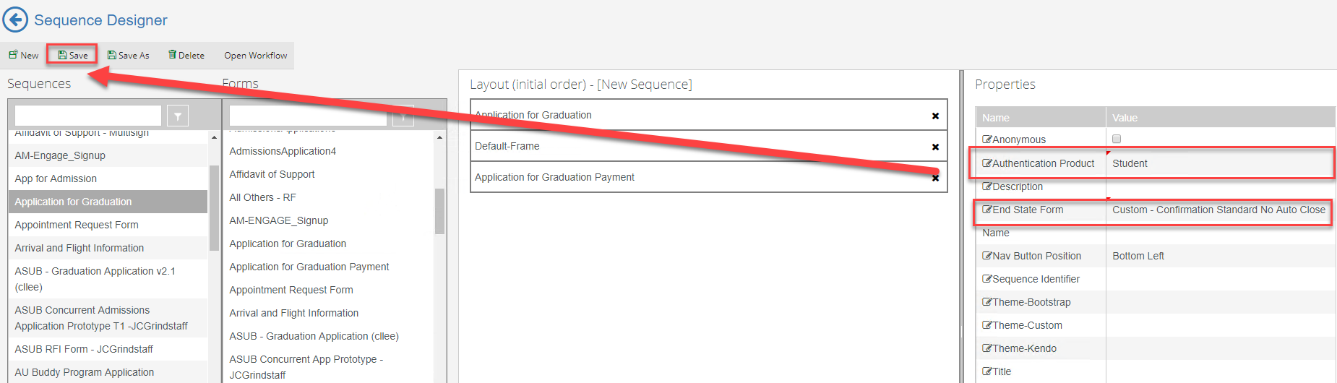
- Save the Sequence with Your initials at the end as shown below.
NOTE: DO NOT PUT EXTRA SPACES OR DASHES IN THE SEQUENCE NAME.

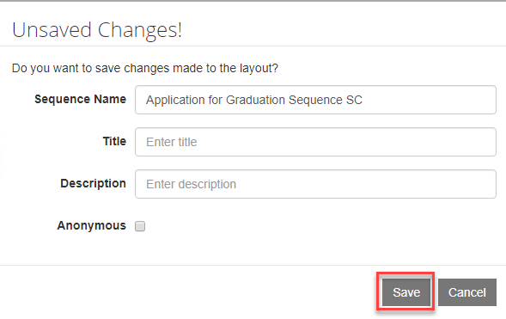

- Once saved, select the Sequence in the Sequence pane and select Open Workflow.
Note: This will open Workflow Composer and create the State Machine Workflow shell for us to start creating our supporting workflow for the form. You can also open up the Workflow directly from Workflow Composer.
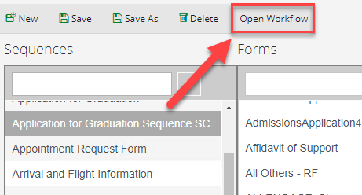

- Rename the StateMachine Flow to StateMachine-Application for Graduation. You can do this by double-clicking on the title at the top.
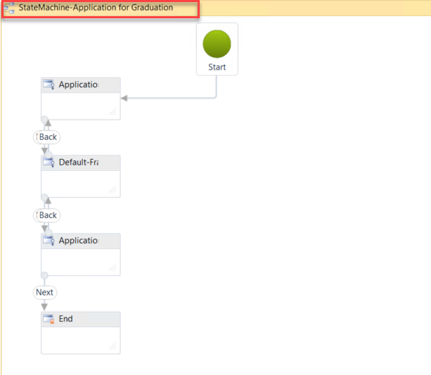

- Select the second sequence in the state machine flow to give it the focus and hit the right arrow on your keyboard to move the sequence to the right. This helps to organize our state machine flow to better navigate.
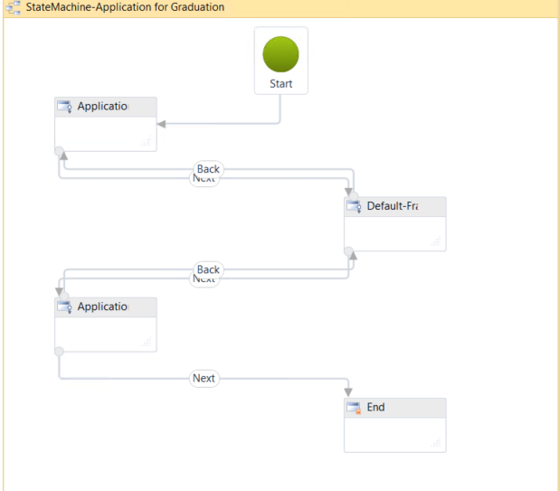

- Double-click the first sequence in the state machine flow. This will allow you to go to the first transition in your form. We can specify in this section what we want to occur when the student enters the form.

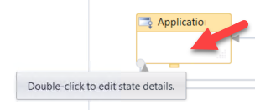

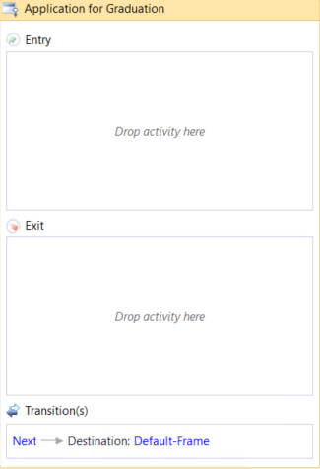

- We want to organize our Workflow by adding containers to specify what we are doing in each section. This will allow us to better understand and visualize the logic occurring within the Workflow.
- Drag a Sequence activity onto the designer in the Entry section of the activity. Rename the sequence to Initialize and Find Values.
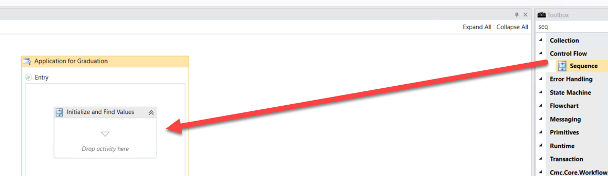

- Drag three Sequence activities onto the designer in the Initialize and Find Values Sequence. Rename each Sequence activity as shown below.
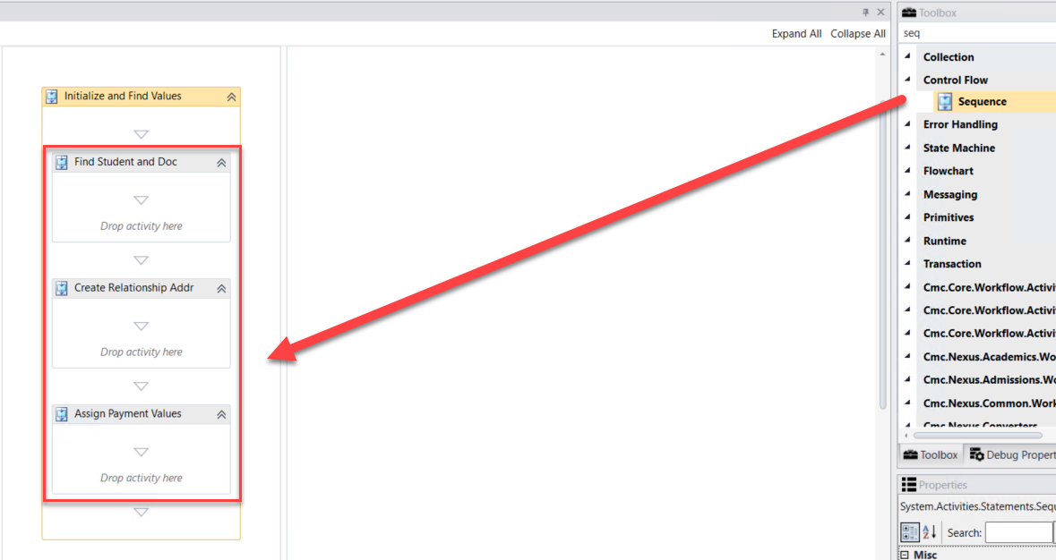

- The first thing that we want to do is find the student that is completing the form in order to initialize the form and display values back to our Application for Graduation Form as needed. We will then continue finding and assigning other values that we will need for the form as the student moves through the sequence.

- Drag the LookupUser activity onto the designer into the Find Student and Doc Sequence. We use this activity to find the student completing the form.
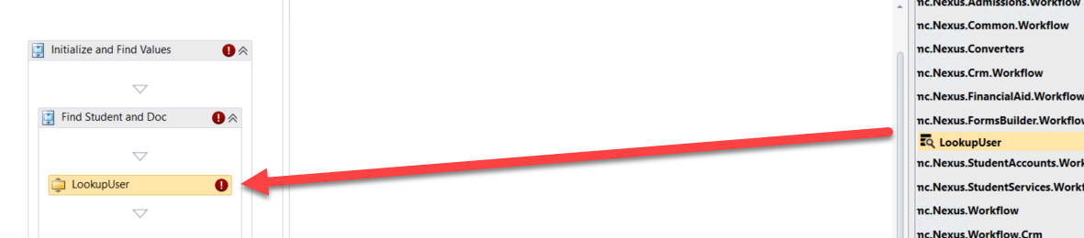

- Create a variable:
- Name: studentid
- Variable type: Int32
- Scope: StateMachine-Application for Graduation
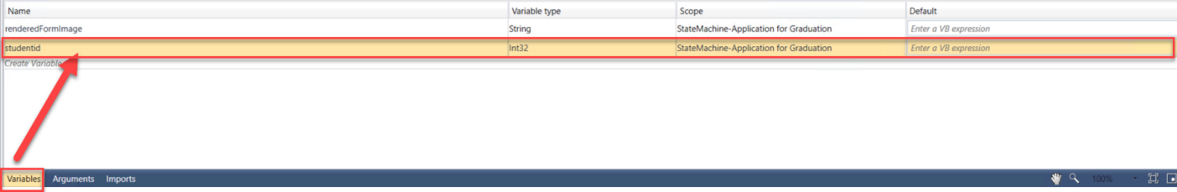
- Complete the properties for the LookupUser activity as shown below:

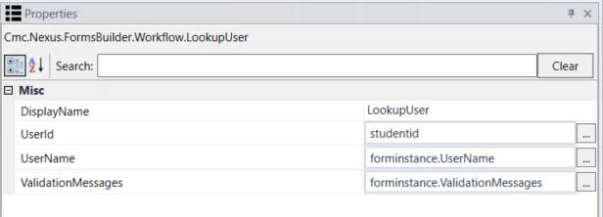

- We then want to get the data from the studentEntity so we can display it back to our form. We use the GetEntity activity since we already have the student in the CampusNexus Student database.
- Drag the GetEntity activity onto the designer below the LookupUser activity.
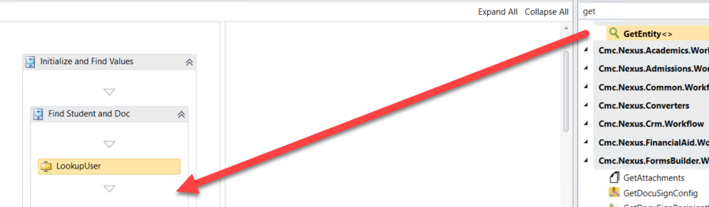
- When the box pops up, Browse for Types.
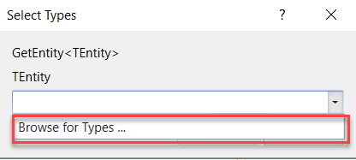
- Navigate to: Cmc.Nexus.Common.Contracts>Cmc.Nexus.Common.Entities>StudentEntity and click OK.
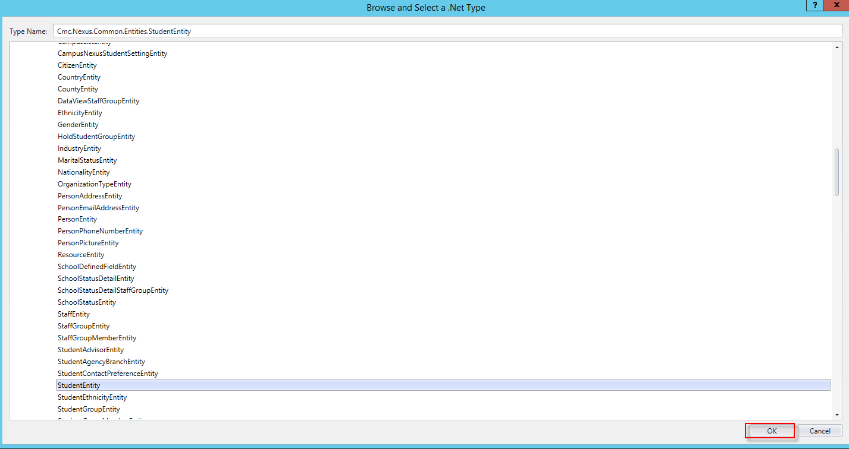
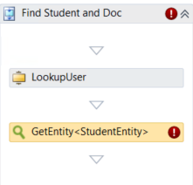
- Specify the properties in the Properties pane for the GetEntity activity.
Note: The EntityId is your variable of studentid and the Result is the studentEntity.
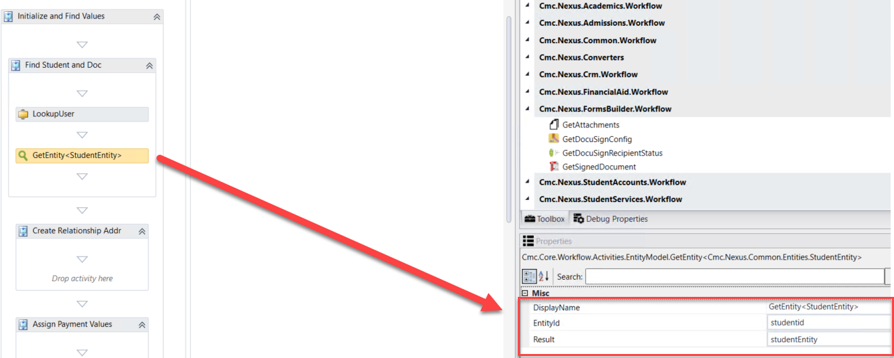

- Now we need to find the document we have configured in CampusNexus Student that will be used for Application for Graduation. Eventually, when the form sequence is completed by a student, we will attach a pdf to the specified document in the student's Document Center. Drag a LookupReferenceItem activity into the Find Student and Doc sequence below the GetEntity activity and rename the activity to Find Document.
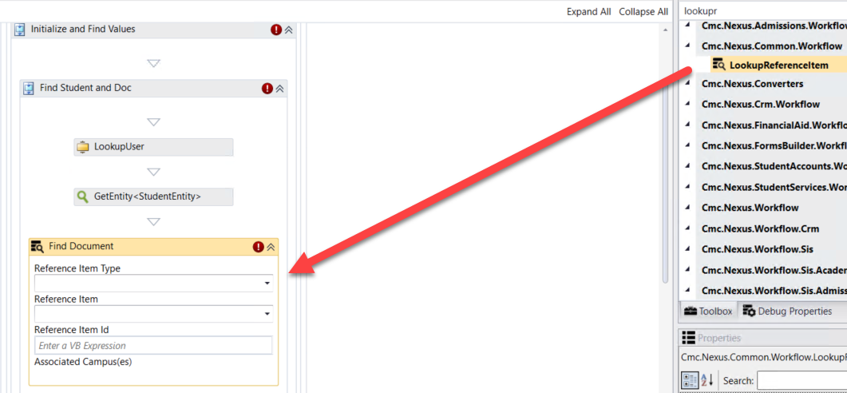
- Populate the values for the activity as shown below:
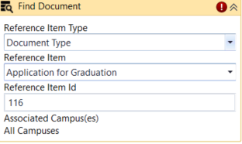
- Create a variable:
- Name: Ref
- Variable type: ReferenceItem (You will need to Browse for Types: Cmc.Nexus.Common.Contracts>Cmc.Nexus.Common.Services>ReferenceItem)
- Scope: StateMachine-Application for Graduation

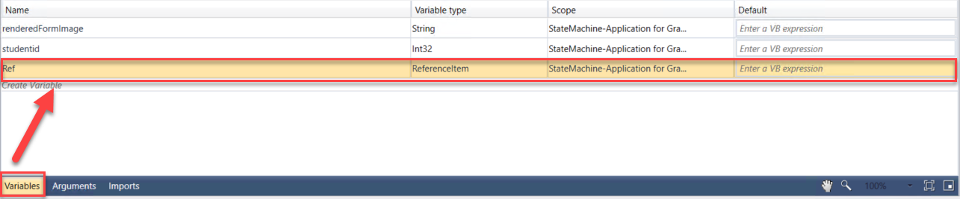
- Assign the variable created in the step above to the ReferenceItem property in the Properties pane for the Find Document ReferenceItem activity as shown below:

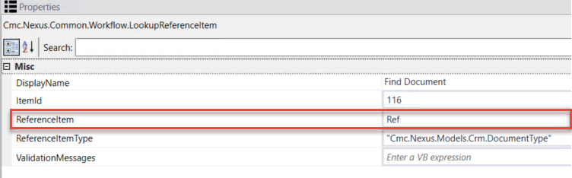

- We now want to see if the document that we looked up above is associated to the student record in CampusNexus Student. Create a variable as follows:
- Name: GradApp
- Type: You will have to browse for the type. In the drop-down select Array of [T] then select Browse for Types….
- Browse for:
- Cmc.Nexus.Crm.Contracts>Cmc.Nexus.Crm.Entities>DocumentEntity and click OK
- Scope: StateMachine-Application for Graduation
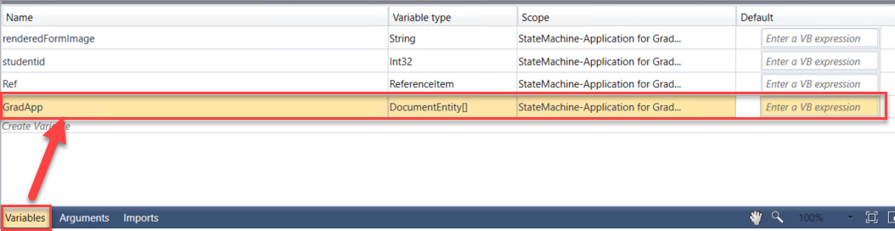

- Drag the LookupStudentDocuments activity onto the designer into the Find Student and Doc sequence below the Find Document LookupReferenceItem activity. Rename the activity to Lookup Document for Student.
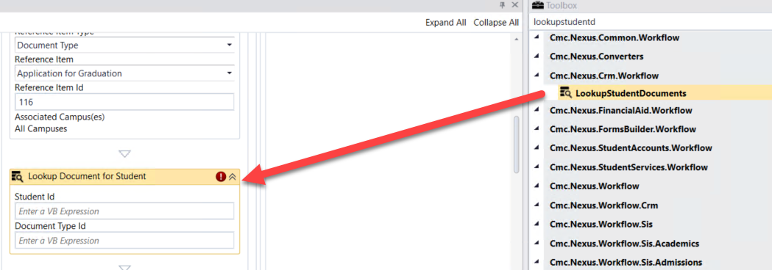
- Update the properties for the Lookup Document for Student LookupStudentDocuments activity in the Properties Pane as shown below:
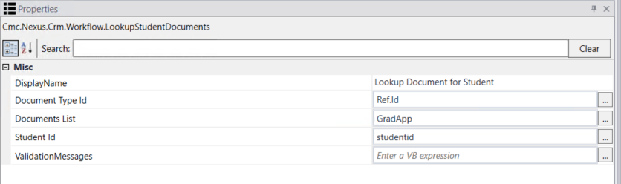

- In our Application for Graduation Sequence, we will be adding an address for the student in the Addresses Folder in CampusNexus Student for mailing the diploma. We need to create the entity so once we collect the data from the student on the form we can save the values back to the database.
- Drag a CreateEntity activity onto the designer in the Create Relationship Addr Sequence activity.
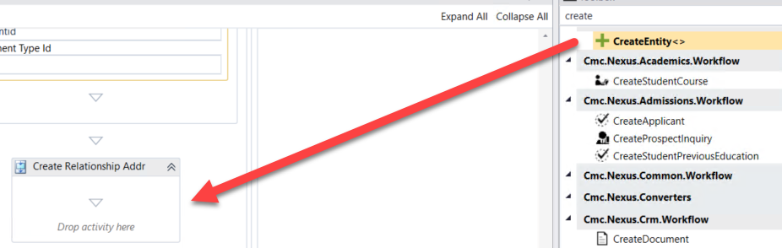
- When the box pops up, Browse for Types.
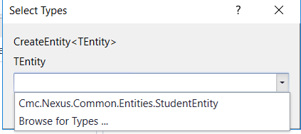

- Navigate to: Cmc.Nexus.Common.Contracts>Cmc.Nexus.Common.Entities>StudentRelationshipAddressEntity and click OK.

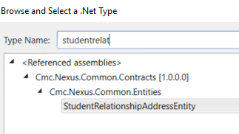
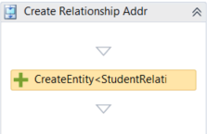

- Specify the properties in the Properties pane for the CreateEntity activity as shown below:
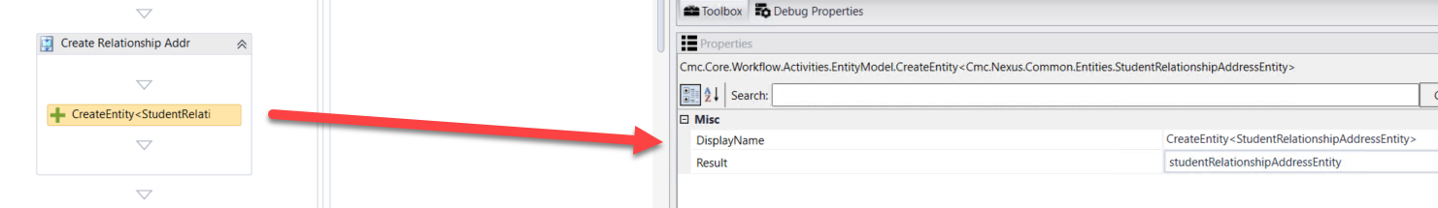

- Drag four Assign activities onto the Designer in the Create Relationship Addr Sequence activity below the CreateEntity activity. Update the properties as follows:
- Display Name: Map ID's; studentRelationshipAddressEntity.StudentId= studentEntity.Id
- Display Name: Assign Address Type;
studentRelationshipAddressEntity.AddressTypeId=26
- Display Name: Assign Address First Name;
studentRelationshipAddressEntity.FirstName=studentEntity.FirstName
- Display Name: Assign Address Last Name;
studentRelationshipAddressEntity.LastName=studentEntity.LastName

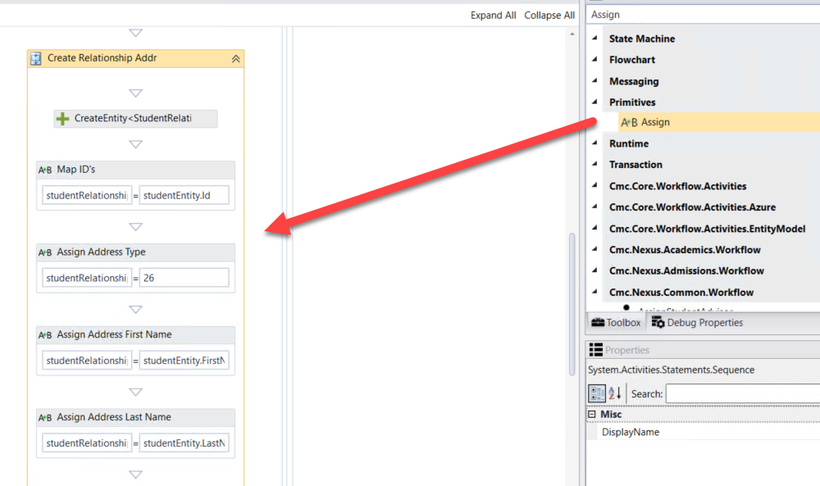

- In our Application for Graduation Sequence, we will be collecting a graduation fee from the student. We need to create the entity and assign default values so we can collect the payment and update the values back to the database.
- Drag a CreateEntity activity onto the designer in the Assign Payment Values Sequence activity.

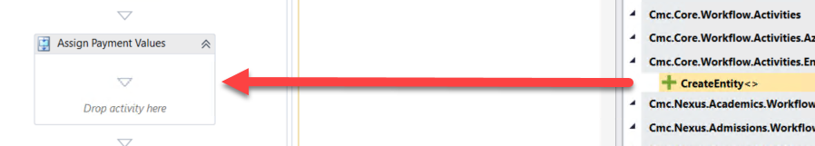
- When the box pops up, Browse for Types.


- Navigate to: Cmc.Nexus.Admissions.Contracts>Cmc.Nexus.Admissions.Entities>DepositEntity and click OK.

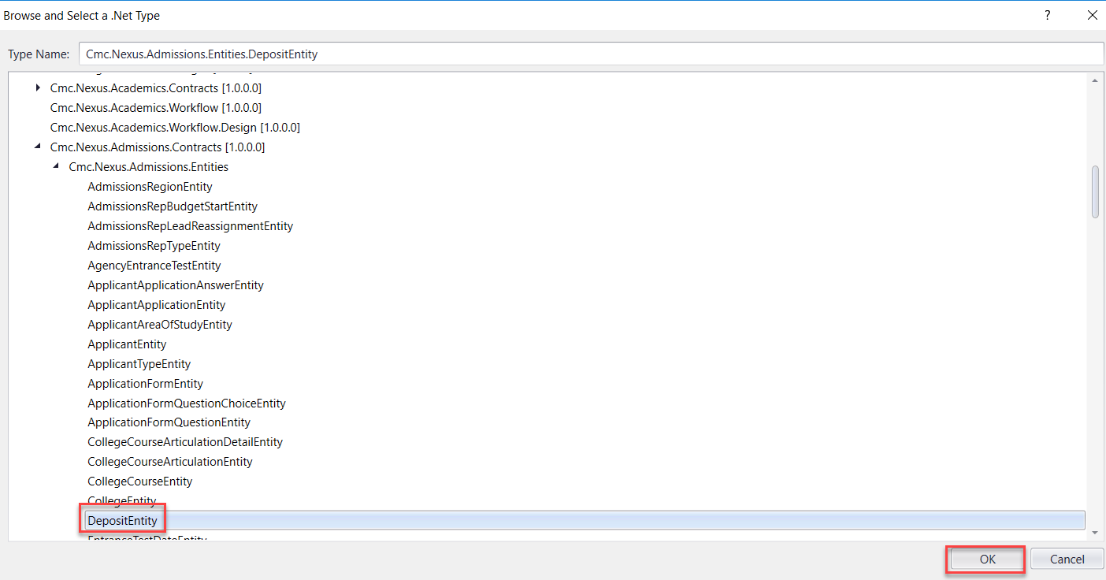

- Specify the properties in the Properties pane for the CreateEntity activity as shown below:
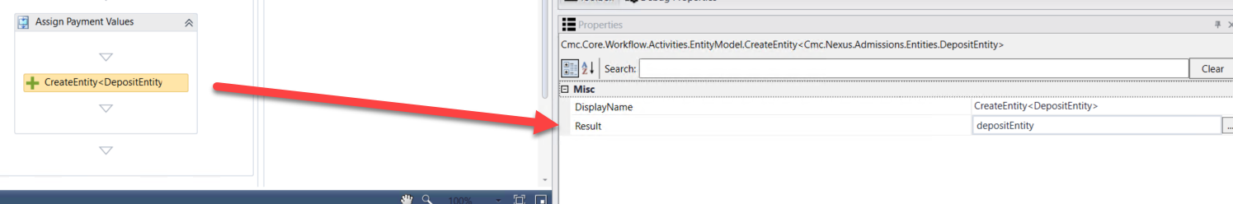

- Drag three Assign activities onto the Designer in the Assign Payment Values Sequence activity below the CreateEntity activity. Update the properties as follows:
- Display Name: Assign Amount Received Date; depositEntity.DepositReceivedDate=datetime.Now
- Display Name: Assign Amount;
depositEntity.Amount=75.00d
- Display Name: Assign Payment Type Credit Card;
depositEntity.PaymentType="Credit Card"

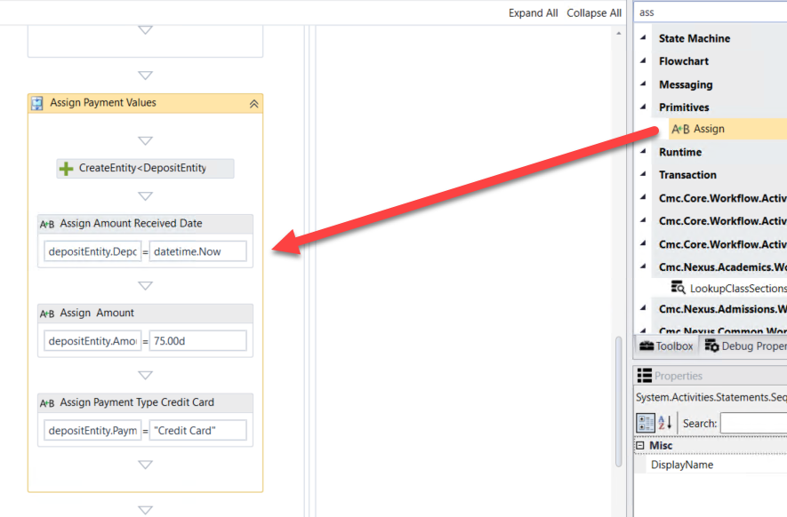

- Click Next at the bottom of the form to enter the next transition of your Application for Graduation Sequence.

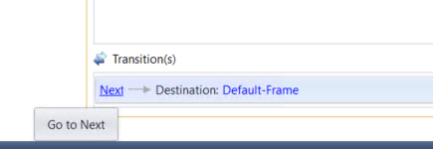

- Rename the WaitForFormBookmark activity and the Next button transition text to Continue.
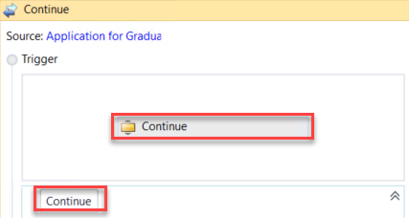

- Once the student has completed the Application for Graduation Form, we want to Save the data back to the database. We will then have the student electronically sign, pdf the form, and collect the payment. To save the data collected on the form for the StudentEntity, drag a SaveEntity below the Continue WaitForFormBookmark activity.
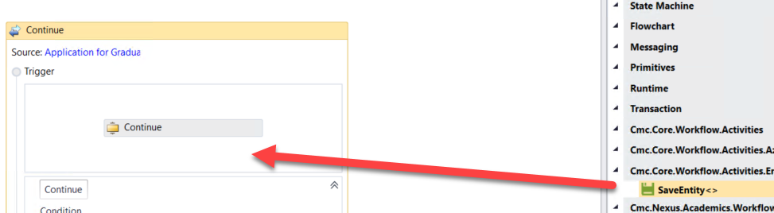

- When the box pops up, Browse for Types.

- Navigate to: Cmc.Nexus.Common.Contracts>Cmc.Nexus.Common.Entities>StudentEntity and click OK.
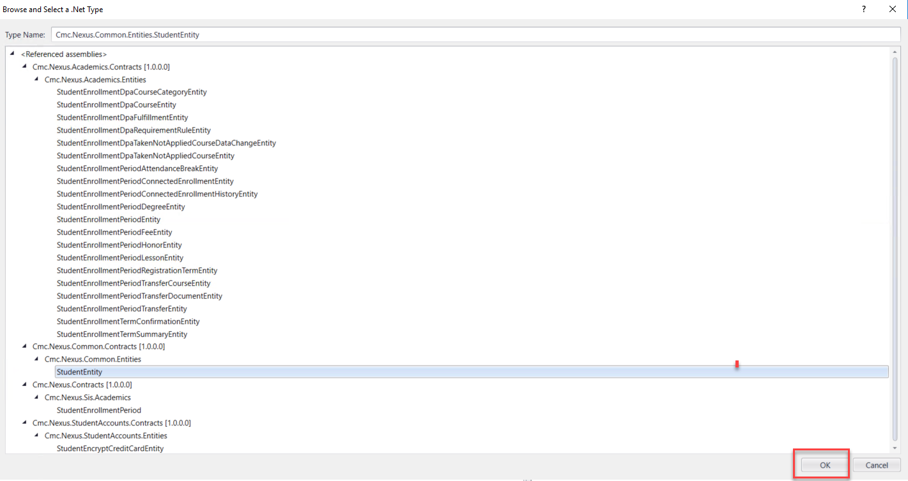
- A Sequence activity is created around the two activities. Rename the Sequence to: Save Student Data
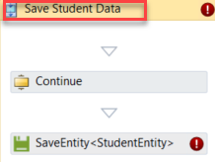

- Specify the properties in the Properties pane for the SaveEntity activity.
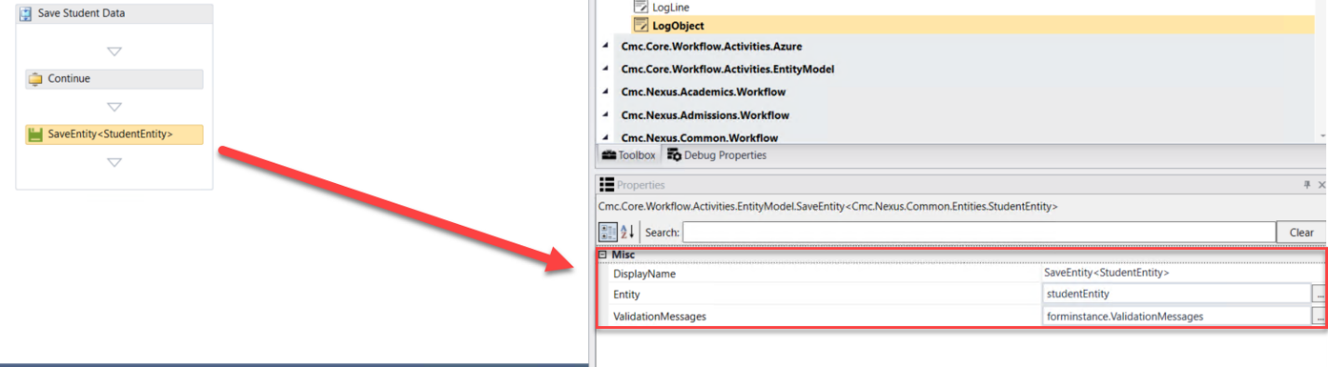
- We now want to log the values from the StudentEntity. Drag the LogObject activity onto the designer below the SaveEntity activity.
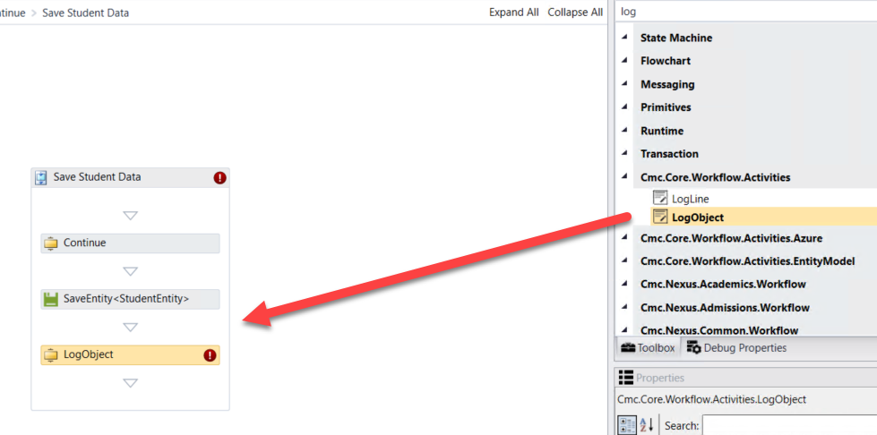

- Specify the properties in the Properties pane for the LogObject activity.
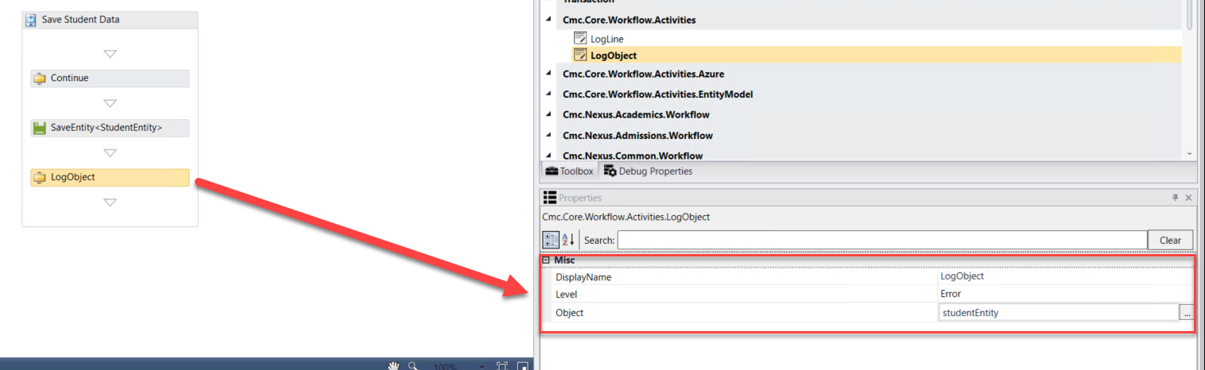
- To save the data collected on the form for the StudentRelationshipAddressEntity, drag a SaveEntity below the LogObject activity.
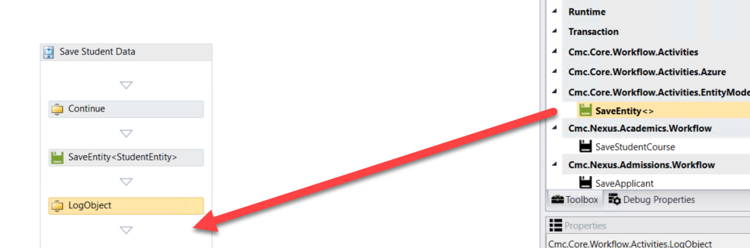

- When the box pops up, Browse for Types.


- Navigate to: Cmc.Nexus.Common.Contracts>Cmc.Nexus.Common.Entities>StudentRelationshipAddressEntity and click OK.
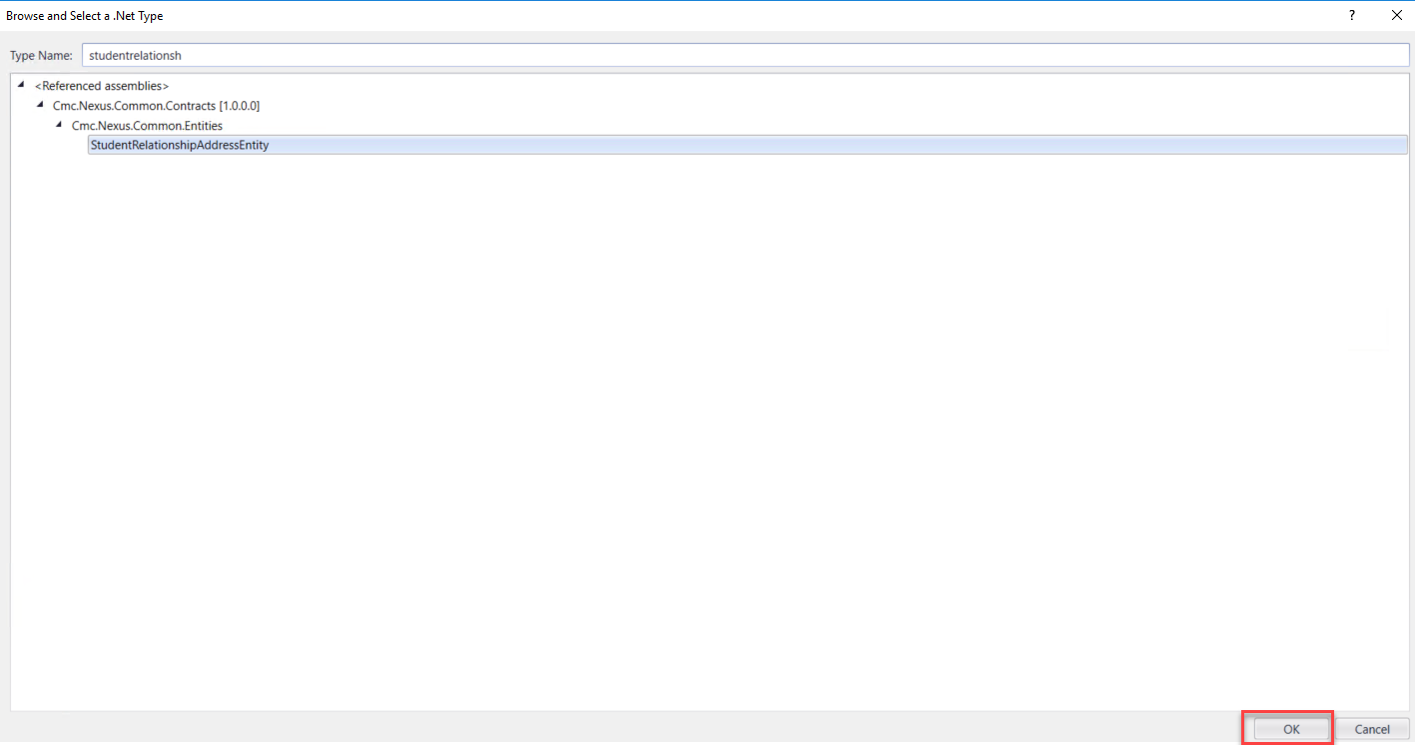
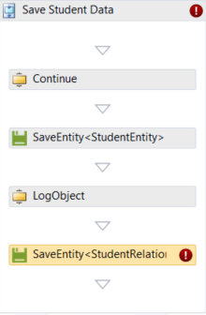

- Specify the properties in the Properties pane for the SaveEntity activity.
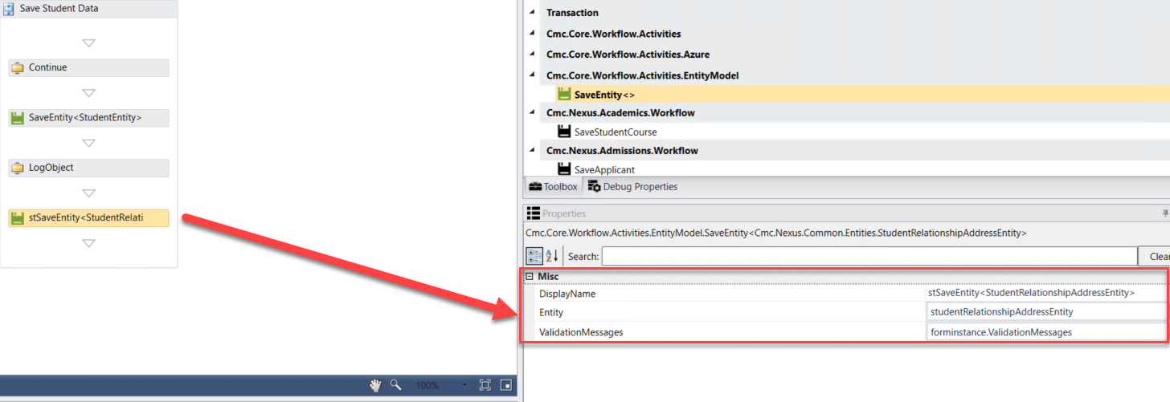
- We now want to log the values from the StudentRelationshipAddressEntity. Drag the LogObject activity onto the designer below the SaveEntity activity.
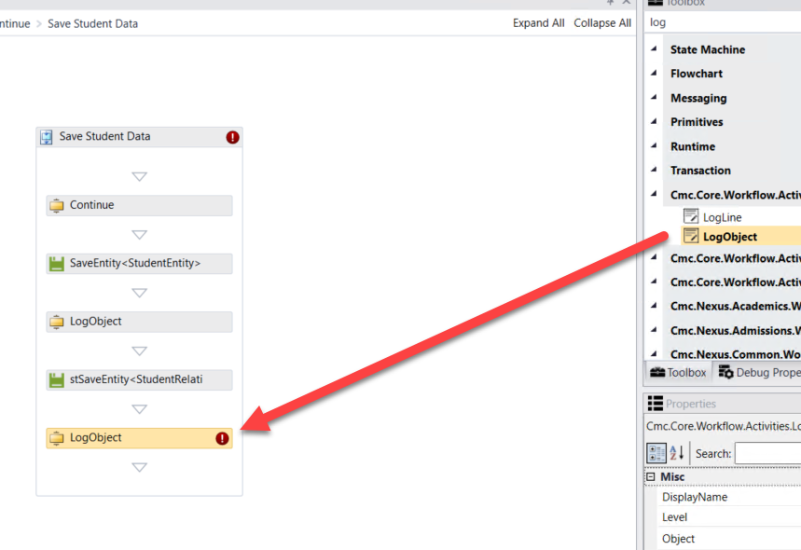

- Specify the properties in the Properties pane for the LogObject activity.
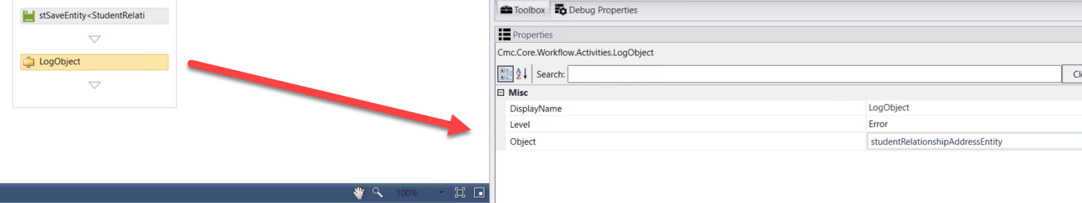

- Select Default-Frame at the bottom of the form to enter the Default-Frame. This is where we will insert the logic to convert the form sequence to a pdf and integrate with DocuSign.
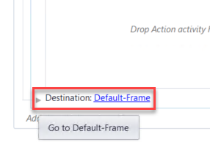

- Upon entry to this form we will be assigning all the values for printing our form(s) to pdf and for the DocuSign values that are needed. Drag each of the following activities onto the form in the Entry section and complete all properties/values for each as defined below.
- Drag a Sequence activity into the Entry section and rename it to: Print PDF get DocuSign Config
- Drag an Assign activity into the sequence.
- Rename to: Assign URL
- Create a variable: Name: URL, Type: string, Scope: StateMachine-Application for Graduation
- Assign Activity Values: URL = forminstance.RendererBaseUrl + "#/viewCreator/" + formInstance.WorkflowDefinitionId.ToString + "/forms=Application+for+Graduation+Sequence+SC"
Note: After forms=, it should be the exact name of your form where the + is used for any spaces.
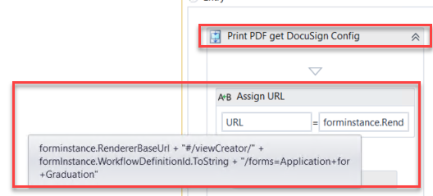
- Drag a Persist activity beneath the Assign URL activity.
- Drag a PrintUrltoPdf activity beneath the Persist activity.
- Create a variable: Name: Pdf, Type: Byte[], Scope: StateMachine-Application for Graduation
- Complete the PrintUrltoPdf properties:
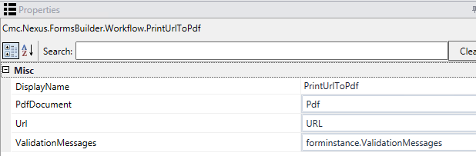

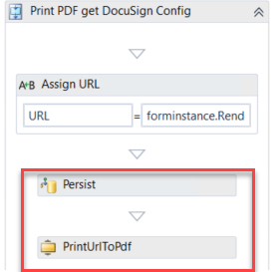
- Drag a LogLine activity beneath the PrintUrlToPdf activity.
- Rename the activity: Log Pdf URL
- Text: Environment.NewLine + “Log URL” + URL.tostring
- Level: Error
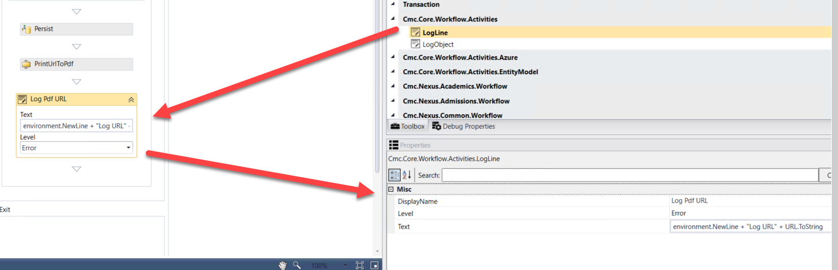

- Drag a Sequence below the Log Pdf URL Logline activity and Rename the Sequence to: DocuSignConfig
- Create the following variables:
- Name: DocuSignConfig, Type: Cmc.Nexus.FormsBuilder.Entities.DocuSignConfig, Scope: StateMachine-Application for Graduation
- Name: DocuSignDocument, Type: Cmc.Nexus.FormsBuilder.Entities.DocuSignDocument, Scope: StateMachine-Application for Graduation, Default: New DocuSignDocument
- Name: DocuSignRecipient, Type: Cmc.Nexus.FormsBuilder.Entities.DocuSignRecipient, Scope: StateMachine-Application for Graduation, Default: New DocuSignRecipient
- Name: DocuSignRequest, Type: Cmc.Nexus.FormsBuilder.Entities.DocuSignRequest, Scope: StateMachine-Application for Graduation
- Name: SignedDocument, Type: Cmc.Nexus.FormsBuilder.Entities.DocuSignDocument, Scope: StateMachine-Application for Graduation
- Create the following argument.
- Name: frameUrl, Direction: In/Out, ArgumentType: String
- Drag the GetDocuSignConfig activity into the DocuSignConfig sequence.
- Complete the properties for the activity as shown below.
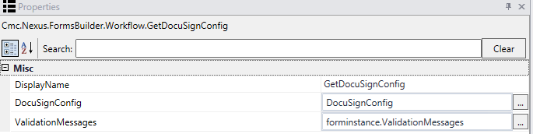
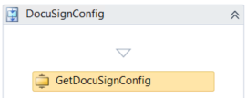

- Drag a LogLine activity beneath the GetDocuSignConfig activity.
- Rename the activity: Log DocuSign Config values
- Text: Environment.NewLine + “Assigning DocuSign Values” + Environment.NewLine
- Level: Error
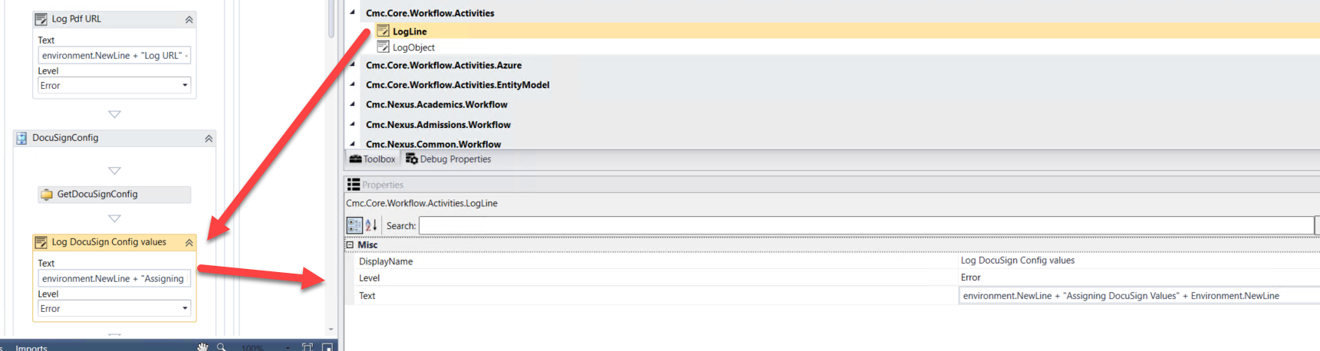
- Drag nine Assign activities beneath the Log DocuSign Config values LogLine. Assign the following values:
- DocuSignConfig.EmailSubject = “CMC Campus DocuSign Testing” (Rename the activity to Assign Email Subject)
- DocuSignConfig.ReturnUrl = forminstance.RendererBaseUrl + “#/docusigncomplete” (Rename the activity to Assign URL)
- DocuSignConfig.BasePath = “https://demo.docusign.net/restapi”
- (Rename the activity to Assign Base Path)
- DocuSignDocument.DocumentId = “1” (Rename the activity to Assign Document ID)
- DocuSignDocument.Name = “Application for Graduation” (Rename the activity to Assign Document Name)
- DocuSignDocument.Content = Pdf (Rename the activity to Assign Document Content)
- DocuSignRecipient.Name = studentEntity.FirstName + studentEntity.LastName (Rename the activity to Assign Recipient Name)
- DocuSignRecipient.Email = studentEntity.EmailAddress (Rename the activity to Assign Recipient Email)
- DocuSignRecipient.SignerId = “1” (Rename the activity to Assign Signer ID)
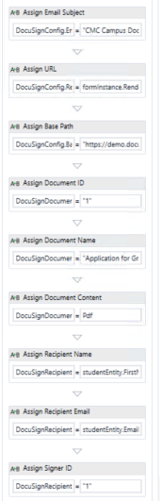

- Drag the CreateDocuSignRequest activity beneath the last Assign activity. Complete the properties for the activity as shown below.
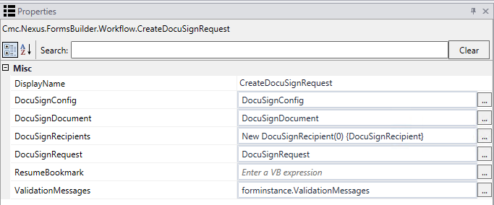
- Drag an Assign activity below the CreateDocuSignRequest activity.
- Rename the activity to Assign URL.
- Assign the value: frameUrl = DocuSignRequest.Url
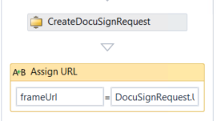

- Drag a LogLine activity beneath the Assign URL activity.
- Rename the activity: Log DocuSign Config values
- Text: Environment.NewLine + “DocuSign Values Assigned” + Environment.NewLine
- Level: Error
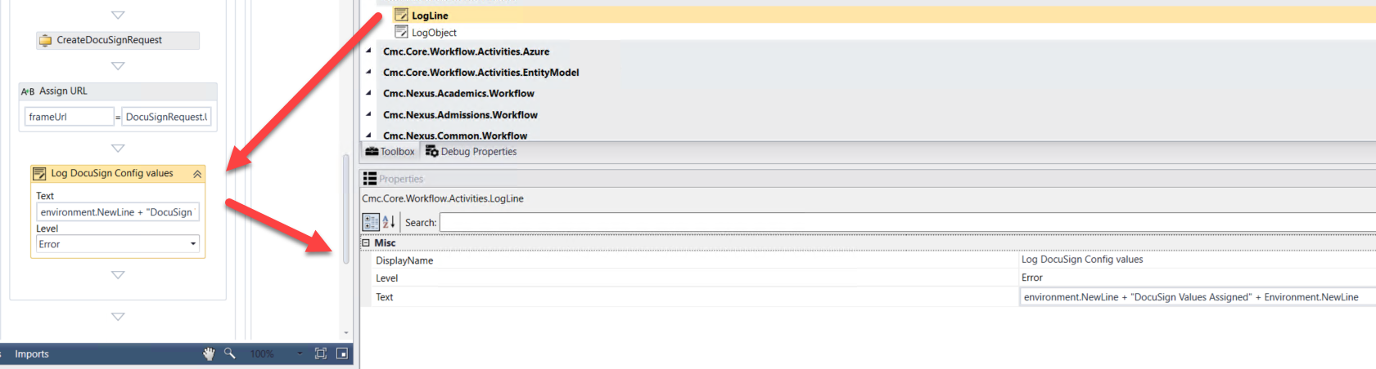

- Select Next at the bottom of the form to go to the next transition.
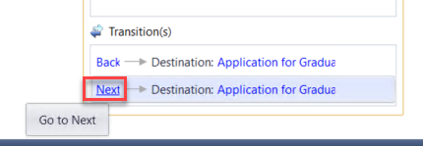

- Rename the WaitForFormBookmark activity and the Next button text to Continue.

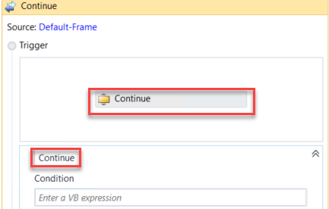

- At the bottom of the screen, select to enter the Application for Graduation Payment form.
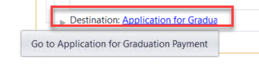

- Select Next to transition to the Application for Graduation Payment form.
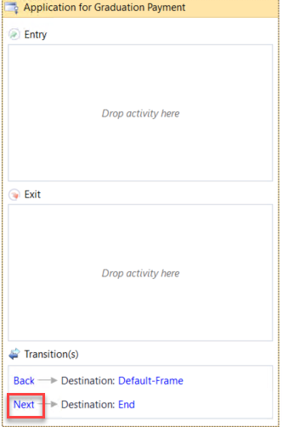
- Rename the WaitForFormBookmark activity and the Next button transition text to Submit.
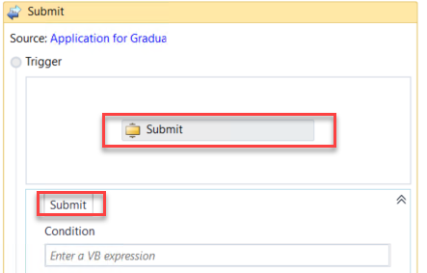

- Drag an If activity below the Submit WaitForFormBookmark activity. Rename the activity and the sequence that was created around both activities to Verify Payment Info. Enter the following for the Condition of the If activity:
String.IsNullOrEmpty(forminstance.PaymentInfo.TransactionId)
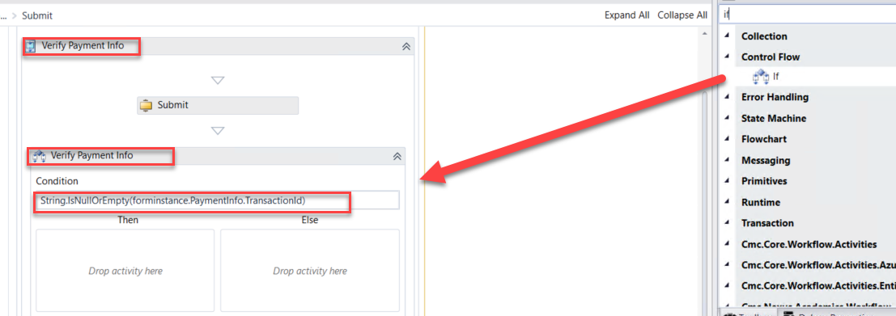
- Drag a CreateValidationItem activity into the Then section of the Verify Payment Info If activity. Update the following properties for the activity:
- Message: "Something went wrong with the payment processing. Please contact customer service to confirm that your payment was processed correctly."
- Messages: forminstance.ValidationMessages
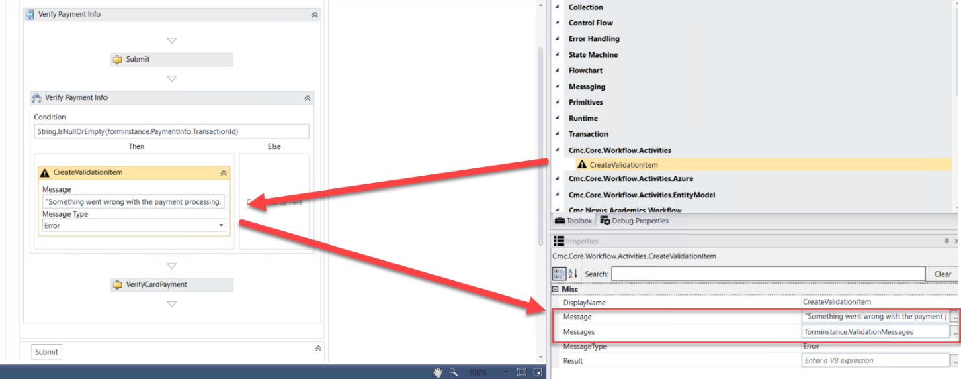

- Drag a LogLine activity in the Else portion of the Verify Payment Info If activity.
- Rename the activity: Payment Processed
- Text: Environment.NewLine + Environment.NewLine + "Payment was processed." +Environment.NewLine + Environment.NewLine
- Level: Error

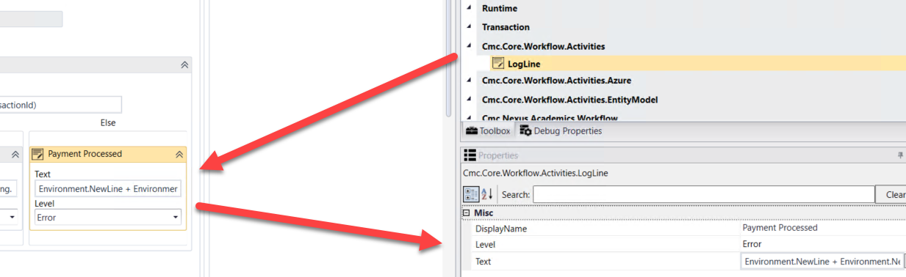

- Drag the VerifyCardPayment activity below the Verify Payment Info If activity. Update the properties for the activity as shown below:
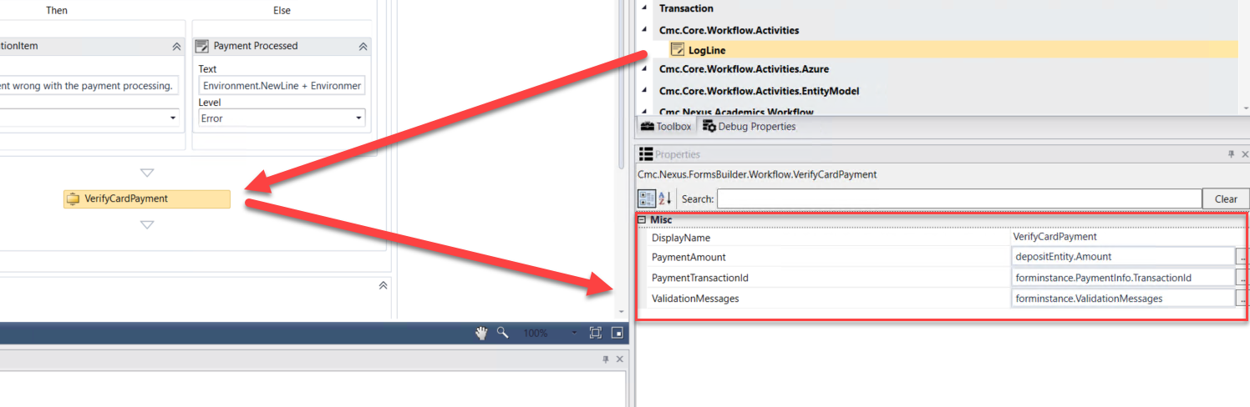

- Select the Submit WaitForFormBookmark activity and update the TransitionType property to MoveForward.
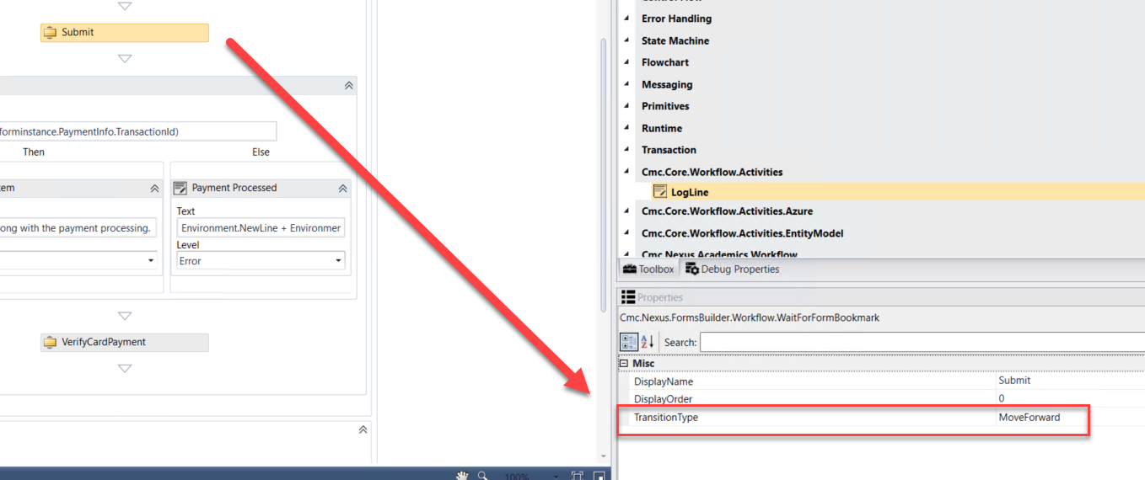
- Enter the following for the Condition in your transition.
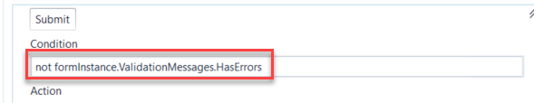
- Drag a Sequence activity into the Action section of your transition. Rename the activity to Process Request.
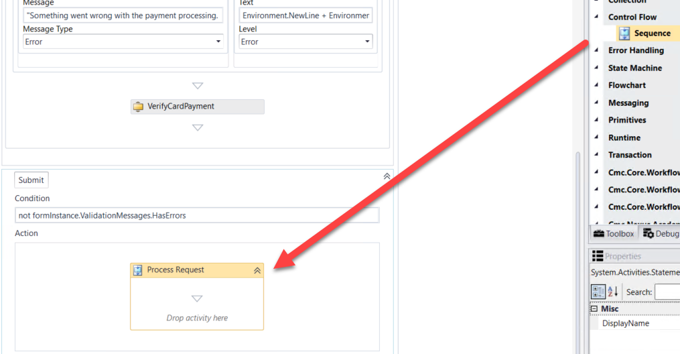
- Drag two Sequence activities into the Process Request Sequence activity. Rename each activity as shown below.
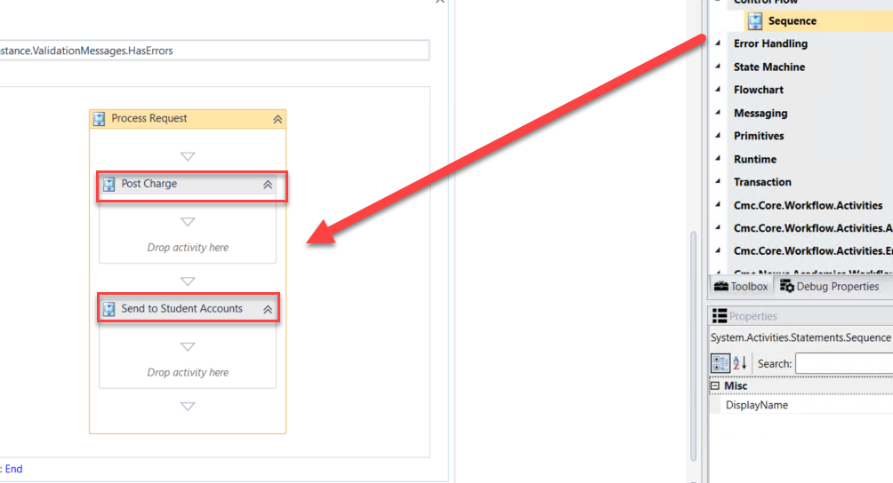

- Drag the LookupCurrentEnrollmentPeriod activity into the Post Charge sequence. Rename the activity to Get Enrollment ID.
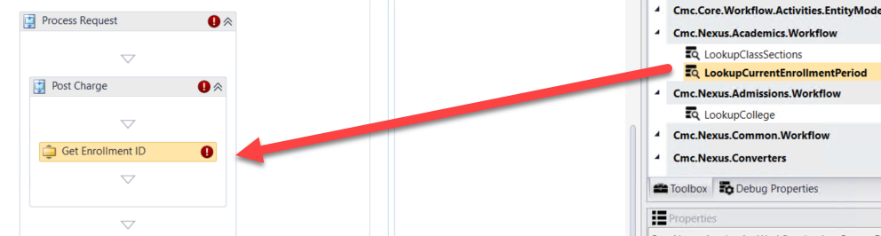
- Create a variable:
- Name: currEnroll
- Variable type: StudentEnrollmentPeriodEntity (You will need to browse for Cmc.Nexus.Academics.Contracts>Cmc.Nexus.Academics.Entities>StudentEnrollmentPeriodEntity)
- Scope: StateMachine-Application for Graduation
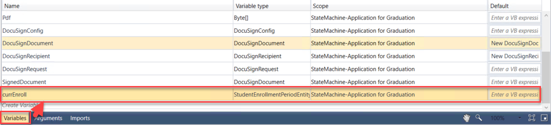
- Complete the properties for the Get Enrollment ID LookupCurrentEnrollmentPeriod activity as shown below.
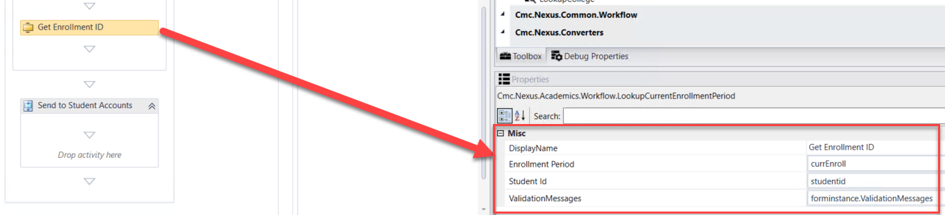

- Drag the CreateCharge activity located under the Cmc.Nexus.StudentAccounts.Workflow entity in the Toolbox below the Get Enrollment ID LookupCurrentEnrollmentPeriod activity. Complete the properties as shown below:
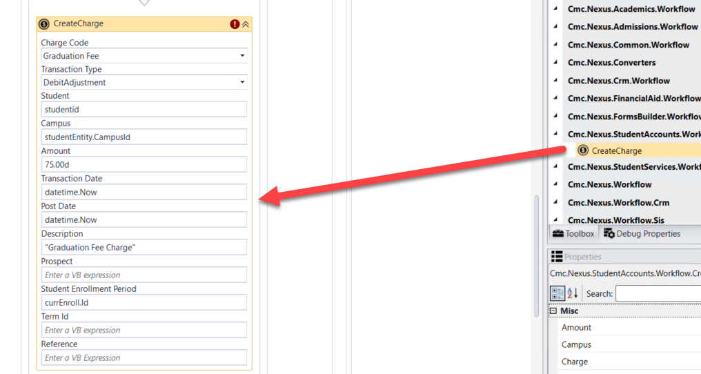
- Create a variable:
- Name: Fee
- Variable type: StudentAccountTransactionEntity (You will need to browse for Cmc.Nexus.StudentAccounts.Contracts>Cmc.Nexus.StudentAccounts.Entities>StudentAccountTransactionEntity)
- Scope: StateMachine-Application for Graduation
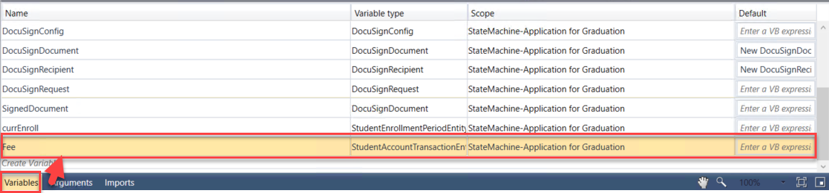

- Assign the Fee variable to the Charge property for the CreateCharge activity.
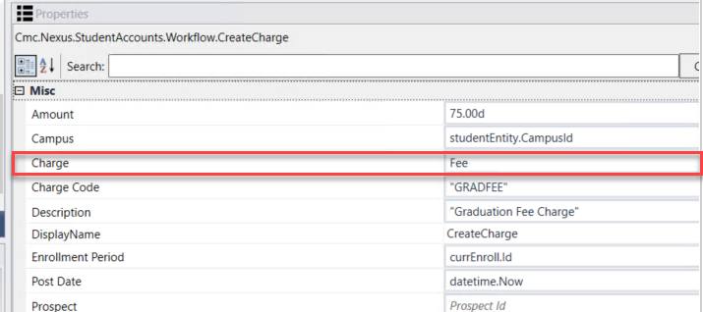

- Drag the SaveCharge activity located under the Cmc.Nexus.StudentAccounts.Workflow entity in the Toolbox below the CreateCharge activity. Update the properties for the activity as shown below.
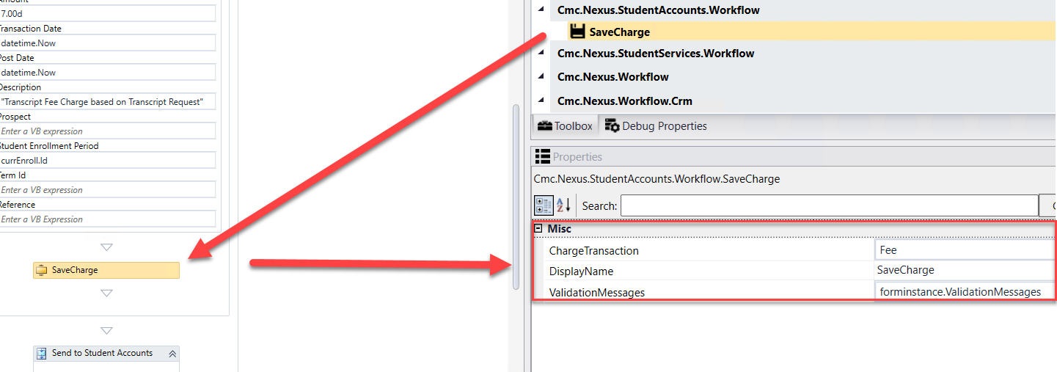

- Drag the GetServiceInstance<> activity into the Send to Student Accounts sequence.
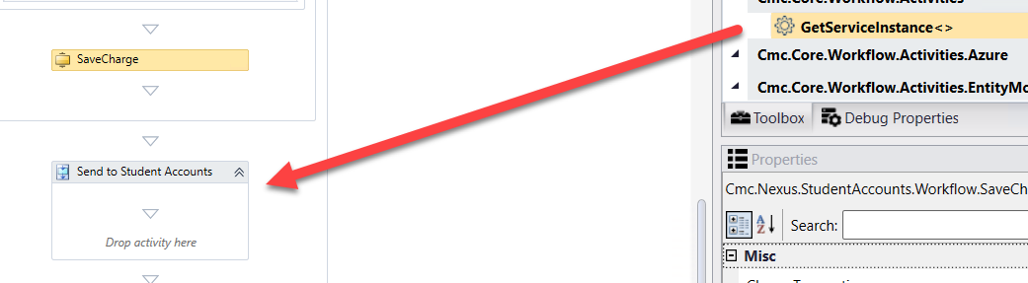
- When the box pops up, Browse for Types.

- Navigate to: Cmc.Nexus.StudentAccounts.Contracts>Cmc.Nexus.StudentAccounts.Services>IStudentAccountTransactionService and click OK.
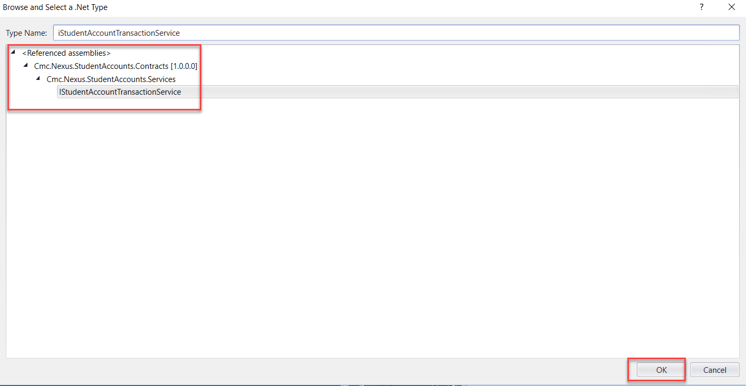

- Create a variable:
- Name: AcctSvc
- Variable type: IStudentAccountTransactionService (You will need to browse for Cmc.Nexus.StudentAccounts.Contracts>Cmc.Nexus.StudentAccounts.Services> IStudentAccountTransactionService)
- Scope: StateMachine-Application for Graduation
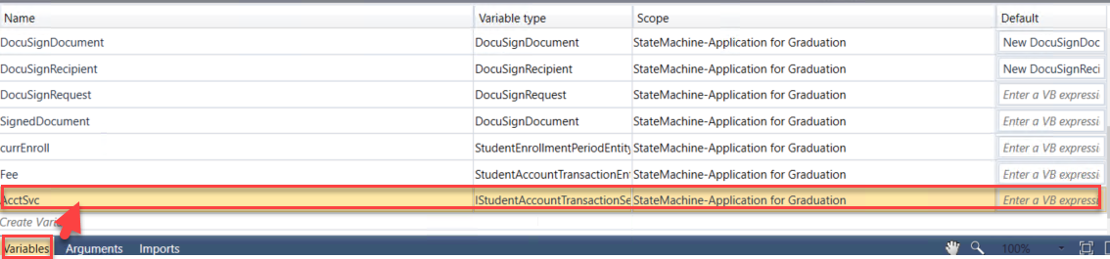
- Update the properties for the GetServiceInstance<> activity as shown below.
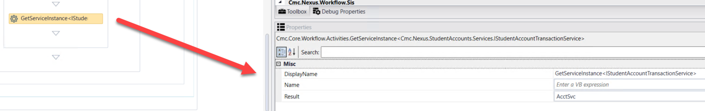

- Create the following variables:
- Variable:
- Name: postRequest
- Variable type: PostAccountTransactionPaymentRequest (You will need to browse for Cmc.Nexus.StudentAccounts.Contracts>Cmc.Nexus.StudentAccounts.Services>PostAccountTransactionPaymentRequest)
- Scope: StateMachine-Application for Graduation
- Default: New PostAccountTransactionPaymentRequest

- Variable:
- Name: postResponse
- Variable type: PostAccountTransactionPaymentResponse (You will need to browse for Cmc.Nexus.StudentAccounts.Contracts>Cmc.Nexus.StudentAccounts.Services>PostAccountTransactionPaymentResponse)
- Scope: StateMachine-Application for Graduation
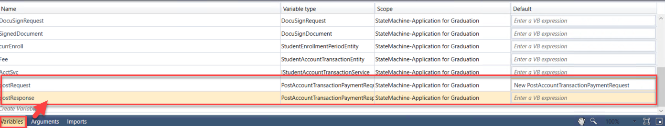

- Drag seven Assign activities below the GetServiceInstance<> activity. Update the properties for the activities as follows:
- Display Name: Assign Student ID; postRequest.StudentId = studentid
- Display Name: Assign Amount; postRequest.TransactionAmount = depositEntity.Amount
- Display Name: Assign Date; postRequest.TransactionDate = depositEntity.DepositReceivedDate
- Display Name: Assign Payment Mode; postRequest.PaymentMode = cmc.Nexus.StudentAccounts.Services.PaymentMode.Normal
- Display Name: Assign Type; postRequest.PaymentType = "C"
- Display Name: Assign Description; postRequest.Description = "Credit Card Payment For Graduation"
- Display Name: Assign Enrollment; postRequest.StudentEnrollmentPeriodId = currEnroll.Id
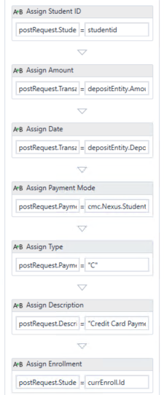

- We now want to log the values from the postRequest.
Drag the LogObject activity onto the designer below the last Assign activity.
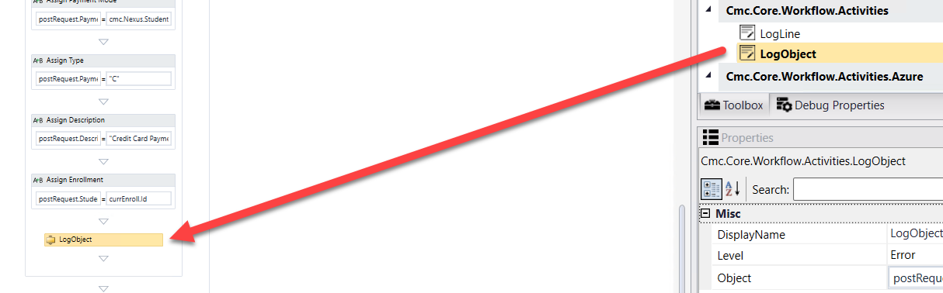
- Specify the properties in the Properties pane for the LogObject activity.
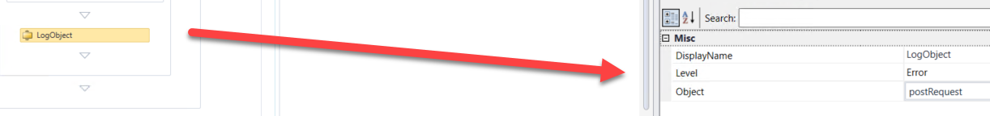

- Drag an Assign activity below the LogObject activity. Update the properties for the activity as follows:
- Display Name: Assign Response; postResponse = AcctSvc.PostAccountTransactionPayment(PostRequest)
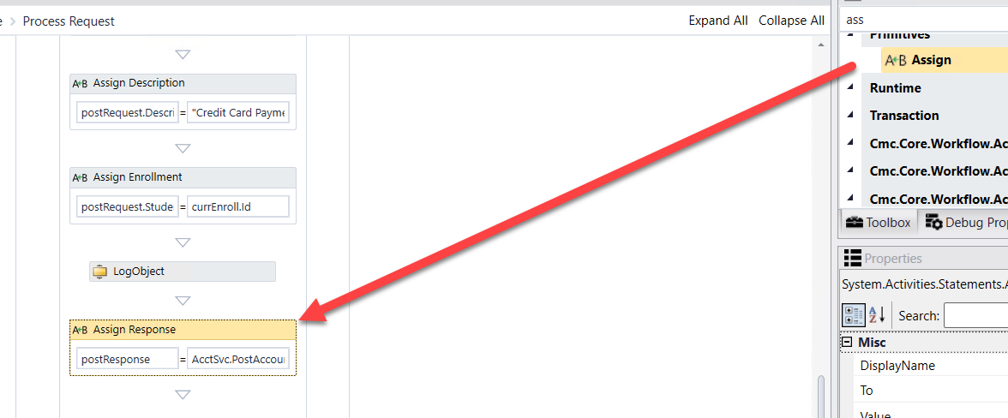

- We now want to log the values from the postResponse.
Drag the LogObject activity onto the designer below the Assign activity.
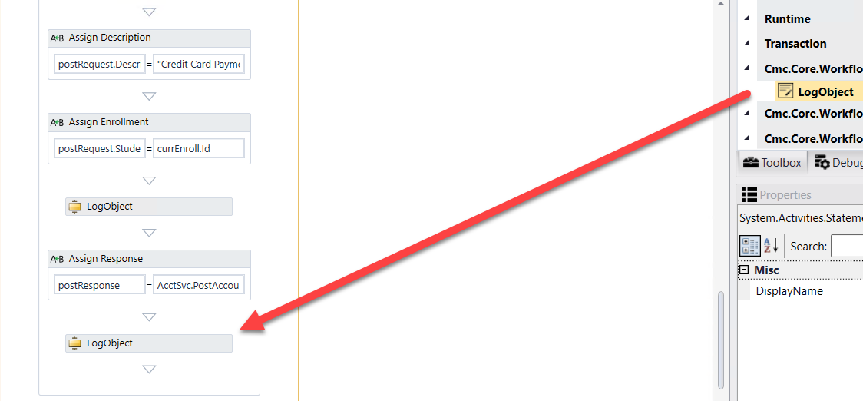
- Specify the properties in the Properties pane for the LogObject activity.
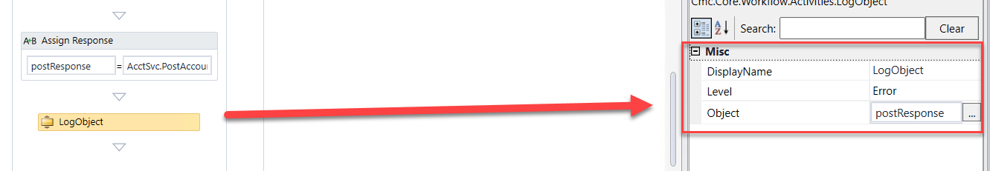
- At the bottom of the screen, go to the End state of the form sequence.
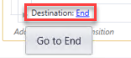

- We now want to insert the pdf into the student's Document Center in CampusNexus Student as well as send a Task to the advisor for follow-up. Drag a Sequence activity into the Entry of the End state. Rename the Sequence activity to Attach pdf and send task to staff.
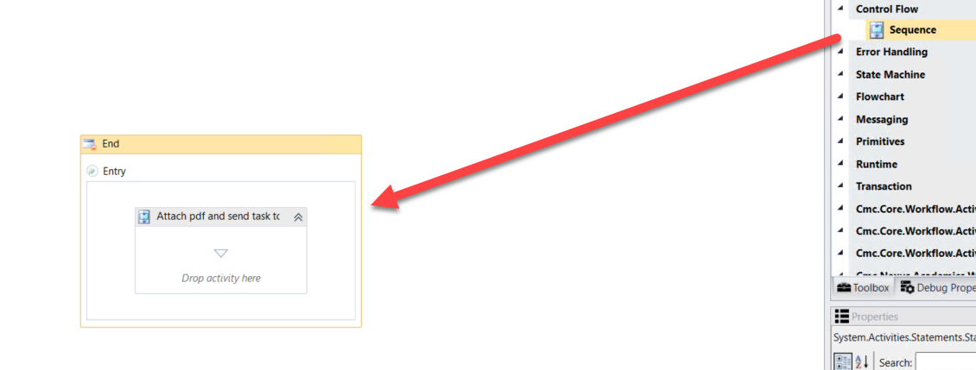
- Drag two Sequence activities into the Attach pdf and send task to staff Sequence activity. Rename the activities as shown below:
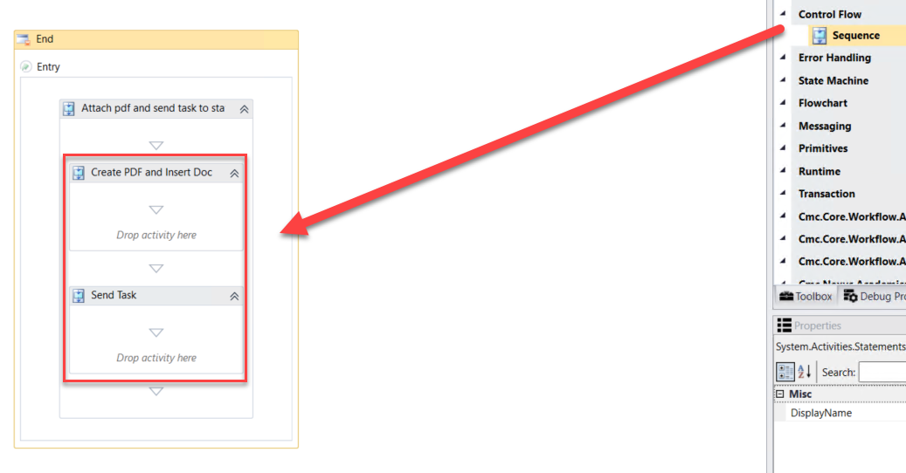

- Drag a LogLine activity in the Create PDF and Insert Doc Sequence activity.
- Rename the activity: Get Signed Document
- Text: environment.NewLine + Environment.NewLine + "Get Signed Document" + Environment.NewLine + Environment.NewLine
- Level: Error

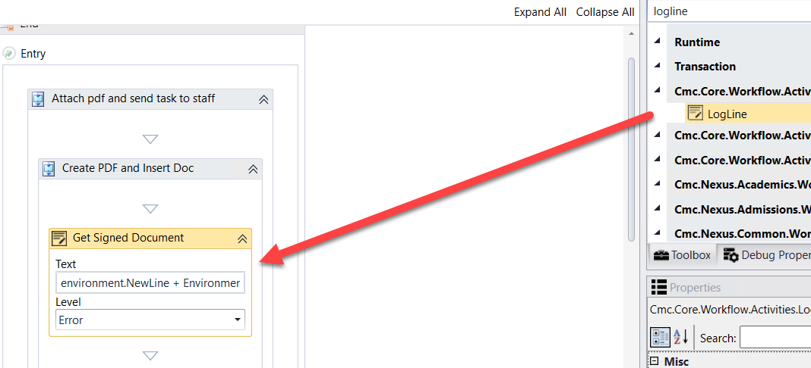

- Drag the GetSignedDocument activity below the Get Signed Document LogLine activity.
- Complete the properties for the GetSignedDocument activity as shown below.
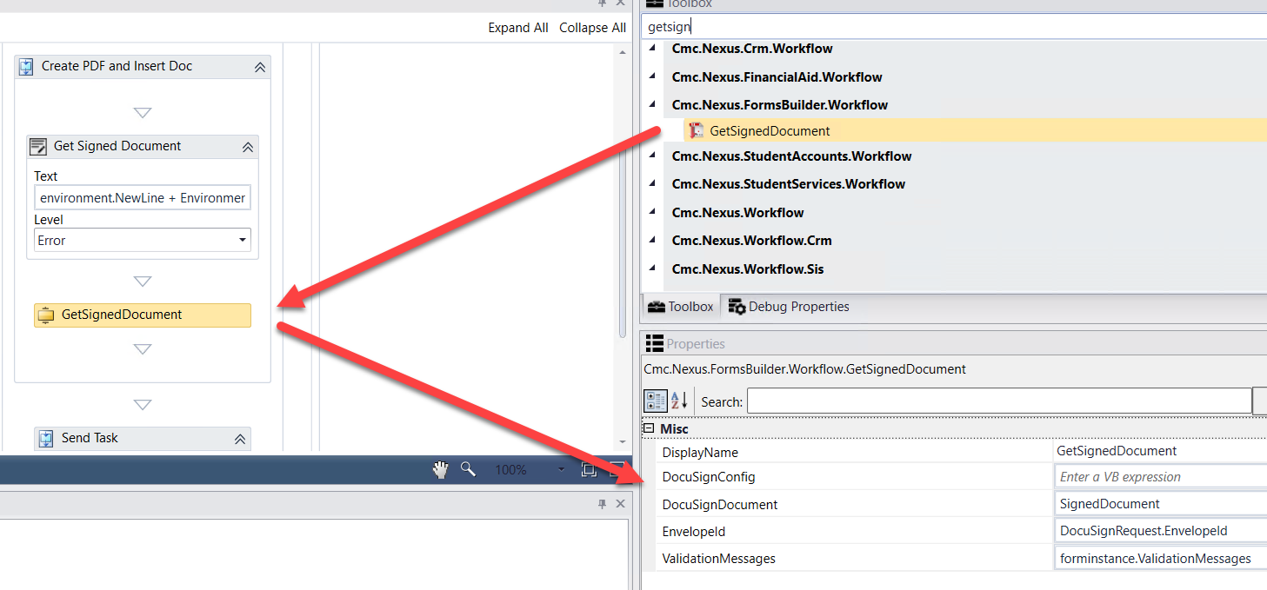

- Drag a LogLine activity in the Create PDF and Insert Doc Sequence activity below the GetSignedDocument activity.
- Rename the activity: Add Doc
- Text: environment.NewLine + Environment.NewLine + "Add/Update Doc for student" + Environment.NewLine + Environment.NewLine
- Level: Error

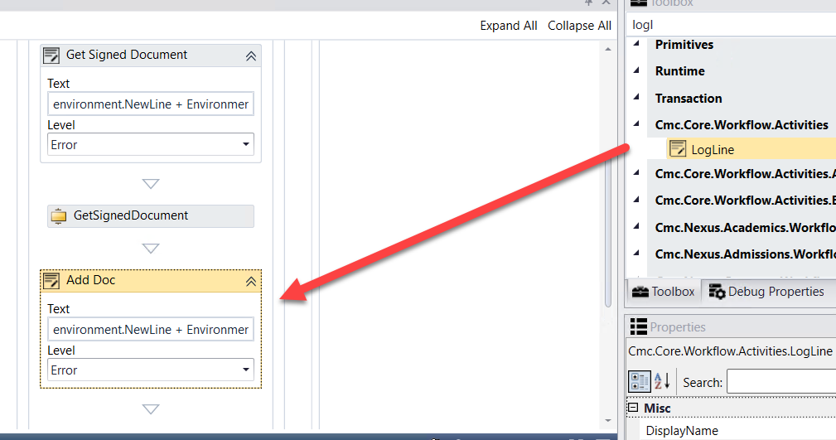

- Drag an If activity below the GetSignedDocument activity.
- Rename the activity to: If document exists
- Condition: GradApp.Length>0
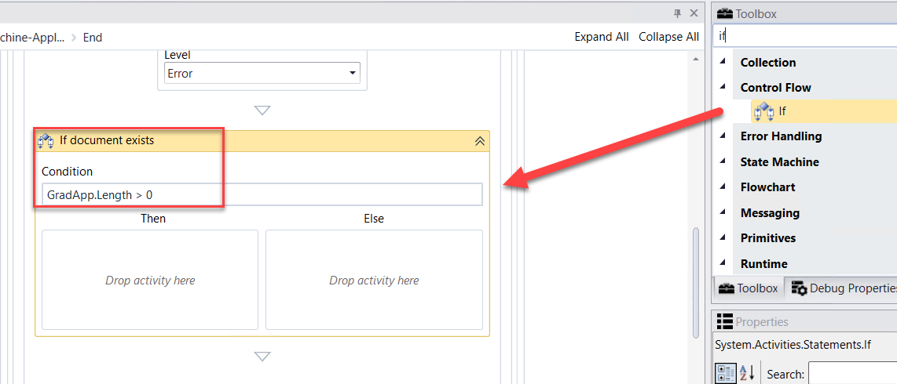

- Create a variable:
- Name: DocumentEntity
- Variable type: DocumentEntity (You will need to browse for Cmc.Nexus.Crm.Contracts>Cmc.Nexus.Crm.Entities>DocumentEntity)
- Scope: StateMachine-Application for Graduation

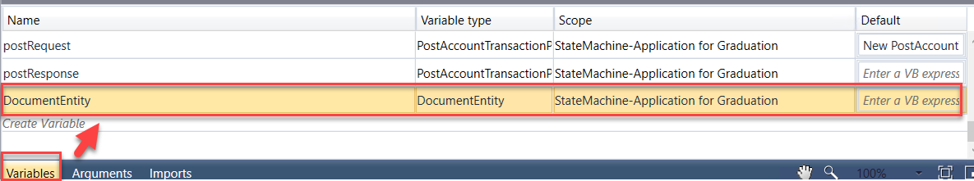

- Drag a GetEntity activity in the Then portion of the If activity.
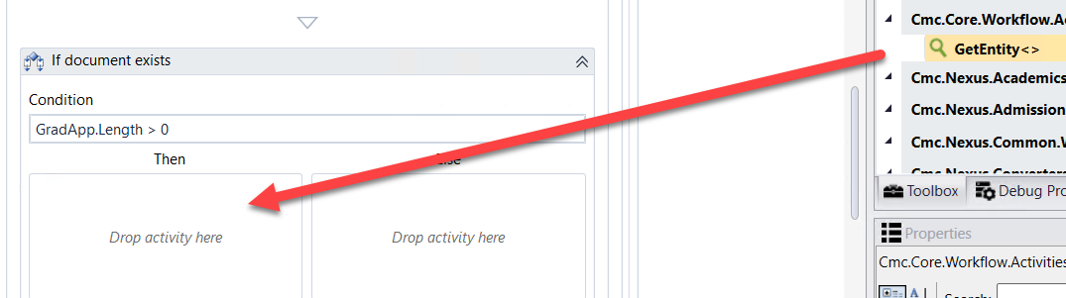

- Browse for Type: Cmc.Nexus.Crm.Contracts>Cmc.Nexus.Crm.Entities>DocumentEntity and Click OK
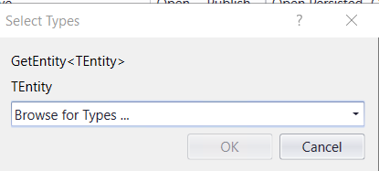
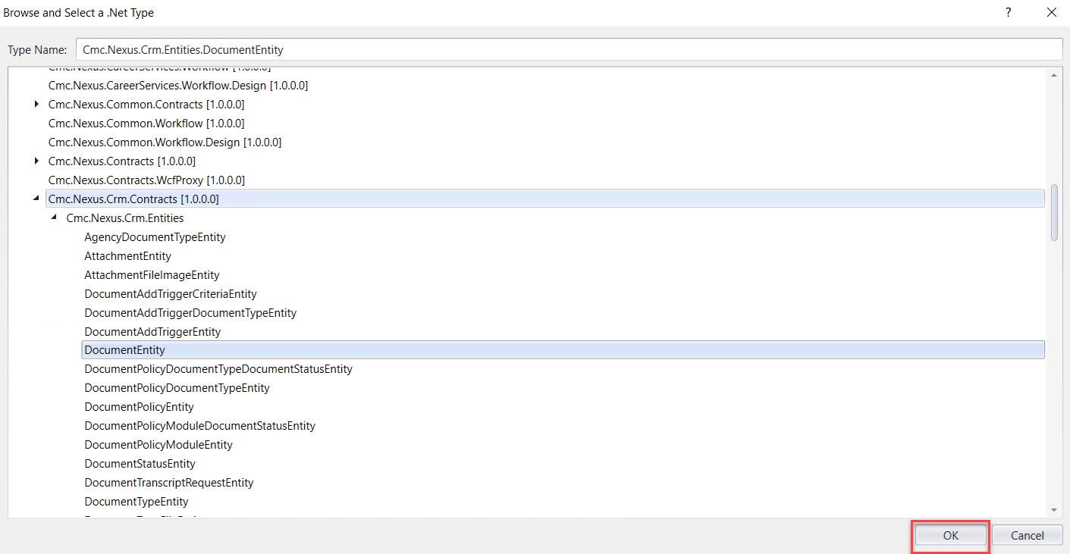

- Complete the properties as shown below.

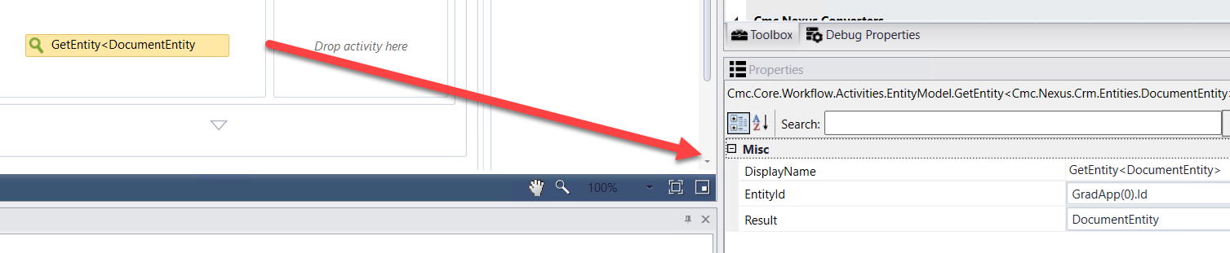

- Drag the CreateDocument activity (Located under Cmc.Nexus.Crm.Workflow) into the Else portion of the If activity. Complete the activity as shown below.

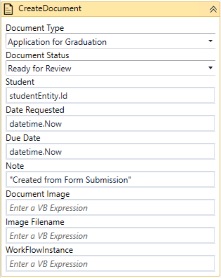

- In the properties for the CreateDocument activity, enter DocumentEntity for the Document property.
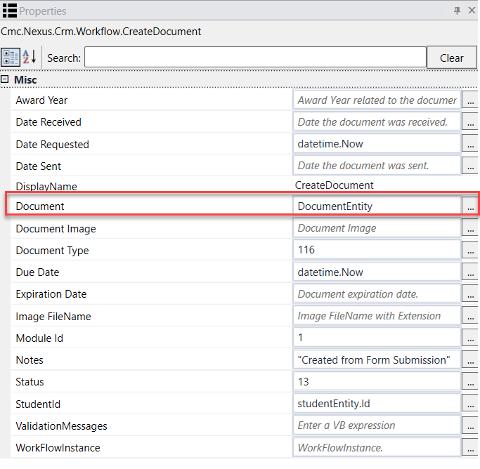
- Drag a Sequence activity below the If activity. Rename the activity to: Assign Doc Values.
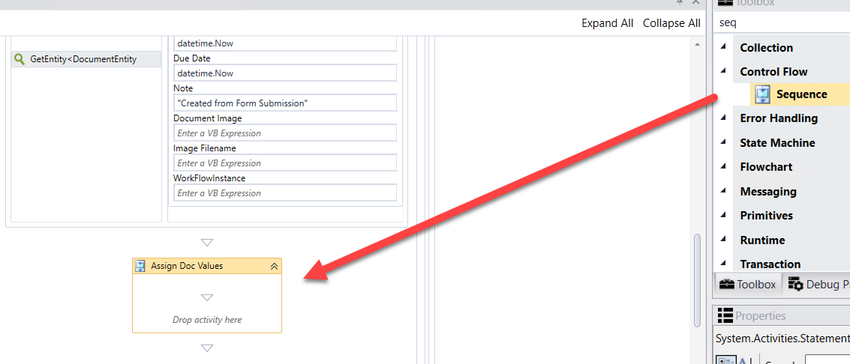

- Drag 7 Assign activities into the Sequence. Assign the following values:
- DocumentEntity.DocumentImage = SignedDocument.Content (Rename the activity to Assign Document Image)
- DocumentEntity.OriginalFileName = “ApplicationforGraduation.Pdf” (Rename the activity to Assign File Name)
- DocumentEntity.ImageType = “Pdf” (Rename the activity to Assign Image Type)
- DocumentEntity.DocumentStatusId = 13 (Rename the activity to Assign Status)
- DocumentEntity.ReceivedDate = datetime.now (Rename the activity to Assign Received Date)
- DocumentEntity.ApprovedDate = datetime.now (Rename the activity to Assign Approved Date)
- DocumentEntity.IsDocumentAddedManually = true (Rename the activity to Assign Doc Added)

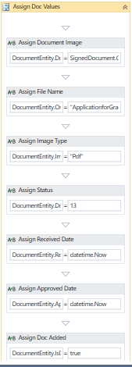

- Drag the SaveDocument activity (Located under Cmc.Nexus.Crm.Workflow) below the Assign Values Sequence. Complete the properties for the activity as shown below:
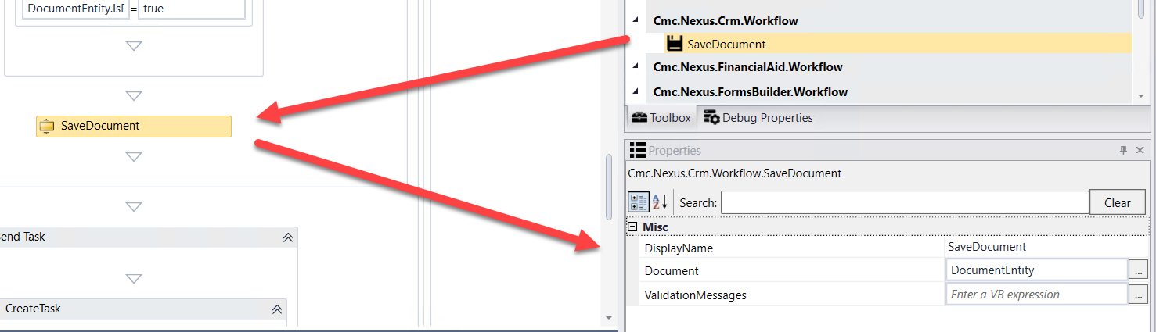

- Create a variable:
- Name: Task
- Variable type: TaskEntity (You will need to browse for Cmc.Nexus.Crm.Contracts>Cmc.Nexus.Crm.Entities>TaskEntity)
- Scope: StateMachine-Application for Graduation
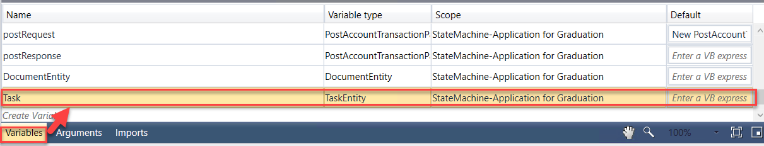

- Drag the CreateTask activity (Located under Cmc.Nexus.Crm.Workflow) into the Send Task Sequence activity. Complete the activity as shown below.
Note: Enter the following for the Subject: "The student: " + studentEntity.FirstName + " " + studentEntity.LastName + ", having a Student Number of: " + studentEntity.StudentNumber + ", " + "has submitted the Application for Graduation." + "Please review and process accordingly."
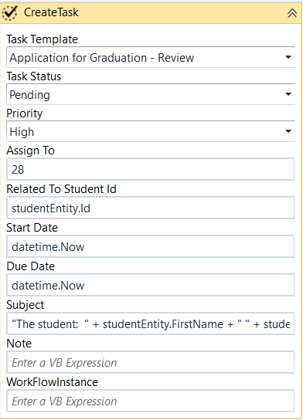

- In the properties for the CreateTask activity, enter Task for the Task property.
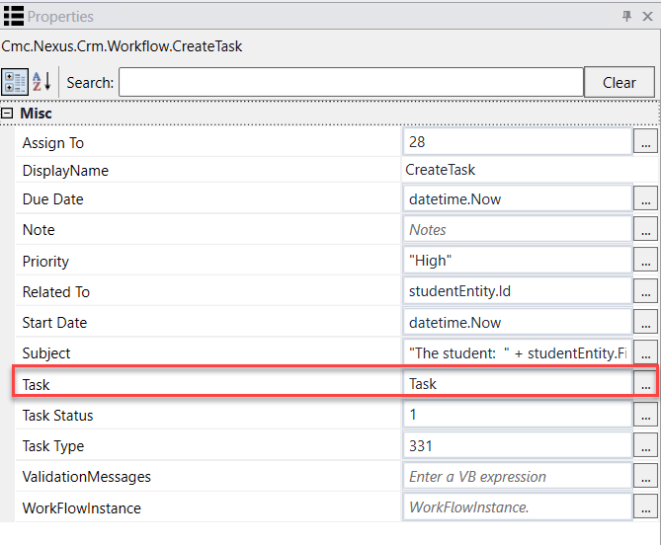
- Drag the SaveTask activity (Located under Cmc.Nexus.Crm.Workflow) below the CreateTask activity. Complete the properties for the activity as shown below:
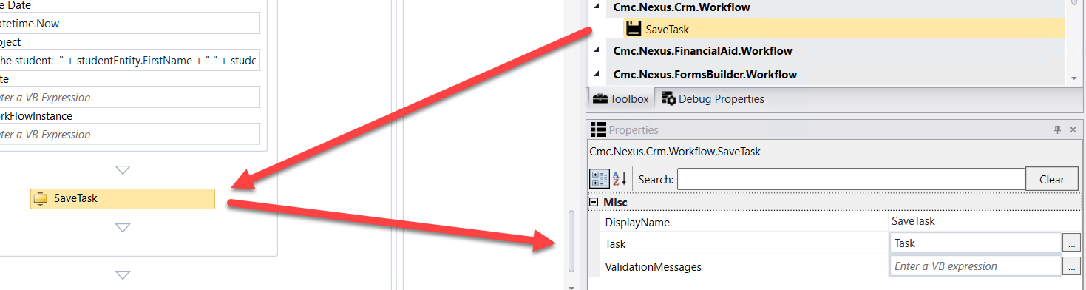

- Confirm there are no Errors in the Error pane.
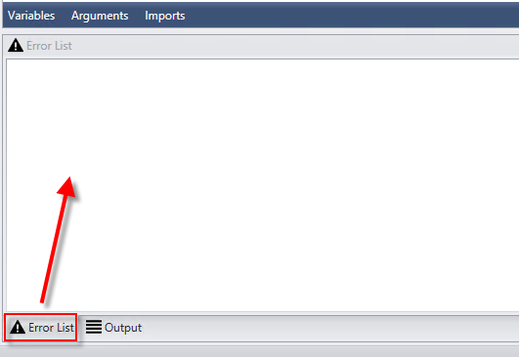

- Save your Workflow to: C:\CampusNexus\Insight2019
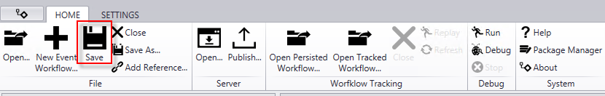
- Publish your Workflow. Make sure you select Enable This Workflow Version? and select Publish. Select OK to the confirmation.
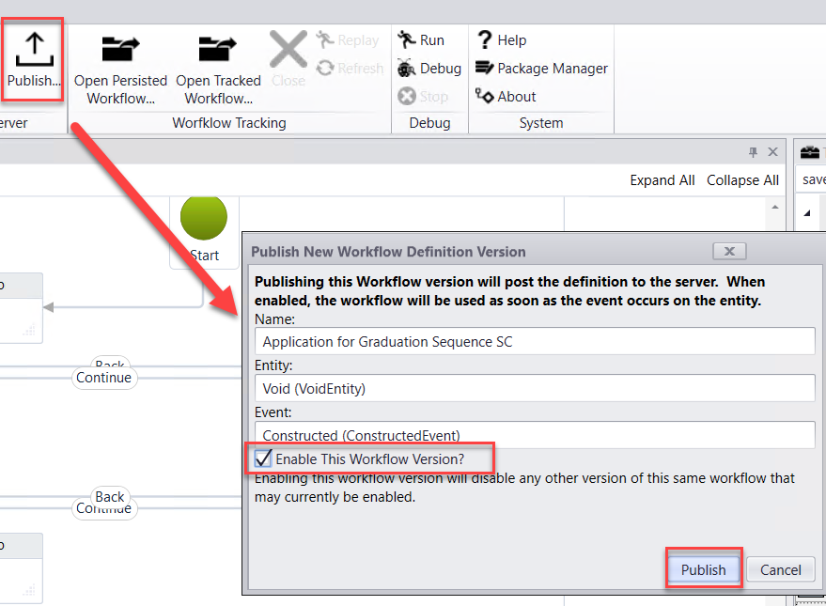

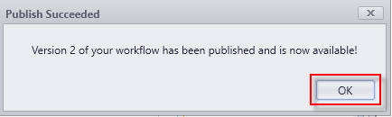

Lesson 2: Validate the Form and Supporting Workflow
In this lesson, you will validate the Application for Graduation Process by logging in as a student and completing the Application for Graduation Form Sequence. You will then validate the student record in the CampusNexus Web Client to ensure the correlating data was updated and the Application for Graduation was received and the appropriate staff members notified. Also, validate that the charge and the payment for the Graduation Fee was posted to the ledger card for the student.
Process:
- The trigger for the Application for Graduation Process will be when a student is added to a Pending Grad group. In this process, the adding to the group will be manual. However, the advising team can run a report to gather their students that are in the last term and add them to the group that way or a WF can be setup to do this based on credits, etc., and even change the status for the student to Pending Grad.
- Once the student is added to the group, a WF is triggered and the Application for Graduation Document is added to the student's Document Center as Requested-Required. Also, the student is sent an email activity with a link to complete the Application for Graduation and pay the Graduation Fee.
- The student will access the Application for Graduation Form, pay the Graduation Fee and Electronically sign the application.
- The pdf of the Application is added to the document in the Document Center and the status is updated to Ready for Review. The charge and payment for the Grad Fee is posted to the Student's Ledger and the staff member is notified that the student has submitted the Application for Graduation form. Updates in the address folder occur to save the address where the student wants the diploma to be mailed. School Defined Fields are used to store Commencement Information such as gap and gown sizes, term, etc.
- The staff member will then review the form and any related records for the student to ensure and confirm graduation status. Once the Application for Graduation Document is approved and the status updated to On File by the staff member, a WF is triggered to send an email activity to the student on the completed process and the student is also removed from the Pending App group.

Exercise: Validate the Student Self-Service Form and Supporting Workflow for Accepting an Online Payment
- Navigate to Google Chrome and launch Student from the Bookmarks Bar.
- Sign in using the following credentials:
administrator
testing
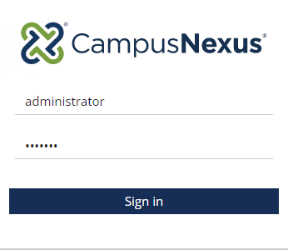

- Select Students.


- Search for student Jose Brown and click on the student link to open the student record.
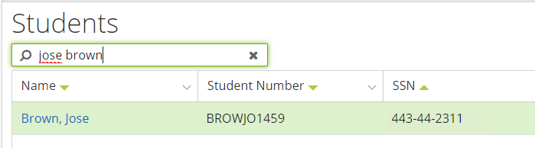
- Update the student's email address with a valid email that can be checked (Enter a personal email).
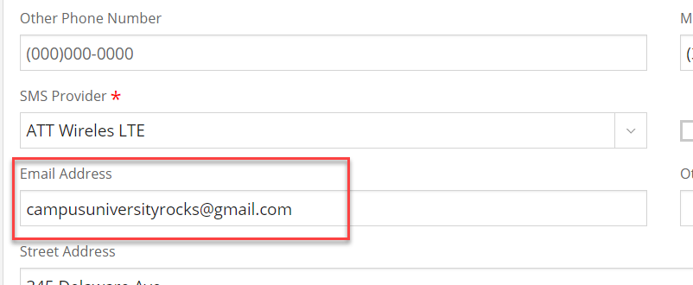

- Navigate to Group Memberships under Contact Manager.
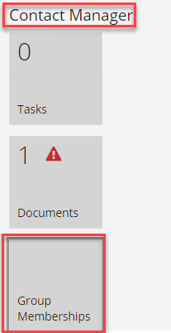

- Add the student to the Pending Grad group.
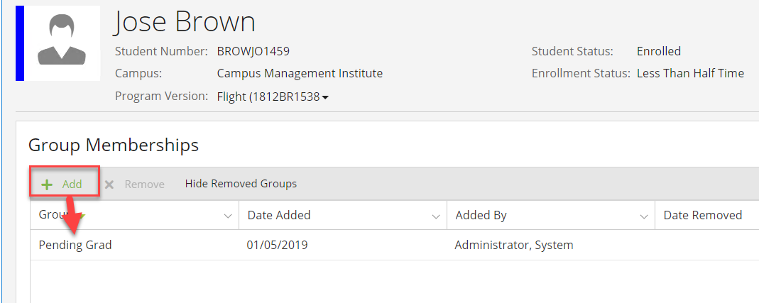

- Navigate to Documents under Contact Manager and verify that the Application for Graduation was added to the student's Document Center.
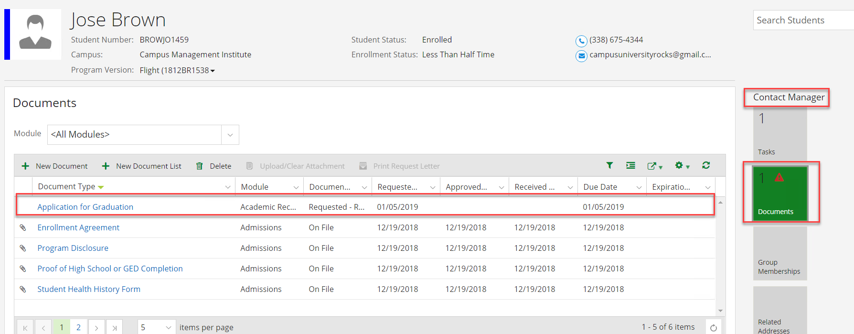

- Navigate to Tasks under Contact Manager and verify that an email task for Application for Graduation was added for the student. You will need to change the Program Version to: All Program Versions.
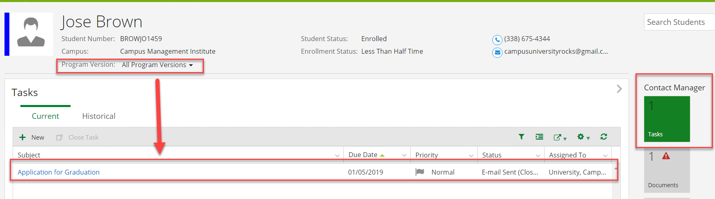

- Check your email and verify the email to the student was received. Click on the link in the email to access the Application for Graduation Form Sequence.
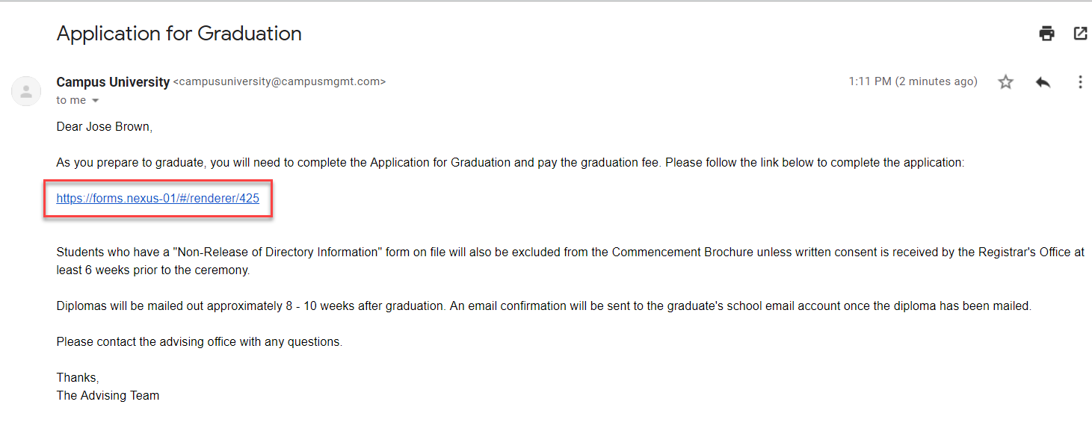

- You will need to login as the student using:
- Username: jose.brown
- Password: nexus123

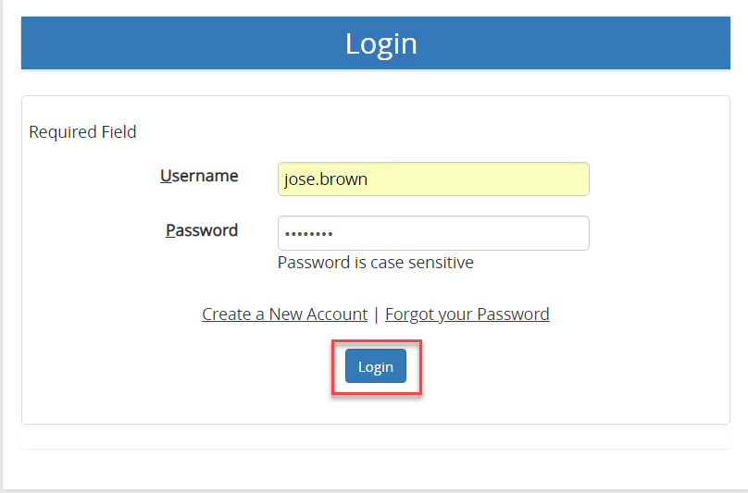
- Complete the Application for Graduation as shown below:

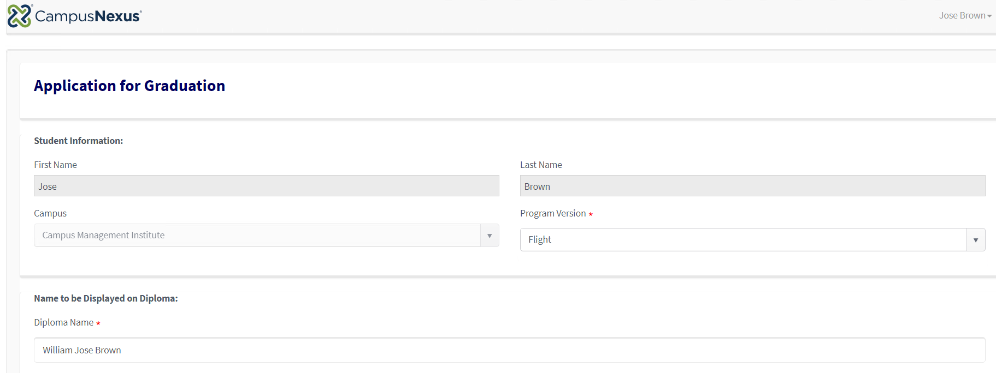
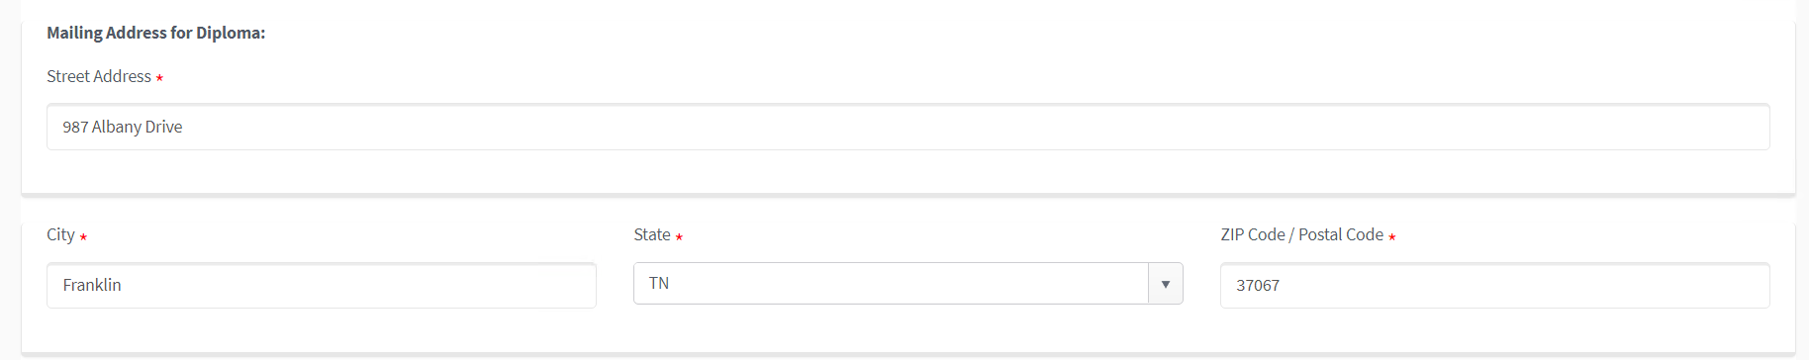
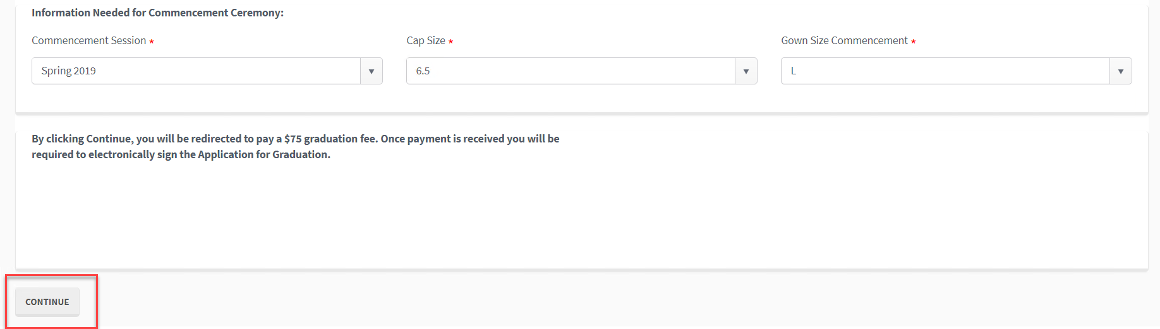

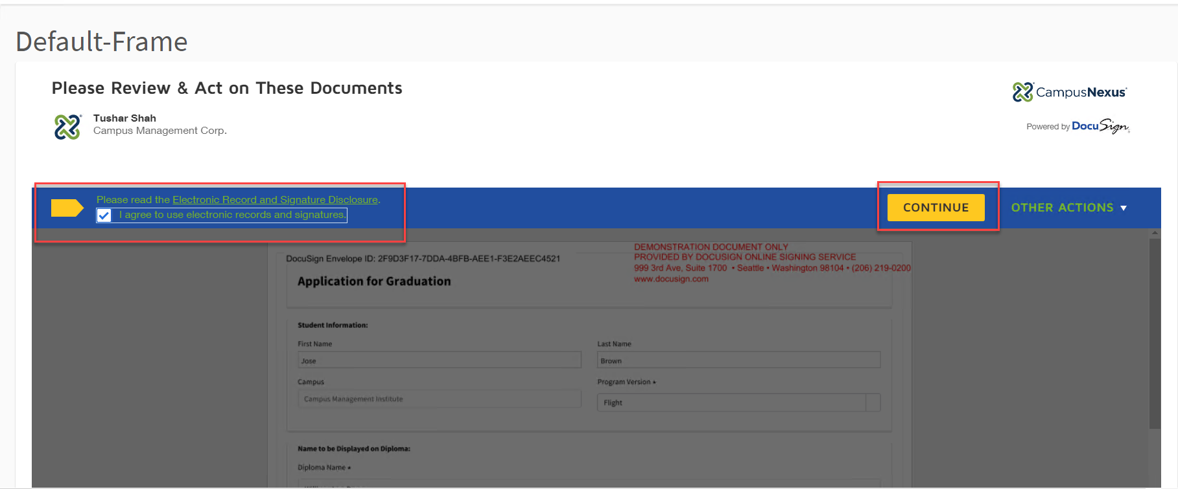
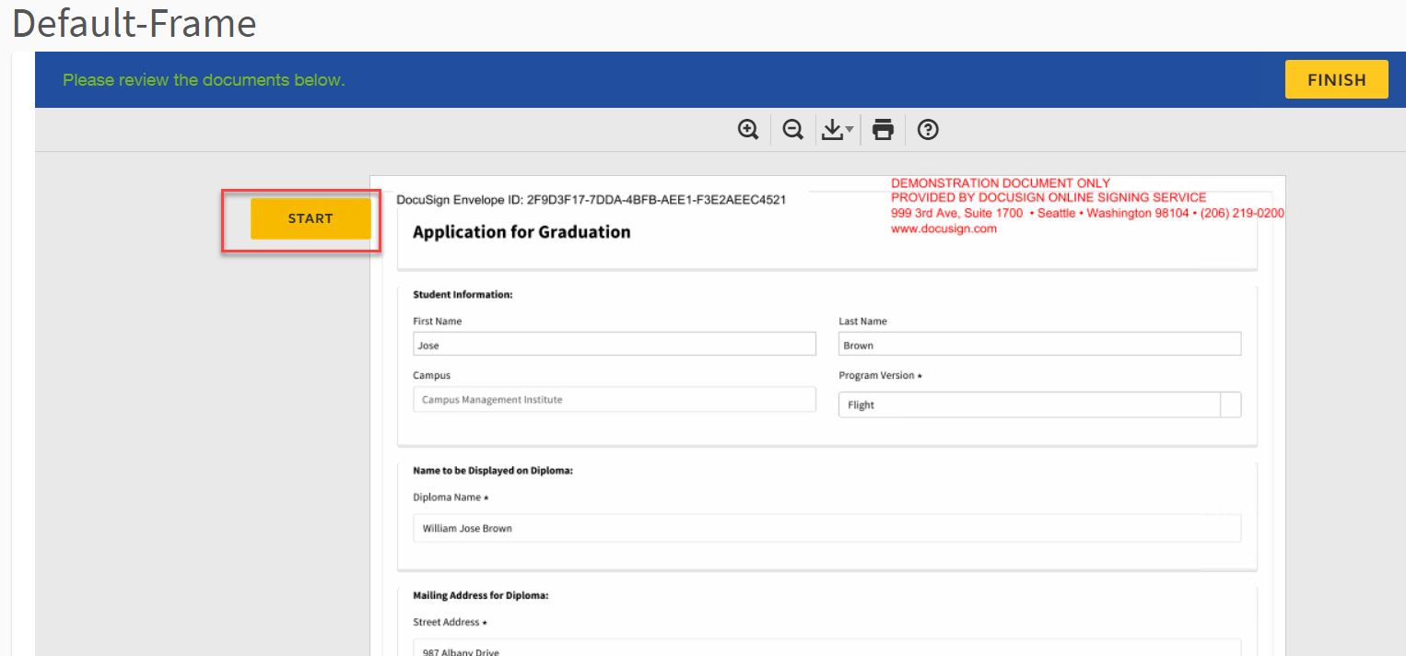
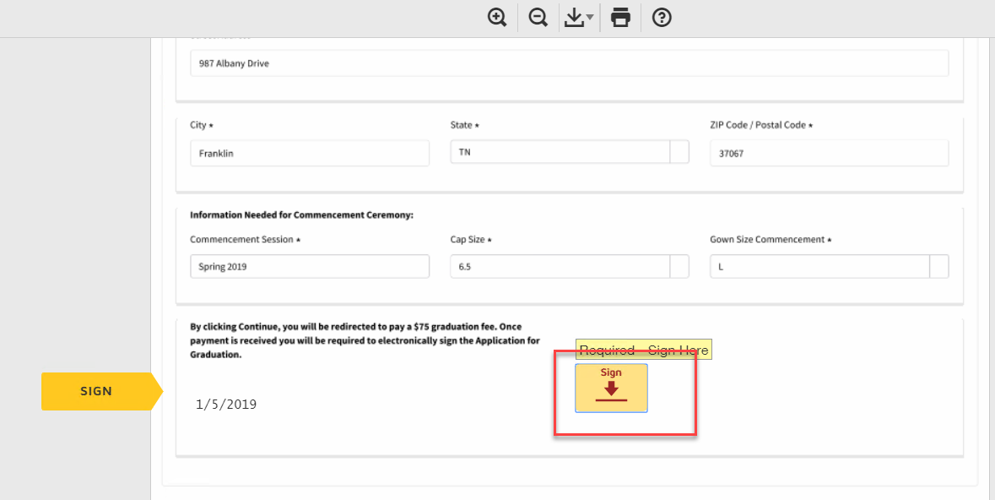

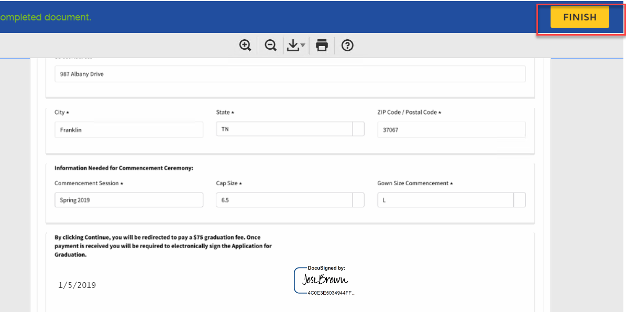
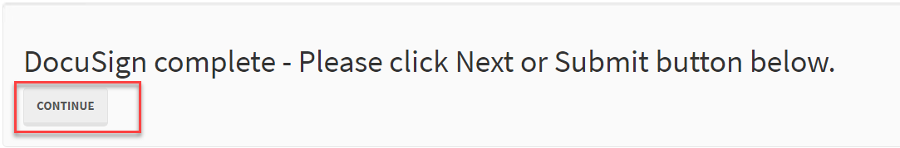
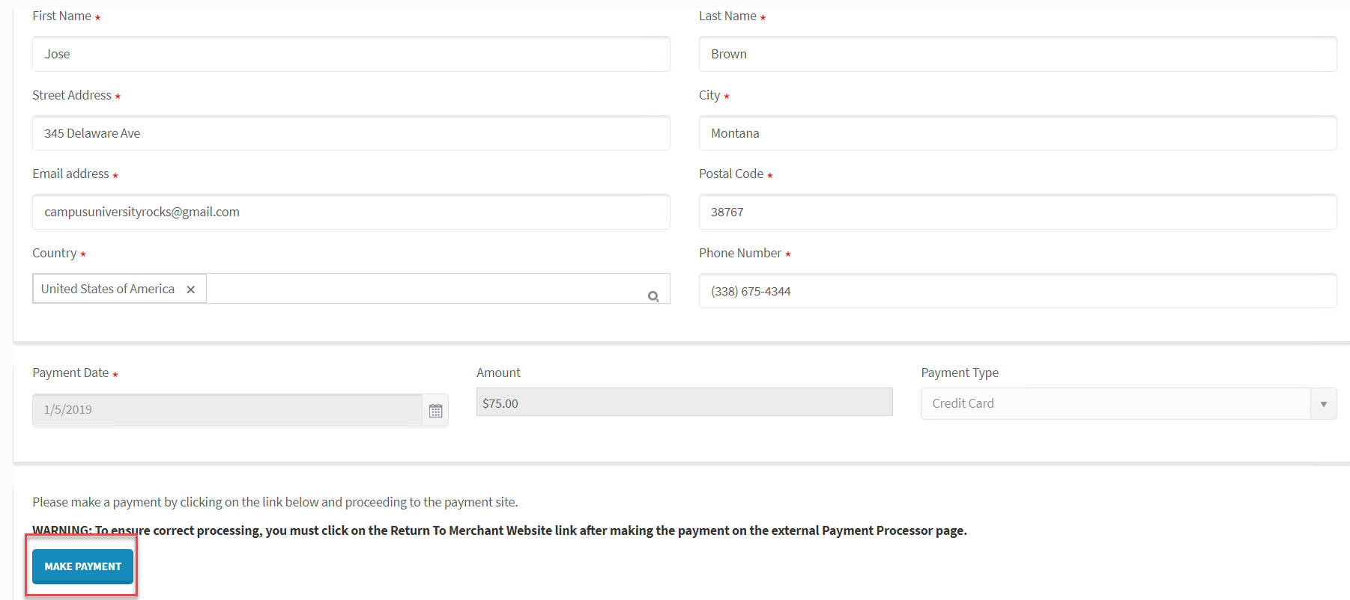

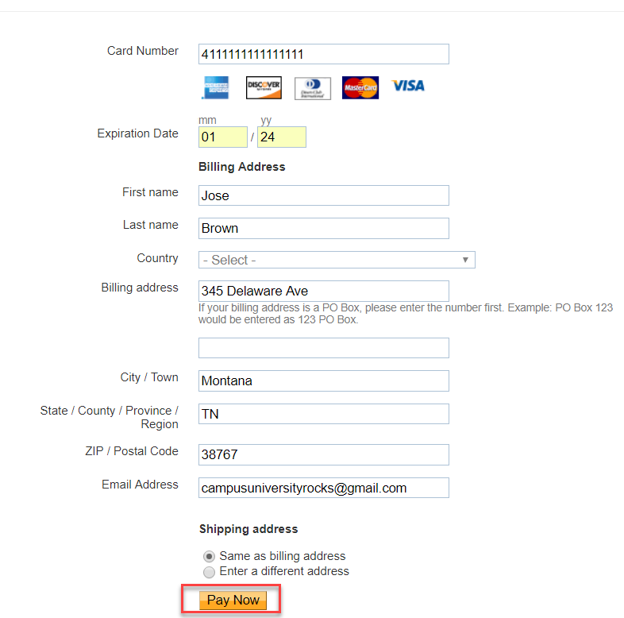
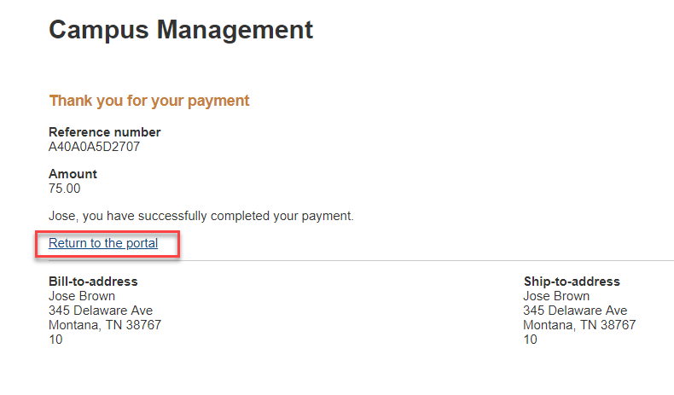
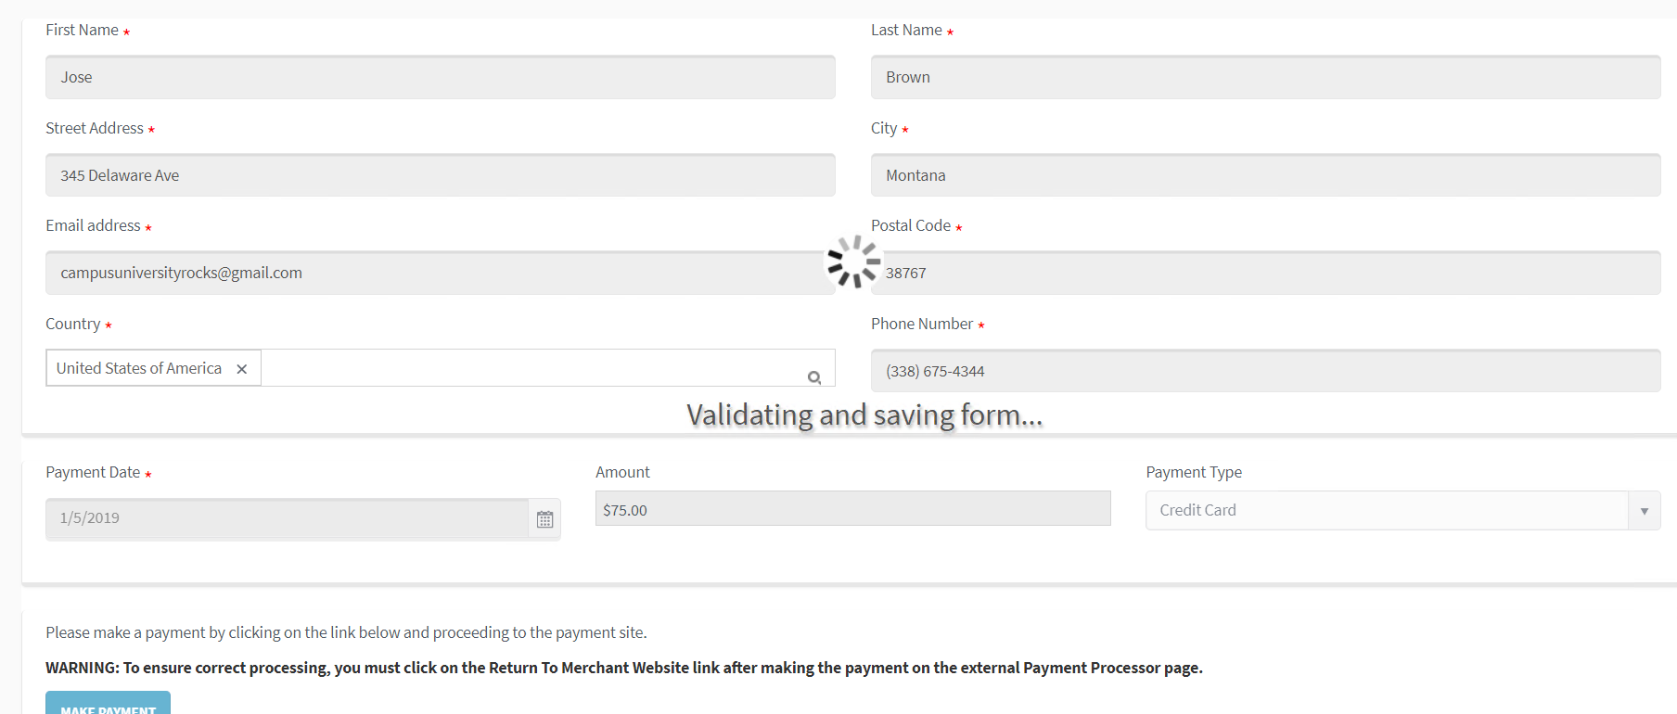
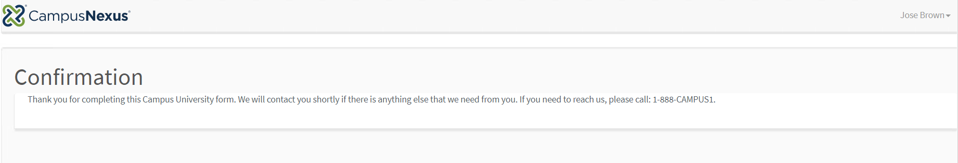

- Navigate back to CampusNexus Student to Documents under Contact Manager. Verify the Application for Graduation document is Ready for Review and you can view the PDF.

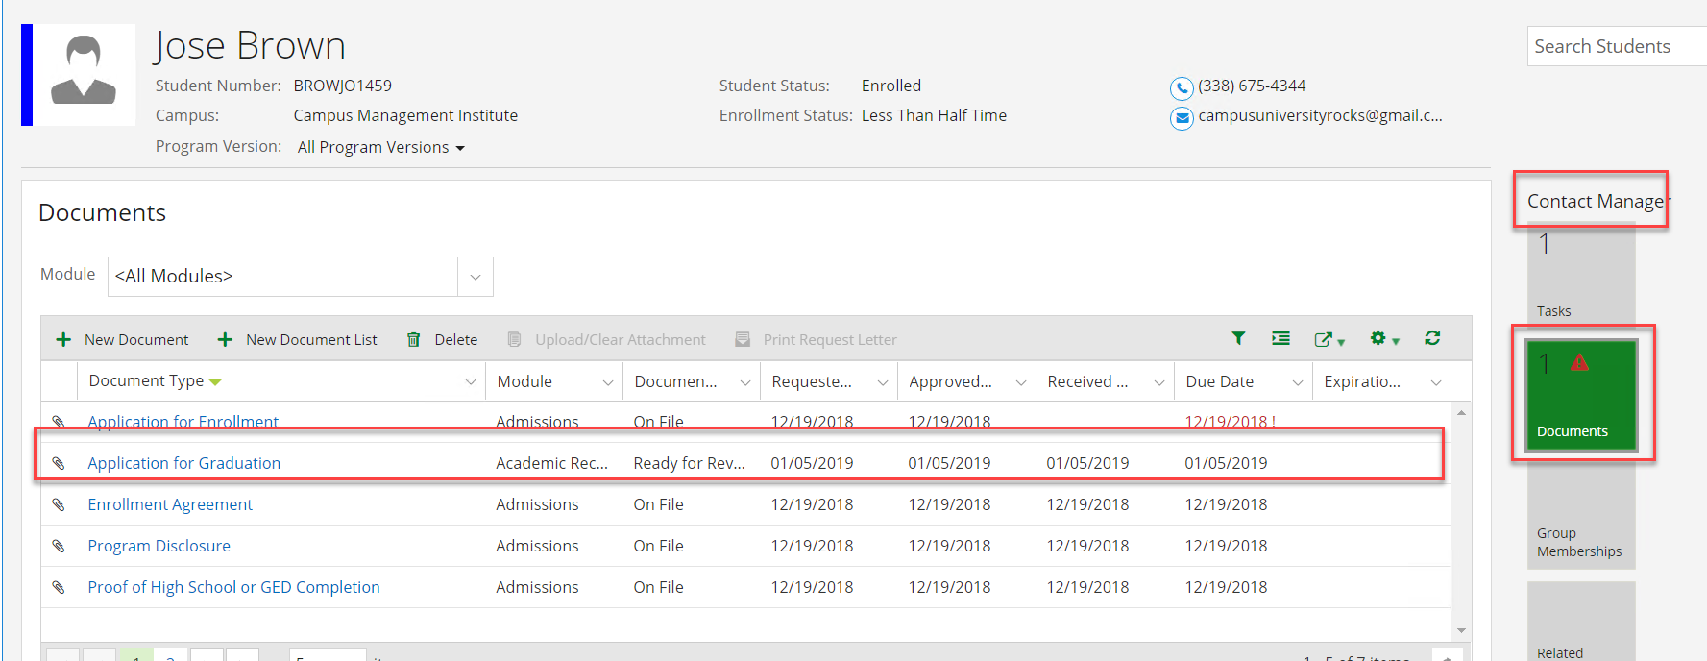
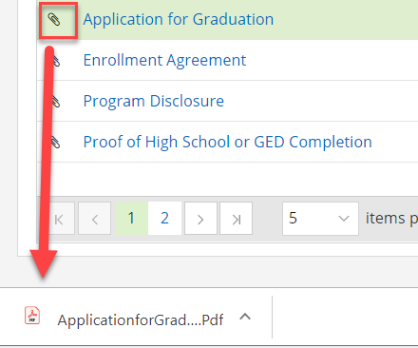
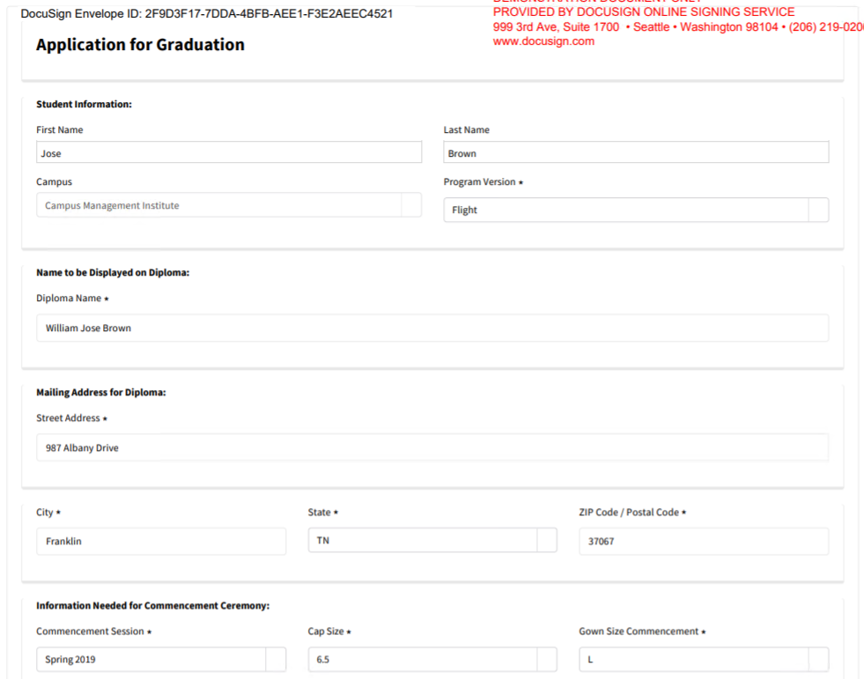
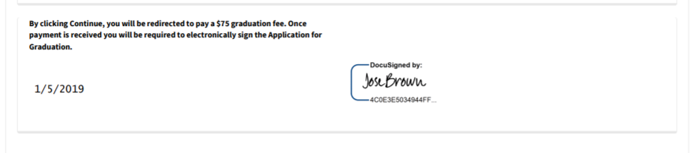

- Navigate to Related Addresses under Contact Manager and verify that the address to mail the diploma was added.
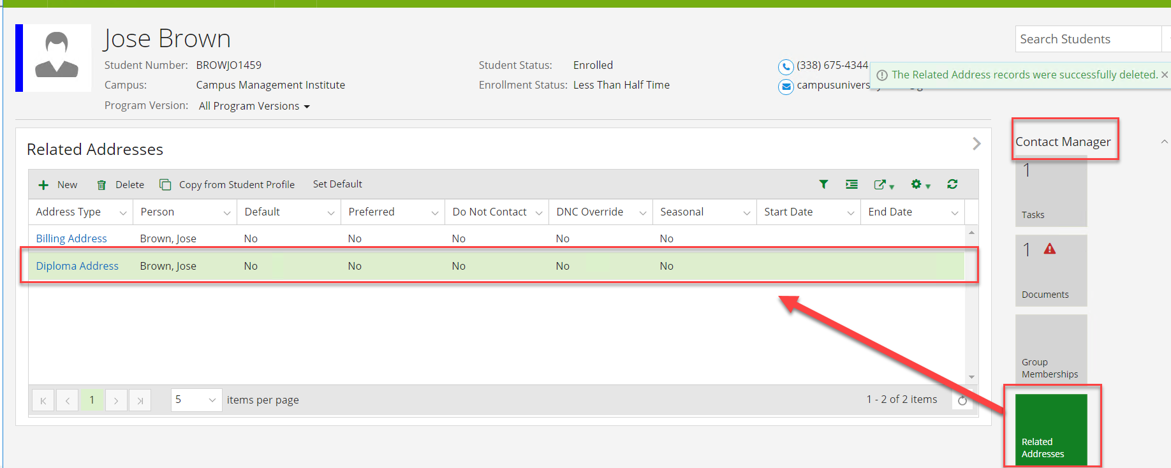

- Navigate to School Fields under Academic Records and verify that the information needed for Commencement was updated.
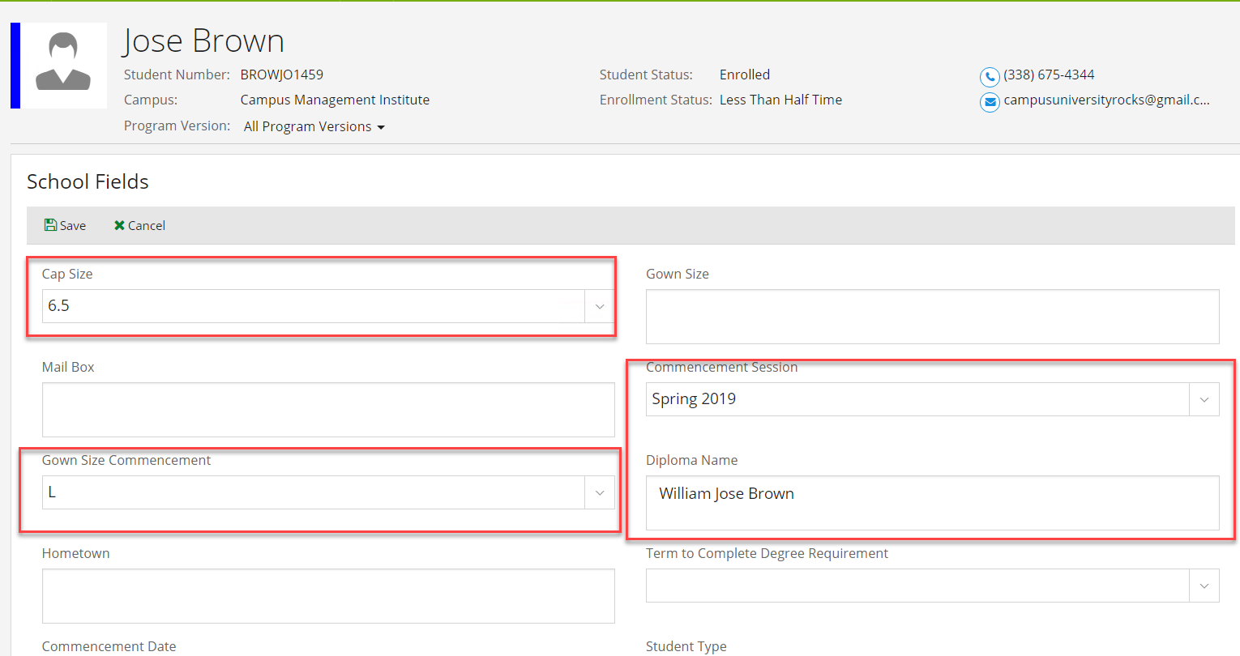

- Navigate to Tasks under Contact Manager and verify the staff member received a task to review the student's information for Graduation. Close the task (Click on the Subject Link to edit the task).
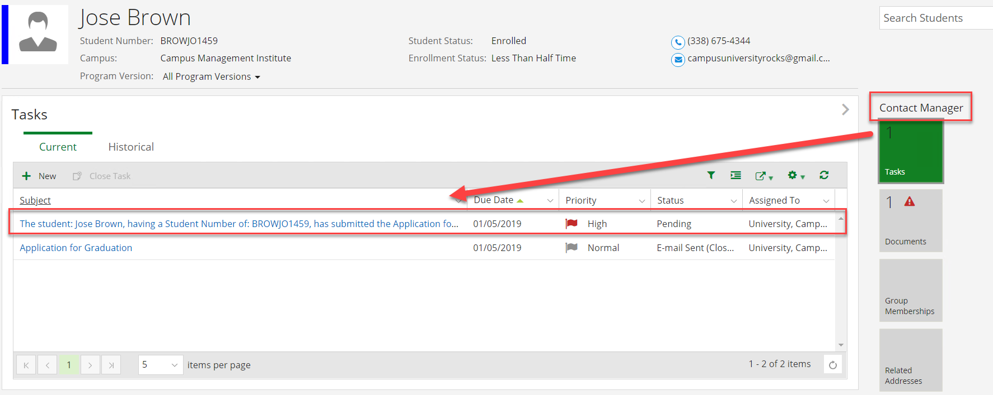
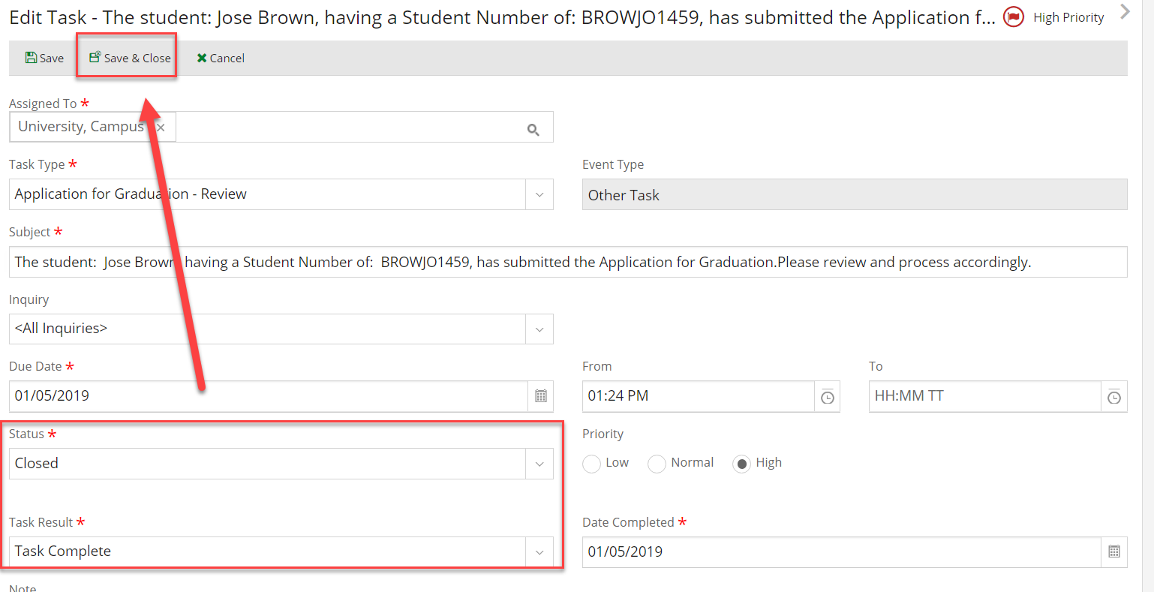

- Navigate to Documents under Contact Manager and change the status of the Application for Graduation document to On File (Click on the link for the Document Type).
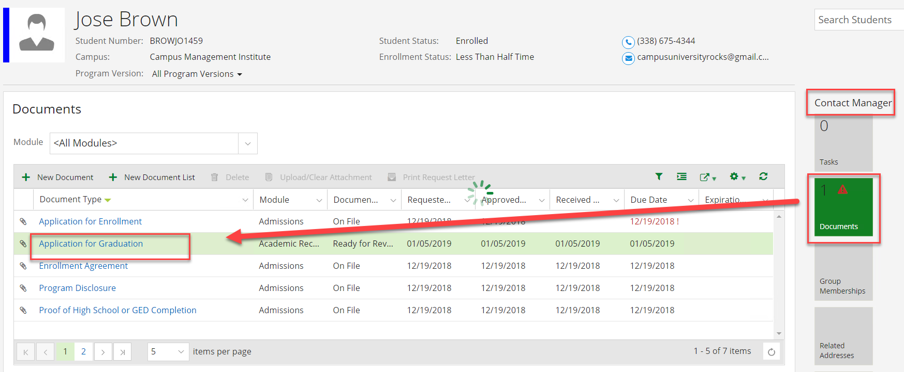
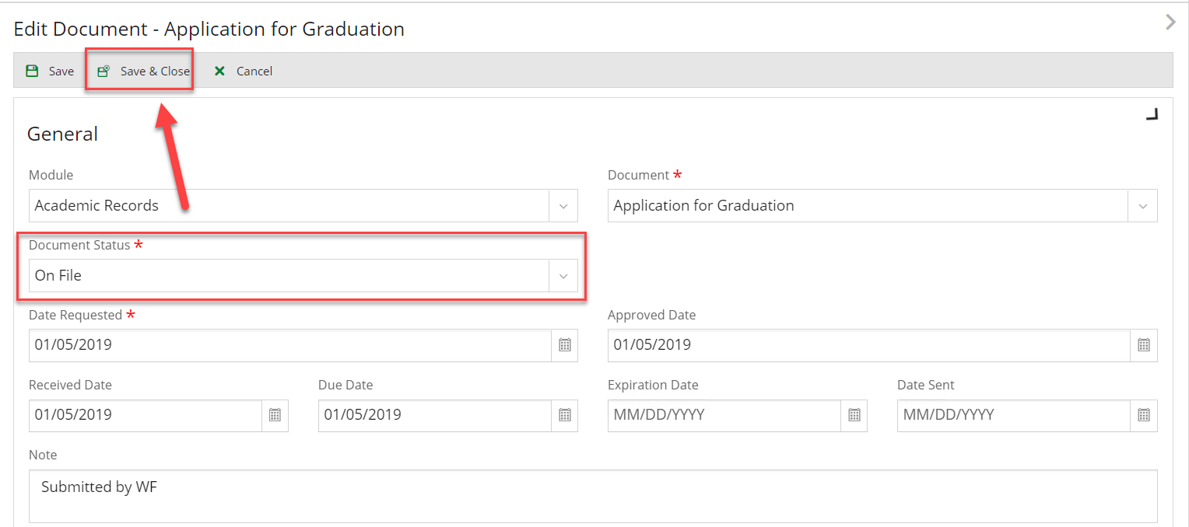
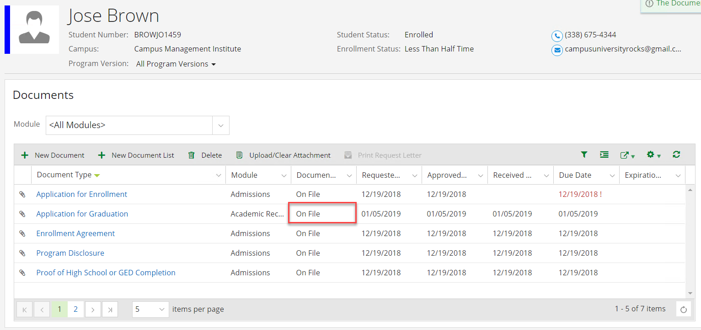

- Navigate to Group Memberships under Contact Manager and verify that the student was removed from the Pending Grad group. Click on Hide Removed Groups and then click on Show Removed Groups.
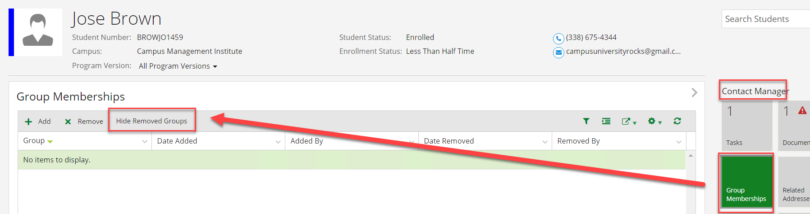
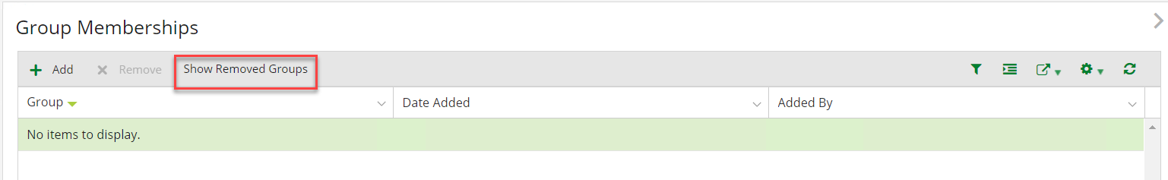
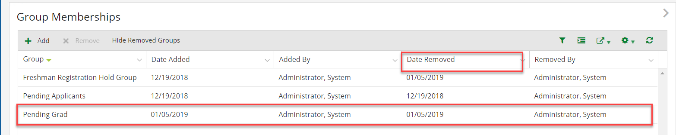
- Navigate to Tasks under Contact Manager and verify that an email task was added for the student.
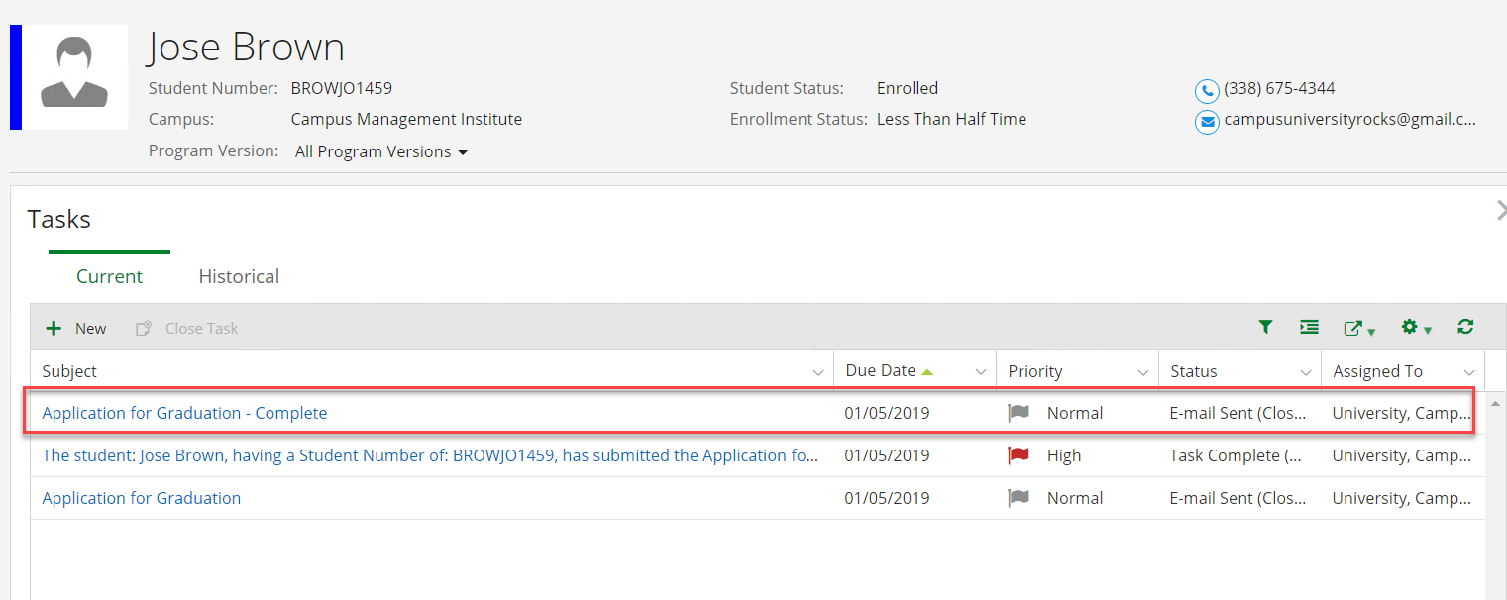

- Check your email to verify the student received the email.

